

**School of Science and Technology**

**CST3390**

**Business Information Systems Project**

**Autumn/Winter term**

**2021/2022**

|  |  |
| --- | --- |
| **Date: -** | **29th April 2022** |
| **Supervisor: -** | **Ms. Geethu Joy** |
| **Student Name: -** | **Alester D’Costa** |
| **Student ID Number: -** | **M00734829** |
| **Campus: -** | **Dubai** |

**Title: -** An investigation of online learning affecting the mental health of students during the COVID-19 pandemic

**Table of Contents**

[Abstract 7](#_Toc102159781)

[Acknowledgments 8](#_Toc102159782)

[1. Introduction 9](#_Toc102159783)

[1.1. Introduction to the project 9](#_Toc102159784)

[1.2. Aims and Objectives 10](#_Toc102159785)

[1.3. Resources utilized in the project 10](#_Toc102159786)

[1.4. Schedule of the project 11](#_Toc102159787)

[1.4.1. Work Breakdown Structure (WBS) 11](#_Toc102159788)

[1.4.2. Activity List 12](#_Toc102159789)

[1.5. Deliverables of the Project 14](#_Toc102159790)

[1.6. Scope of Work 14](#_Toc102159791)

[2. Literature Review 15](#_Toc102159792)

[Abstract of Literature Review 15](#_Toc102159793)

[2.1. Introduction of Literature Review 15](#_Toc102159794)

[2.2. Review of Literature 17](#_Toc102159795)

[2.2.1. Defining online learning and its evolution in the educational industry 17](#_Toc102159796)

[2.2.1.1. History of online learning and distance learning 18](#_Toc102159797)

[2.2.2. The use of technology in education and the utilization of online learning during the COVID-19 pandemic 19](#_Toc102159798)

[2.2.2.1. Online learning during the COVID-19 pandemic 20](#_Toc102159799)

[2.2.2.2. SWOT analysis of online learning during unanticipated events 21](#_Toc102159800)

[2.2.3. Online learning’s impact on the mental health of students during the COVID-19 pandemic 24](#_Toc102159801)

[2.2.4. Improving students’ mental health while utilizing online learning platforms 27](#_Toc102159802)

[2.3. Conclusion of Literature Review 30](#_Toc102159803)

[3. Research Methodology 31](#_Toc102159804)

[3.1. Research Design and Population of study 31](#_Toc102159805)

[3.2. Tools utilized 32](#_Toc102159806)

[4. Data Collection, Data Analysis, and Visualizations 34](#_Toc102159807)

[4.1. Introduction to Visualizations 34](#_Toc102159808)

[4.2. Data Analysis and Presentation of Results 35](#_Toc102159809)

[4.2.1. Individual analysis of variables 35](#_Toc102159810)

[4.2.2. Further analysis and findings 87](#_Toc102159811)

[4.2.3. Implementation of dashboard and story 97](#_Toc102159812)

[4.2.3.1. Components of the dashboard 97](#_Toc102159813)

[4.2.3.2. Components of the dashboard story 102](#_Toc102159814)

[5. Discussion and Evaluation 109](#_Toc102159815)

[5.1. Main findings of the research 109](#_Toc102159816)

[5.2. Limitations of the research 111](#_Toc102159817)

[6. Conclusion 112](#_Toc102159818)

[6.1. Evaluation of the project 112](#_Toc102159819)

[6.2. Limitations of the project 112](#_Toc102159820)

[6.3. Recommendations for future work 113](#_Toc102159821)

[7. References 114](#_Toc102159822)

[8. Appendices 122](#_Toc102159823)

[8.1. Ethics Approval Form 122](#_Toc102159824)

[8.2 Survey Questions and Qualtrics Screenshots 143](#_Toc102159825)

[8.2.1. Survey Questions 143](#_Toc102159826)

[8.2.2. Screenshots of survey questions on Qualtrics 150](#_Toc102159827)

[8.3. Meeting Logs 160](#_Toc102159828)

**Table of Figures**

[Figure 1: - Work Breakdown Structure (WBS) of the project 11](file:///F:\Year%203\UG%20Indvidual%20Project\Coursework%203-%20Final%20Report\CST3390-%20Undergraduate%20Individual%20Project%20(Alester).docx#_Toc102159829)

[Figure 2: - SWOT Analysis of online learning (Dhawan, 2020) 23](file:///F:\Year%203\UG%20Indvidual%20Project\Coursework%203-%20Final%20Report\CST3390-%20Undergraduate%20Individual%20Project%20(Alester).docx#_Toc102159830)

[Figure 3: - Coping strategies to be implemented while attending extended online activities and learning sessions (Mheidly, Fares and Fares, 2020) 29](file:///F:\Year%203\UG%20Indvidual%20Project\Coursework%203-%20Final%20Report\CST3390-%20Undergraduate%20Individual%20Project%20(Alester).docx#_Toc102159831)

[Figure 4: - Gender of students 35](file:///F:\Year%203\UG%20Indvidual%20Project\Coursework%203-%20Final%20Report\CST3390-%20Undergraduate%20Individual%20Project%20(Alester).docx#_Toc102159832)

[Figure 5: - Age group of students 36](file:///F:\Year%203\UG%20Indvidual%20Project\Coursework%203-%20Final%20Report\CST3390-%20Undergraduate%20Individual%20Project%20(Alester).docx#_Toc102159833)

[Figure 6: - Subject area of students 37](file:///F:\Year%203\UG%20Indvidual%20Project\Coursework%203-%20Final%20Report\CST3390-%20Undergraduate%20Individual%20Project%20(Alester).docx#_Toc102159834)

[Figure 7: - Year of study 38](file:///F:\Year%203\UG%20Indvidual%20Project\Coursework%203-%20Final%20Report\CST3390-%20Undergraduate%20Individual%20Project%20(Alester).docx#_Toc102159835)

[Figure 8: - Platforms accessed while attending online classes 40](file:///F:\Year%203\UG%20Indvidual%20Project\Coursework%203-%20Final%20Report\CST3390-%20Undergraduate%20Individual%20Project%20(Alester).docx#_Toc102159836)

[Figure 9: - Devices utilized while attending online classes 41](file:///F:\Year%203\UG%20Indvidual%20Project\Coursework%203-%20Final%20Report\CST3390-%20Undergraduate%20Individual%20Project%20(Alester).docx#_Toc102159837)

[Figure 10: - Easiness or difficulty of using online platforms during the COVID-19 pandemic lockdown 42](file:///F:\Year%203\UG%20Indvidual%20Project\Coursework%203-%20Final%20Report\CST3390-%20Undergraduate%20Individual%20Project%20(Alester).docx#_Toc102159838)

[Figure 11: - Quality of education delivered through online learning platforms 44](file:///F:\Year%203\UG%20Indvidual%20Project\Coursework%203-%20Final%20Report\CST3390-%20Undergraduate%20Individual%20Project%20(Alester).docx#_Toc102159839)

[Figure 12: - Perception of studying through online learning platforms instead of traditional face-to-face classes 46](file:///F:\Year%203\UG%20Indvidual%20Project\Coursework%203-%20Final%20Report\CST3390-%20Undergraduate%20Individual%20Project%20(Alester).docx#_Toc102159840)

[Figure 13: - Challenges faced while attending online classes 48](file:///F:\Year%203\UG%20Indvidual%20Project\Coursework%203-%20Final%20Report\CST3390-%20Undergraduate%20Individual%20Project%20(Alester).docx#_Toc102159841)

[Figure 14: - Advantages of online learning as compared to a traditional class 50](file:///F:\Year%203\UG%20Indvidual%20Project\Coursework%203-%20Final%20Report\CST3390-%20Undergraduate%20Individual%20Project%20(Alester).docx#_Toc102159842)

[Figure 15: - Maintaining time with academic work, social life, and extracurricular activities while attending online classes 52](file:///F:\Year%203\UG%20Indvidual%20Project\Coursework%203-%20Final%20Report\CST3390-%20Undergraduate%20Individual%20Project%20(Alester).docx#_Toc102159843)

[Figure 16: - State of mental health 55](file:///F:\Year%203\UG%20Indvidual%20Project\Coursework%203-%20Final%20Report\CST3390-%20Undergraduate%20Individual%20Project%20(Alester).docx#_Toc102159844)

[Figure 17: - Disturbance of the COVID-19 pandemic on the normal university experience 57](file:///F:\Year%203\UG%20Indvidual%20Project\Coursework%203-%20Final%20Report\CST3390-%20Undergraduate%20Individual%20Project%20(Alester).docx#_Toc102159845)

[Figure 18: - Online learning affecting mental health at the beginning of the COVID-19 pandemic 59](file:///F:\Year%203\UG%20Indvidual%20Project\Coursework%203-%20Final%20Report\CST3390-%20Undergraduate%20Individual%20Project%20(Alester).docx#_Toc102159846)

[Figure 19: - Anxiousness while attending online classes 61](file:///F:\Year%203\UG%20Indvidual%20Project\Coursework%203-%20Final%20Report\CST3390-%20Undergraduate%20Individual%20Project%20(Alester).docx#_Toc102159847)

[Figure 20: - Regular Attendance during online sessions 63](file:///F:\Year%203\UG%20Indvidual%20Project\Coursework%203-%20Final%20Report\CST3390-%20Undergraduate%20Individual%20Project%20(Alester).docx#_Toc102159848)

[Figure 21: - Reasons behind not attending online classes 65](file:///F:\Year%203\UG%20Indvidual%20Project\Coursework%203-%20Final%20Report\CST3390-%20Undergraduate%20Individual%20Project%20(Alester).docx#_Toc102159849)

[Figure 22: - Zoom Fatigue during online classes 67](file:///F:\Year%203\UG%20Indvidual%20Project\Coursework%203-%20Final%20Report\CST3390-%20Undergraduate%20Individual%20Project%20(Alester).docx#_Toc102159850)

[Figure 23: - Approaches used to deal with Zoom Fatigue 69](file:///F:\Year%203\UG%20Indvidual%20Project\Coursework%203-%20Final%20Report\CST3390-%20Undergraduate%20Individual%20Project%20(Alester).docx#_Toc102159851)

[Figure 24: - Course performance affecting mental health 71](file:///F:\Year%203\UG%20Indvidual%20Project\Coursework%203-%20Final%20Report\CST3390-%20Undergraduate%20Individual%20Project%20(Alester).docx#_Toc102159852)

[Figure 25: - Difficulty in attaining a good grade through online learning platforms instead of traditional classes 73](file:///F:\Year%203\UG%20Indvidual%20Project\Coursework%203-%20Final%20Report\CST3390-%20Undergraduate%20Individual%20Project%20(Alester).docx#_Toc102159853)

[Figure 26: - Relevant learning resources provided during online classes 75](file:///F:\Year%203\UG%20Indvidual%20Project\Coursework%203-%20Final%20Report\CST3390-%20Undergraduate%20Individual%20Project%20(Alester).docx#_Toc102159854)

[Figure 27: - Helpfulness of tutors while attending online classes 77](file:///F:\Year%203\UG%20Indvidual%20Project\Coursework%203-%20Final%20Report\CST3390-%20Undergraduate%20Individual%20Project%20(Alester).docx#_Toc102159855)

[Figure 28: - One-to-one discussions with tutors for assignment feedback while attending online classes 79](file:///F:\Year%203\UG%20Indvidual%20Project\Coursework%203-%20Final%20Report\CST3390-%20Undergraduate%20Individual%20Project%20(Alester).docx#_Toc102159856)

[Figure 29: - Online examinations held while utilizing online modes of education 81](file:///F:\Year%203\UG%20Indvidual%20Project\Coursework%203-%20Final%20Report\CST3390-%20Undergraduate%20Individual%20Project%20(Alester).docx#_Toc102159857)

[Figure 30: - Leniency of marking scale for students attending online classes 83](file:///F:\Year%203\UG%20Indvidual%20Project\Coursework%203-%20Final%20Report\CST3390-%20Undergraduate%20Individual%20Project%20(Alester).docx#_Toc102159858)

[Figure 31: - Online learning replacing traditional mode of classes 85](file:///F:\Year%203\UG%20Indvidual%20Project\Coursework%203-%20Final%20Report\CST3390-%20Undergraduate%20Individual%20Project%20(Alester).docx#_Toc102159859)

[Figure 32: - Relationship between mental health and year of study of students 87](file:///F:\Year%203\UG%20Indvidual%20Project\Coursework%203-%20Final%20Report\CST3390-%20Undergraduate%20Individual%20Project%20(Alester).docx#_Toc102159860)

[Figure 33: - Relationship between online learning affecting mental health at the beginning of the COVID-19 pandemic and year of study of students 89](file:///F:\Year%203\UG%20Indvidual%20Project\Coursework%203-%20Final%20Report\CST3390-%20Undergraduate%20Individual%20Project%20(Alester).docx#_Toc102159861)

[Figure 34: - Relationship between anxiousness while attending online classes and year of study of students 91](file:///F:\Year%203\UG%20Indvidual%20Project\Coursework%203-%20Final%20Report\CST3390-%20Undergraduate%20Individual%20Project%20(Alester).docx#_Toc102159862)

[Figure 35: - Relationship between regular attendance during online sessions and year of study of students 93](file:///F:\Year%203\UG%20Indvidual%20Project\Coursework%203-%20Final%20Report\CST3390-%20Undergraduate%20Individual%20Project%20(Alester).docx#_Toc102159863)

[Figure 36: - Relationship between Zoom Fatigue and year of study of students 95](file:///F:\Year%203\UG%20Indvidual%20Project\Coursework%203-%20Final%20Report\CST3390-%20Undergraduate%20Individual%20Project%20(Alester).docx#_Toc102159864)

[Figure 37: - Survey Analysis Dashboard (Sheet 1) 98](file:///F:\Year%203\UG%20Indvidual%20Project\Coursework%203-%20Final%20Report\CST3390-%20Undergraduate%20Individual%20Project%20(Alester).docx#_Toc102159865)

[Figure 38: - Survey Analysis Dashboard (Sheet 2) 99](file:///F:\Year%203\UG%20Indvidual%20Project\Coursework%203-%20Final%20Report\CST3390-%20Undergraduate%20Individual%20Project%20(Alester).docx#_Toc102159866)

[Figure 39: - Survey Analysis Dashboard (Sheet 3) 100](file:///F:\Year%203\UG%20Indvidual%20Project\Coursework%203-%20Final%20Report\CST3390-%20Undergraduate%20Individual%20Project%20(Alester).docx#_Toc102159867)

[Figure 40: - Survey Analysis Dashboard (Sheet 4) 101](file:///F:\Year%203\UG%20Indvidual%20Project\Coursework%203-%20Final%20Report\CST3390-%20Undergraduate%20Individual%20Project%20(Alester).docx#_Toc102159868)

[Figure 41: - Survey Analysis Dashboard (Sheet 5) 102](file:///F:\Year%203\UG%20Indvidual%20Project\Coursework%203-%20Final%20Report\CST3390-%20Undergraduate%20Individual%20Project%20(Alester).docx#_Toc102159869)

[Figure 42: - Survey Analysis Dashboard Story (Sheet 1) 103](file:///F:\Year%203\UG%20Indvidual%20Project\Coursework%203-%20Final%20Report\CST3390-%20Undergraduate%20Individual%20Project%20(Alester).docx#_Toc102159870)

[Figure 43: - Survey Analysis Dashboard Story (Sheet 2) 104](file:///F:\Year%203\UG%20Indvidual%20Project\Coursework%203-%20Final%20Report\CST3390-%20Undergraduate%20Individual%20Project%20(Alester).docx#_Toc102159871)

[Figure 44: - Survey Analysis Dashboard Story (Sheet 3) 105](file:///F:\Year%203\UG%20Indvidual%20Project\Coursework%203-%20Final%20Report\CST3390-%20Undergraduate%20Individual%20Project%20(Alester).docx#_Toc102159872)

[Figure 45: - Survey Analysis Dashboard Story (Sheet 4) 106](file:///F:\Year%203\UG%20Indvidual%20Project\Coursework%203-%20Final%20Report\CST3390-%20Undergraduate%20Individual%20Project%20(Alester).docx#_Toc102159873)

[Figure 46: - Survey Analysis Dashboard Story (Sheet 5) 107](file:///F:\Year%203\UG%20Indvidual%20Project\Coursework%203-%20Final%20Report\CST3390-%20Undergraduate%20Individual%20Project%20(Alester).docx#_Toc102159874)

[Figure 47: - Survey Analysis Dashboard Story (Sheet 6) 108](file:///F:\Year%203\UG%20Indvidual%20Project\Coursework%203-%20Final%20Report\CST3390-%20Undergraduate%20Individual%20Project%20(Alester).docx#_Toc102159875)

[Figure 48: - Survey questions on demographics of students implemented in Qualtrics (Page 1) 150](file:///F:\Year%203\UG%20Indvidual%20Project\Coursework%203-%20Final%20Report\CST3390-%20Undergraduate%20Individual%20Project%20(Alester).docx#_Toc102159876)

[Figure 49: - Survey questions on demographics of students implemented in Qualtrics (Page 2) 150](file:///F:\Year%203\UG%20Indvidual%20Project\Coursework%203-%20Final%20Report\CST3390-%20Undergraduate%20Individual%20Project%20(Alester).docx#_Toc102159877)

[Figure 50: - Survey questions on demographics of students implemented in Qualtrics (Page 3) 151](file:///F:\Year%203\UG%20Indvidual%20Project\Coursework%203-%20Final%20Report\CST3390-%20Undergraduate%20Individual%20Project%20(Alester).docx#_Toc102159878)

[Figure 51: - Survey questions on technical aspects of online learning implemented in Qualtrics (Page 3) 151](file:///F:\Year%203\UG%20Indvidual%20Project\Coursework%203-%20Final%20Report\CST3390-%20Undergraduate%20Individual%20Project%20(Alester).docx#_Toc102159879)

[Figure 52: - Survey questions on technical aspects of online learning implemented in Qualtrics (Page 5) 152](file:///F:\Year%203\UG%20Indvidual%20Project\Coursework%203-%20Final%20Report\CST3390-%20Undergraduate%20Individual%20Project%20(Alester).docx#_Toc102159880)

[Figure 53: - Survey questions on technical aspects of online learning implemented in Qualtrics (Page 6) 152](file:///F:\Year%203\UG%20Indvidual%20Project\Coursework%203-%20Final%20Report\CST3390-%20Undergraduate%20Individual%20Project%20(Alester).docx#_Toc102159881)

[Figure 54: - Survey questions on technical aspects of online learning implemented in Qualtrics (Page 7) 153](file:///F:\Year%203\UG%20Indvidual%20Project\Coursework%203-%20Final%20Report\CST3390-%20Undergraduate%20Individual%20Project%20(Alester).docx#_Toc102159882)

[Figure 55: - Survey questions on technical aspects of online learning implemented in Qualtrics (Page 8) 153](file:///F:\Year%203\UG%20Indvidual%20Project\Coursework%203-%20Final%20Report\CST3390-%20Undergraduate%20Individual%20Project%20(Alester).docx#_Toc102159883)

[Figure 56: - Survey questions on students' mental health implemented in Qualtrics (Page 9) 154](file:///F:\Year%203\UG%20Indvidual%20Project\Coursework%203-%20Final%20Report\CST3390-%20Undergraduate%20Individual%20Project%20(Alester).docx#_Toc102159884)

[Figure 57: - Survey questions on students' mental health implemented in Qualtrics (Page 10) 154](file:///F:\Year%203\UG%20Indvidual%20Project\Coursework%203-%20Final%20Report\CST3390-%20Undergraduate%20Individual%20Project%20(Alester).docx#_Toc102159885)

[Figure 58: - Survey questions on students' mental health implemented in Qualtrics (Page 11) 155](file:///F:\Year%203\UG%20Indvidual%20Project\Coursework%203-%20Final%20Report\CST3390-%20Undergraduate%20Individual%20Project%20(Alester).docx#_Toc102159886)

[Figure 59: - Survey questions on students' mental health implemented in Qualtrics (Page 12) 155](file:///F:\Year%203\UG%20Indvidual%20Project\Coursework%203-%20Final%20Report\CST3390-%20Undergraduate%20Individual%20Project%20(Alester).docx#_Toc102159887)

[Figure 60: - Survey questions on students' mental health implemented in Qualtrics (Page 13) 156](file:///F:\Year%203\UG%20Indvidual%20Project\Coursework%203-%20Final%20Report\CST3390-%20Undergraduate%20Individual%20Project%20(Alester).docx#_Toc102159888)

[Figure 61: - Survey questions on students' mental health implemented in Qualtrics (Page 14) 156](file:///F:\Year%203\UG%20Indvidual%20Project\Coursework%203-%20Final%20Report\CST3390-%20Undergraduate%20Individual%20Project%20(Alester).docx#_Toc102159889)

[Figure 62: - Survey questions on students' mental health implemented in Qualtrics (Page 15) 156](file:///F:\Year%203\UG%20Indvidual%20Project\Coursework%203-%20Final%20Report\CST3390-%20Undergraduate%20Individual%20Project%20(Alester).docx#_Toc102159890)

[Figure 63: - Survey questions on students' mental health implemented in Qualtrics (Page 16) 157](file:///F:\Year%203\UG%20Indvidual%20Project\Coursework%203-%20Final%20Report\CST3390-%20Undergraduate%20Individual%20Project%20(Alester).docx#_Toc102159891)

[Figure 64: - Survey questions on student experiences with university and tutors implemented in Qualtrics (Page 17) 158](file:///F:\Year%203\UG%20Indvidual%20Project\Coursework%203-%20Final%20Report\CST3390-%20Undergraduate%20Individual%20Project%20(Alester).docx#_Toc102159892)

[Figure 65: - Survey questions on student experiences with university and tutors implemented in Qualtrics (Page 18) 159](file:///F:\Year%203\UG%20Indvidual%20Project\Coursework%203-%20Final%20Report\CST3390-%20Undergraduate%20Individual%20Project%20(Alester).docx#_Toc102159893)

[Figure 66: - Survey questions on student experiences with university and tutors implemented in Qualtrics (Page 19) 159](file:///F:\Year%203\UG%20Indvidual%20Project\Coursework%203-%20Final%20Report\CST3390-%20Undergraduate%20Individual%20Project%20(Alester).docx#_Toc102159894)

# Abstract

The last 50 years have seen technology play a vital role in the educational industry. Since the beginning of the COVID-19 pandemic in March 2020, technology has played a crucial role with educational institutions forced to widely adopt changes in the modes of learning from face-to-face classes to online ways of learning because of the measures enforced by governments globally to minimize the spread of the coronavirus. As a result of the sudden switch to online learning, the student’s mental health may be impacted by online learning due to the rising stress and burnout levels caused by viewing screens of online learning platforms for more extended periods, as well as the student’s inability to interact with other students and teachers. This project enables to comprehend whether the utilization of online learning platforms has impacted students' mental health during the COVID-19 pandemic.

This project report has been organized into eight chapters. The report first introduces the project that lays a foundation for how the project has been carried out. The second chapter of the literature review comprises various existing publications based on online learning impacting students' mental health during the COVID-19 pandemic. The third chapter of the research methodology details how the research has been carried out, establishing the basis of the fourth chapter of data collection, data analysis, and visualizations, where the primary data collected through a survey has been analyzed and visualized using the statistical tools of charts, a dashboard, and a dashboard story. The fifth chapter of discussion and evaluation evaluates and interprets the overall findings of the research as well as describes the limitations encountered during the investigation. The sixth chapter concludes the entire project, rounding off the study and providing suggestions for improving the project in the future. The eighth and ninth chapters of references and appendices of the project contain the source material used and additional information, respectively.

# Acknowledgments

Firstly, I would like to express my deepest and most sincere gratitude to my supervisor Ms. Geethu Joy for her guidance and support throughout this project. Her commitment and dedication have inspired me to do this project in the best way possible. Through her strong knowledge and wisdom, I learned newer skills and be more creative, and was able to solve any challenges encountered throughout the project through regular meetings and conversations.

Next, I would like to express my sincere gratitude to all my Computer Engineering and Informatics Department tutors. Throughout my last three years, I have been able to apply the knowledge and skills they taught in this project.

Lastly, I would like to express my sincere gratitude to my family, friends, and everyone for their support who have encouraged me to carry out this project on a timely basis.

# Introduction

## 1.1. Introduction to the project

In the modern world, technology is a critical aspect; with the flow of time, new software or gadgets are brought into the market that helps improve people's lives in some form or another (Budhwar, 2017). Technology plays a critical role in all fields, and one such instance of an area with a sheer existence of technology is the education industry. With newer technologies becoming accessible in education, it is essential to appraise how using technology contributes to learning and teaching (Lai and Bower, 2019). The trends have divulged that the use of contemporary technological resources boosts students learning and communication (Raja and Nagasubramani, 2018). The various ways students can utilize technology include using the internet, projects and visuals, digital footprint, and pursuing online degrees. Among the social technologies that have been incorporated within the educational sector is online learning.

Online learning has been described as a new social process emerging as a complete substitute for distance learning and regular in-person learning (Hiltz and Turoff, 2005). Many higher education institutes have provided wholly online and/or blended courses integrating online learning with face-to-face teaching (Sun and Chen, 2016). In the United States, the Pew Research Center has revealed that in the academic term of 2010-11, 89% of four-year colleges and universities had provided courses delivered wholly online or blended or through other forms of distance instruction. Within online learning, numerous technologies have been used: - correspondence courses, audio recordings, video recordings, computer-assisted instruction, both synchronous and asynchronous group discussions, collaborative knowledge systems, immersive simulations, and wireless handheld devices (Hiltz and Turoff, 2005). While these technologies have enabled students to be technically knowledgeable, they can also lead to mental health issues. According to Lattie, Lipson and Eisenberg (2019), the rise in the accessibility of personal computing devices, for instance, smartphones, is a probable cause of students' mental health issues. The Pew Research Center conducted a study in 2018, which disclosed that 91% of Americans within the age group of 18-29 years possess a smartphone. A social convention of the youth being connected to the internet has been established; it has been estimated that typical college-aged Americans aged 18-24 years view their phones more than 80 times a day (Lattie, Lipson and Eisenberg, 2019).

The World Health Organization, in March 2020, characterized COVID-19 as a pandemic, triggering the declaration of a public health emergency (World Health Organization, 2020). The abrupt outbreak of the COVID-19 pandemic in the early stages of 2020 has notably increased the need for the educational industry to utilize online platforms for learning. Social distancing and quarantine measures were inflicted to control the pandemic, resulting in the learning activities in the learning activities being shifted from offline to online learning (Vargo et al., 2020). With educational institutions being widely shut down due to the pandemic, students were likely to feel unsettled due to isolation or lack self-discipline (Camilleri, 2021). A survey conducted by Khattar, Jain and Quadri (2020) in India during the COVID-19 pandemic has ascertained that a significant figure of 28.1% students had not at all been able to maintain a routine during online classes, a sharp contrast to only 7.3% students who had very much been able to maintain a routine while attending online classes. This poses an obstacle to the students concerning their mental well-being. Numerous studies have discovered that stress, anxiety, and depression have risen among students, along with negative feelings, including worry, fear, and boredom (Baltà-Salvador et al., 2021).

## 1.2. Aims and Objectives

This project aims to discover how online learning affects students' mental health during the COVID-19 pandemic. Baltà-Salvador et al. (2021) stated that even though mental health has gained wider attention during the COVID-19 pandemic within the academic field, research has focused on scrutinizing unfavorable mental health states, including depression, stress, and anxiety. However, a broader viewpoint has been placed on the state of students emotionally, with positive states of emotions, such as calm or trust, found to be missing. To accomplish the aim of this research, there are various objectives, as described by the following points: -

1. Comprehending a proper definition of online learning and its progression in the educational industry
2. Identifying the benefits and challenges of online learning in the educational industry.
3. Interpreting the need for online learning within the educational industry during the COVID-19 pandemic.
4. Analyzing students' viewpoints towards online learning by collecting data from students through a survey.
5. Creating a dashboard and a dashboard story that visualize the trends among students’ perceptions concerning online learning.

## 1.3. Resources utilized in the project

Throughout this project, several resources have been utilized to ensure that the project is carried out successfully. These resources have been described by the following points: -

* Google Scholar and Middlesex Library search, to find relevant publications for the secondary research that initiates the fundamentals of this project. Some of the publications used include books, journal articles, and conference proceedings.
* Qualtrics, for creating the survey to be sent to the participants (students) from whom the data has been collected.
* Microsoft Excel, to obtain and clean the dataset of the survey responses that have been collected from students.
* Tableau, for analyzing the survey responses from students and creating dashboards and a dashboard story that visualizes the responses of students from the survey.

## 1.4. Schedule of the project

### 1.4.1. Work Breakdown Structure (WBS)

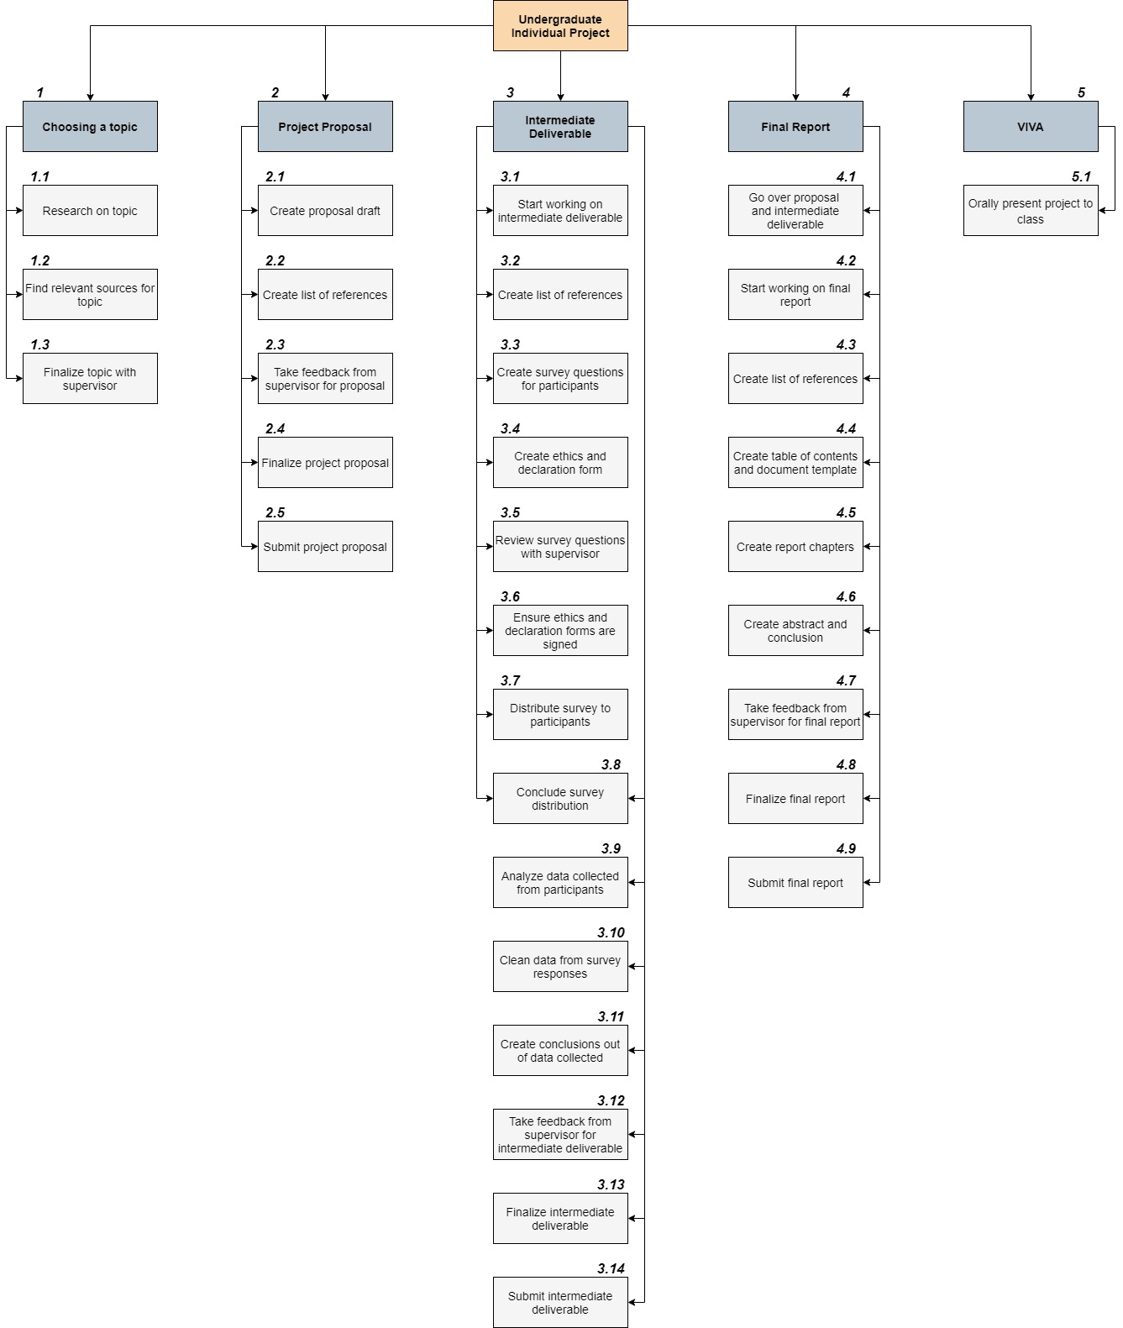

Figure 1: - Work Breakdown Structure (WBS) of the project

### 1.4.2. Activity List

|  |  |  |  |  |  |  |
| --- | --- | --- | --- | --- | --- | --- |
| **ID** |  | **Task Name** | **Start Week** | **End Week** | **Duration (in days)** | **Dependency** |
| *1* |  | *Choosing a topic* | *Week 1* | *Week 4* | *28 days* |  |
|  | 1.1 | Research on topic | Week 1 | Week 3 | 21 days |  |
|  | 1.2 | Find relevant sources for topic | Week 3 | Week 3 | 6 days | 1.1 |
|  | 1.3 | Finalize topic with supervisor | Week 4 | Week 4 | 1 day | 1.1,1.2 |
|  |  |  |  |  |  |  |
| *2* |  | *Project Proposal* | *Week 4* | *Week 5* | *10 days* |  |
|  | 2.1 | Create proposal draft | Week 4 | Week 5 | 4 days | 1 |
|  | 2.2 | Create list of references | Week 4 | Week 5 | 3 days | 1.1,1.2 |
|  | 2.3 | Take feedback from supervisor for proposal | Week 5 | Week 5 | 1 day | 2.1 |
|  | 2.4 | Finalize project proposal | Week 5 | Week 5 | 1 day | 2.3 |
|  | 2.5 | Submit project proposal | Week 5 | Week 5 | 1 day | 2.4 |
|  |  |  |  |  |  |  |
| *3* |  | *Intermediate Deliverable* | *Week 6* | *Week 13* | *56 days* |  |
|  | 3.1 | Start working on intermediate deliverable | Week 6 | Week 7 | 14 days | 2 |
|  | 3.2 | Create list of references | Week 6 | Week 7 | 3 days |  |
|  | 3.3 | Create survey questions for participants | Week 7 | Week 8 | 3 days |  |
|  | 3.4 | Create ethics and declaration form | Week 8 | Week 8 | 1 day |  |
|  | 3.5 | Review survey questions with supervisor | Week 8 | Week 8 | 2 days | 3.3 |
|  | 3.6 | Ensure ethics and declaration forms are signed | Week 8 | Week 8 | 1 day | 3.4 |
|  | 3.7 | Distribute survey to participants | Week 9 | Week 10 | 7 days | 3.5,3.6 |

|  |  |  |  |  |  |  |
| --- | --- | --- | --- | --- | --- | --- |
| **ID** |  | **Task Name** | **Start Week** | **End Week** | **Duration (in days)** | **Dependency** |
|  | 3.8 | Conclude survey distribution | Week 10 | Week 10 | 1 day | 3.7 |
|  | 3.9 | Analyze data collected from participants | Week 10 | Week 11 | 14 days | 3.8 |
|  | 3.10 | Clean data from survey responses | Week 11 | Week 11 | 2 days | 3.9 |
|  | 3.11 | Create conclusions out of data collected | Week 12 | Week 12 | 3 days | 3.9,3.10 |
|  | 3.12 | Take feedback from supervisor for intermediate deliverable | Week 13 | Week 13 | 2 days | 3.11 |
|  | 3.13 | Finalize intermediate deliverable | Week 13 | Week 13 | 2 days | 3.12 |
|  | 3.14 | Submit intermediate deliverable | Week 13 | Week 13 | 1 day | 3.13 |
|  |  |  |  |  |  |  |
| *4* |  | *Final Report* | *Week 14* | *Week 24* | *77 days* | *2,3* |
|  | 4.1 | Go over proposal and intermediate deliverable | Week 14 | Week 14 | 7 days | 2,3 |
|  | 4.2 | Start working on final report | Week 14 | Week 16 | 21 days | 4.1 |
|  | 4.3 | Create list of references | Week 16 | Week 17 | 5 days |  |
|  | 4.4 | Create table of contents and document template | Week 16 | Week 17 | 11 days | 2,3 |
|  | 4.5 | Create report chapters | Week 17 | Week 20 | 21 days | 2,3 |
|  | 4.6 | Create abstract and conclusion | Week 20 | Week 23 | 7 days | 2,3 |
|  | 4.7 | Take feedback from supervisor for final report | Week 23 | Week 24 | 2 days | 4.3, 4.4,4.5,4.6 |
|  | 4.8 | Finalize final report | Week 24 | Week 24 | 2 days | 4.7 |
|  | 4.9 | Submit final report | Week 24 | Week 24 | 1 day | 4.8 |
|  |  |  |  |  |  |  |
| *5* |  | *VIVA* | *Week 24* | *Week 24* | *1 day* | *2,3,4* |
|  | 5.1 | Orally present project to class | Week 24 | Week 24 | 1 day | 2,3,4 |

## 1.5. Deliverables of the Project

Within this project, several deliverables have been attained. Each of these deliverables has been described by the following points: -

* **Research: -** To find out what is needed to carry out the project, a wide range of secondary research has been conducted to analyze the state of students who have been using online learning during the COVID-19 pandemic.
* **Literature Review: -** The literature review has described the existing publications related to the research topic of online learning affecting students' mental health during the COVID-19 pandemic.
* **Data Collection: -** The project contains an analysis of primary data collected from students through a survey; this data has been analyzed to understand how students perceive online learning during the COVID-19 pandemic.
* **Visualization: -** Based on the data collected and analyzed from the survey participants (students), the data has been visualized using a dashboard and a dashboard story that statistically depicts students' perceptions of online learning during the COVID-19 pandemic.

## 1.6. Scope of Work

The scope of work concerning this project involves finding out whether online learning has impacted students’ mental health by analyzing the survey results collected from students through bar charts and pie charts and visualizing the results by creating a dashboard and dashboard story.

# Literature Review

## Abstract of Literature Review

The need for online learning has been widely increased since the emergence of the COVID-19 pandemic in March 2020 due to the various measures set out by governments worldwide to minimize coronavirus threats. Despite this, however, the utilization of online learning platforms during the pandemic may impact students' mental health due to increased on-screen time that could give rise to levels of stress and burnout. This literature highlights the need for online learning during the COVID-19 pandemic and how online learning platforms can impact students' mental health. The findings have suggested that the concept of online learning affecting the student’s mental health is a relatively newer concept that requires considerable attention.

## 2.1. Introduction of Literature Review

Technology plays an essential role in people's lives and is seen as the rationale for the growth of the economy (Raja and Nagasubramani, 2018). One of the fields that have been influenced by technology is the educational industry. The last 50 years have seen a significant rise in the delivery of education at all levels globally (Daniel, 2020). The emergence of the internet and the persuasive incorporation of advanced technological measures have led to online education within the educational industry by offering exclusive choices catering to wider audiences than in the past (Bartley and Golek, 2004). Various academic institutions have provided independent online courses and whole degree programs through the internet (Lundberg, Castillo-Merino and Dahmani, 2008). Moreover, virtual universities have surfaced that offer courses fully through the internet; some of these universities do not have their premises, hence, without on-campus students.

The emergence of the COVID-19 pandemic has led to the most considerable interruption of education in history, with students and teachers have been widely affected globally (United Nations Sustainable Development Group, 2020). By the middle of April 2020, the pandemic had impacted 94% of students globally, constituting 1.58 billion children and youth, from pre-primary to higher education, in 200 countries. Due to the pandemic, face-to-face classes were halted by educational institutions worldwide and transitioned to online learning (Araújo et al., 2020). Due to the pandemic, there has been a surge in the utilization of technology, which has already been incorporated into the contemporary world and, consequently, for the motives of education (Garfin, 2020). The sudden transition of all synchronous education to online learning has raised questions about the effectiveness of interactions and experiences of students while attending classes (Meulenbroeks, 2020). The rapid transition to telecommunication, a form of communication performed through remote applications, could raise stress and burnout levels from increased on-screen time (Mheidly, Fares and Fares, 2020). With many students taking part in online learning or distance learning, it is essential to recognize the ideal interventions for remote learners (Lister, Seale and Douce, 2021). It is vital to discern the barriers and implementers to students' mental well-being in a distance learning environment.

This literature review aims to find out how the use of online learning impacts students' mental health during the COVID-19 pandemic. Before understanding how online learning affects students’ mental health, the literature review first focuses on understanding the meaning of online learning and its evolution within the educational industry. The literature review then highlights the need for technology within the academic sector and how online learning has been implemented during the COVID-19 pandemic. Additionally, a SWOT analysis has been carried out to understand the strengths, weaknesses, opportunities, and threats of online learning during an unprecedented crisis, such as the COVID-19 pandemic. The review then emphasizes how online learning impacts students' mental health based on various reasons. After the topic of mental health has been taken into account, the review then provides suggestions through health strategies to improve students' mental health while utilizing online learning platforms.

This literature review has utilized secondary data sources, including journal articles, books, and conference proceedings, to understand the various theories related to online learning and its implementation during the COVID-19 pandemic. This would enable identifying the different mental health challenges students face while using online learning platforms and offering recommendations to improve students’ mental health during the COVID-19 pandemic.

## 2.2. Review of Literature

### 2.2.1. Defining online learning and its evolution in the educational industry

Before understanding the need for online learning and how it affects students' mental health, it is vital to comprehend the general meaning of online learning within the educational industry. A review by Moore, Dickson-Deane and Galyen (2011) has stated that the concepts of distance learning, e-learning, and online learning are frequently superseded. Similarly, Smith (2005) has noted that the concept of online learning may be applied at two extremes: - firstly, at one extreme where learning resources are electronically accessible to students that can be read on-screen or downloaded, albeit without any communication between the tutor and the student. At another extreme, it could simply mean exchanging emails between the tutor and the student, with no other learning resources or experiences delivered electronically. As part of online education, the following definition provided by Singh and Thurman (2019) covers both aspects of online learning and teaching, which has stated that: -

*“Online education is defined as education being delivered in an online environment through the use of the internet for teaching and learning. This includes online learning on the part of the students that are not dependent on their physical or virtual co-location. The teaching content is delivered online, and the tutors develop teaching modules that enhance learning and interactivity in the synchronous or asynchronous environment.”*

It is essential to understand the meaning of the synchronous and asynchronous learning environment within the above definition. The synchronous learning environment is structured so that students attend live lectures, with concurrent interactions between the tutors and the students and the prospect of prompt feedback (Dhawan, 2020). On the contrary, the asynchronous learning environment is not adequately structured; the learning resources are not accessible as live lectures or lessons. Instead, they are available through various learning systems and forums, with no prospects of prompt feedback and instant response in this learning environment (Dhawan, 2020). In addition, Hiltz and Turoff (2005) have stated that online learning acts as a whole substitute for both distance learning and traditional face-to-face classes. This implies a relationship between distance education and online learning; however, many authors seem skeptical about their definitive narrative (Moore, Dickson-Deane and Galyen, 2011). Sun and Chen (2016) have pointed out a professed need to conceptualize distance education due to the accelerated revolution of technology and the considerable growth of online education; however, its numerous elements make it challenging to concur on a single definition and what comprises distance education practically. Online learning can be incorporated either wholly online or combined with face-to-face learning, referred to as blended learning (Lestari, Astuti and Bhakti, 2020). Previous research by Allen and Seaman (2015, p. 7) claimed that an online course contains roughly 80% of the course content delivered online. Face-to-face instruction encompasses courses where zero to 29% of the content is delivered online; this category comprises traditional and web facilitated courses. The remaining alternative, blended (or hybrid) instruction, offers between 30% and 80% of the course content online.

#### 2.2.1.1. History of online learning and distance learning

The earliest implementation of online education and distance learning within the educational industry has gone through several stages, with various authors providing different perspectives. The University of London, in the United Kingdom, had commenced the earliest correspondence and distance learning educational programs in the mid-1800s (Paul and Jefferson, 2019). This academic learning model was reliant on the postal service, and thus, the model did not emerge until the late 19th century in the United States. Ultimately, the late 19th century saw the American public involved with correspondence education using the postal service. Distance learning had expanded with technology with the introduction of radio programming, later local television, for instance, the Public Broadcasting Service (PBS), and finally, telephone and video-based courses (Bartley and Golek, 2004). The United States had seen its first formal correspondence education transmission set up in Boston in 1873, called the “Society to Encourage Home Studies”. With the 1970s and 1980s seeing both computers and emailing technologies evolving, there was a rise in the implementation of distance learning (Sun and Chen, 2016). In 1981, the first wholly online courses were introduced, including non-credit "mini-courses" and executive training programs (Harasim, 2000). Among the first was the Western Behavioral Sciences Institute's (WBSI) online Executive Education program, which was initiated in 1982. Although the planning was considered to be enthusiastic, the course had faced issues such as the lack of experience in utilizing online courses by both the WBSI faculty and the students, the lectures being excessively filled with text to taught on an online basis, and the inability to hold Q&A sessions (Freenberg, 1993).

It was not until the 1990s that online education had transformed significantly due to the introduction of the World Wide Web (WWW). The implementation of the World Wide Web (WWW) was a significant catalyst in the further progress of distance education. It was seen as a turning point in the speedy expansion and growth of online learning (Sun and Chen, 2016). The University of Phoenix, in the United States, noted today for providing wholly online programs, first implemented online technology with CompuServe, the first online service provider in 1989 (Palvia et al., 2018). In 1990, Tim Berners Lee, a computer scientist, invented the World Wide Web as a group work environment to simplify online collaboration among his colleagues at the European Organization for Nuclear Research (CERN) (Harasim, 2017). The general intention of the World Wide Web was to combine the technologies of personal computers (PCs), computer networking, and hypertext into a dynamic and user-friendly worldwide information system. Tim Berners Lee developed the protocols that form the basis of the World Wide Web in 1990, and the first website went online in 1991 (Harasim, 2017). After earlier using CompuServe for its online programs, in the same year, 1991, the University of Phoenix had used the World Wide Web to implement online technology in its online programs (Palvia et al., 2018). It was in the year 1998 that saw the growth of online programs when New York University launched NYU Online, which was followed by several other online programs; however, these programs did not survive. Due to the unsuccessful implementation of these online programs to fulfill the needed expectations, the idea of “blended” programs materialized in 1999/2000. It merged traditional classes with online classes intending to complement the benefits of both programs (Palvia et al., 2018). As a result, all universities and colleges globally have provided entire degree programs online in addition to just online courses (Wallace, 2003).

### 2.2.2. The use of technology in education and the utilization of online learning during the COVID-19 pandemic

The role of technology within the educational sector is four-fold; it is included as part of the curriculum, as an instructional delivery system, as a way of supporting instructions, and as a tool to complement the whole learning process (Raja and Nagasubramani, 2018). The utilization of technology has ensured that education has gone from passive and interactive to interactive and aggressive. Astuti, Lestari and Bhakti (2019) have described the combination of technology and individuals within the educational sector as an innovation in the industrial revolution. With the advancement of technology, students presently would like to have quality programs that can be accessed from any location and at any time (Paul and Jefferson, 2019). Due to these demands, online education has become a feasible, captivating option for business professionals, stay-at-home parents, and similar populations (Lestari, Astuti and Bhakti, 2020). Muthuprasad et al. (2021) have stated that the present growth of technology enables applying various ways to design the content of online courses. While creating these courses, the preferences and viewpoints of students need to be assessed to ensure that learning is efficient and valuable. Students' inclination is associated with the preparedness or eagerness of students to engage in collaborative learning and the aspects that determine the readiness for online learning (Muthuprasad et al., 2021). According to Lundberg, Castillo-Merino and Dahmani (2008), a student may choose to attend an online course or a fully online-based degree program as online courses, providing more flexible study hours. For instance, an employed student may participate in the virtual class by viewing instruction films and streaming videos of lectures after working hours. Similarly, Raja and Nagasubramani (2018) have stated that top institutions provide exciting online programs using numerous applications and the internet. Online programs are a concept that would expand with more support and recognition. Bakia et al. (2012, p.2) have stated that the utilization of online learning has become prevalent due to its discerned capability to offer more flexible access to content and instruction by: -

* Expanding the availability of learning experiences for students who are unable or do not prefer to attend traditional institutes,
* Assembling and disseminating instructional content more productively, and
* Expanding student-instructor ratios while attaining learning outcomes corresponding to traditional classroom instruction.

Raja and Nagasubramani (2018) have stated that Information and Communication Technology (ICT) can expand access to education and refine its purpose and quality. Information and Communication Technology (ICT) enables the processing and storage of digital information and communication between computers (Williams and James, 2001). By using ICT in education, students can sustain their self-learning; ICT is considered a critical instrument to enhance knowledge and skills in the 21st century (Mahajan, 2021). Teachers and students are connected using ICT through audio-video learning materials and information related to their curriculums. In addition to fostering learning, ICT enables students to gain technical skills essential for many professions (Mahajan, 2021).

#### 2.2.2.1. Online learning during the COVID-19 pandemic

The outbreak of the COVID-19 pandemic during the early stages of 2020 forced educational institutions to be shut down. Due to the measures to minimize the coronavirus transmission, proximity, presence, and the relevance of being physically present were widely put to a stop (Taylor-Beswick, 2021). As an infectious disease whose agent can be spread through social interaction, containment measures, including social distancing, have been incorporated globally, with lockdown and quarantine enforced to respond to the halt of the pandemic (Bellini et al., 2021). Business meetings, academic conferences, education, and governmental management were enforced to comply with the challenge and hazards created by the COVID-19 pandemic (Mheidly, Fares and Fares, 2020). The swift rise in access to the internet has had a significant impact on organizations and, presently, has had a considerable effect on the educational sector (Simamora, 2020). The COVID-19 pandemic has disturbed students' lives in various ways, not only based on their level and course of study but also at the stage they have reached in their respective programs (Daniel, 2020). For instance, during the beginning of the pandemic, some students faced challenges since they were approaching the end of one phase of their education to another, including those who were progressing from school to tertiary education or from tertiary education to employment. The students were unable to complete their school curriculum and assessment in a usual manner, and in certain situations, they were split apart from social groups practically overnight (Daniel, 2020). Furthermore, it was doubtful if students, who were set to make a shift to tertiary education, could take part in their year-end school examinations (for instance, the International Baccalaureate) later. In response to the COVID-19 pandemic, nations around the world swiftly ended face-to-face classes and switched instruction to numerous types of virtual settings (Hussein et al., 2020).

Due to the COVID-19 pandemic, the continuation of learning processes during the shutting down of schools became the prime concern for governments globally, due to which the governments turned to Information and Communication Technology (ICT), which needed teachers to shift to the online delivery of lessons (United Nations Sustainable Development Group, 2020). Mheidly, Fares and Fares (2020) have stated that before the emergence of the COVID-19 pandemic, online communication and learning has been evolving regularly globally, with the materialization of newer digital technologies and the increasing adoption of the internet worldwide. Even though the transition to online learning has already become part of educational systems globally, the level of use and how technology is utilized to attain the quality of online education differs (Duraku, 2021). The resistance to change, based on the past or current situation of the COVID-19 pandemic in various nations, has not helped any educational institution; these institutions would be judged on their speediness in adapting to the changes in a brief period and their capacity to preserve the quality of education (Dhawan, 2020). As a result, the stature of the educational instructions has been under scrutiny during the pandemic, with how they respond and how they preserve their quality of education revealing their competence in adaptation. During the pandemic, the use of online learning has been implemented through WhatsApp, Zoom, Google Meet, Google Classroom, and numerous other platforms in the absence of face-to-face classes (Lestari, Astuti and Bhakti, 2020). These platforms need to be accessed through an electronic gadget, either a computer or laptop. Basilaia et al. (2020) have stated that due to the dangers of the coronavirus, online learning platforms should possess features where: -

* Lecture sessions can be held with a minimum of 50 students concurrently through video conferencing,
* Lecturers or tutors can hold discussions with students to ensure that the teaching process is more systematic and viable,
* Online sessions are recorded and uploaded for students who are unable to have access to high-speed internet connections,
* Online lectures are accessible through both computers and smartphones,
* Existing recorded lectures can be viewed again, and
* Students can work and submit their assignments and examinations.

#### 2.2.2.2. SWOT analysis of online learning during unanticipated events

Knowledge delivery becomes a difficult task during the occurrence of natural disasters, for instance, floods, cyclones, earthquakes, hurricanes, and more (Dhawan, 2020). These dangers interrupt the educational processes at academic institutions in several ways. Academic institutions are often forced to shut down, which causes severe ramifications for students. As a result, students are denied their fundamental right to education which presents future risks (Dhawan, 2020). Academic institutions need to be potent when natural disasters occur and find ways to persist with online learning. As previously discussed, the COVID-19 pandemic forced students to switch to online learning. However, there have been other instances where students were forced to change to online learning. One of these instances occurred in New Zealand, where a 6.3 magnitude earthquake struck the city of Christchurch, resulting in the collapse of the University of Canterbury (Todorova and Bjorn-Andersen, 2011). Eventually, due to online learning, the university resumed its operations.

To understand the effectiveness of online learning during unanticipated events, such as the COVID-19 pandemic, a SWOT (Strengths, Weaknesses, Opportunities, Threats) analysis has been conducted. According to Gürel (2017), SWOT analysis refers to the tool utilized for strategic planning and strategic management in organizations. This analysis can be used to appraise an organization, a plan, a project, or a business activity. Within the SWOT analysis of online learning, strengths indicate the positive characteristics of online learning; weaknesses indicate the negative characteristics of online learning; opportunities indicate the positive conditions for its growth, and threats indicate the negative conditions (Siranjeevi and Pattanwala, 2021).

To comprehend the strengths, weaknesses, opportunities, threats of online learning, Dhawan (2020) has described the SWOT analysis of online learning, as explained by the following points: -

1. **Strengths: -**Due to the nature of the pandemic, the only possible solution to continue educational activities is the utilization of online learning.Online learning provides students with the flexibility of time and location. The wide availability of online tools enables creating a competent learning environment. Tutors can utilize a combination of audio, videos, and text to connect with students during a crisis to uphold the human touch in their lectures. This can lead to a collaborative and interactive environment; students can provide immediate feedback, ask questions, and gain knowledge. During a natural disaster or crisis like the COVID-19 pandemic, the feature of anywhere-anytime is a valuable characteristic of online learning.
2. **Weaknesses: -**Although the use of online learning possesses several strengths amid a crisis, such as the COVID-19 pandemic, it has its limitations too. One of these weaknesses is the hindrance of immediate communication between the student and the tutor. Students may face various technical difficulties that disrupt and minimize the learning process. While time and location flexibility are strengths of online learning, these may lead to hurdles. The non-behavior of students concerning time and flexibility could create obstacles, as all students may not be the same; they are different in their level of capabilities and levels of confidence. Some students are uncomfortable while utilizing online platforms, resulting in rising frustrations and confusion. Insufficient compatibility between the design of the technology and component of psychology needed by the learning process and incompetent personalization of learning processes can inhibit the teaching process and strike a divergence.
3. **Opportunities:** - Usually, online learning contains various opportunities at a student’s disposal; however, a crisis like the COVID-19 pandemic has enabled the growth of online learning with educational institutions transitioning to this mode of learning. These institutions can seize this opportunity by making students gain knowledge through online learning. The crisis has created a new stage for online learning and has empowered individuals to understand the valuable aspects of online learning. This is a period where there is a capacity to deliver remarkable innovations and digital developments. Teachers can practice technology and design numerous flexible programs for students' improved understanding. Online learning would complement problem-solving skills, critical thinking abilities, and adaptability among students. During this challenging situation, individuals of any age can access the online tools and obtain the time and locational flexibility corresponding to online learning. Teachers can establish innovative pedagogical approaches during this perplexing situation, referred to as *panicgogy*.
4. **Threats: -**The use of online learning amid a crisis, such as the COVID-19 pandemic, poses several threats that vary from learners’ issues, educators’ issues, and content issues. The participation of students in the learning process poses a challenge for educational institutions and, from the teacher’s perspective, the challenge of transitioning from offline to an online mode that modifies their teaching techniques and time management. Moreover, the quality of education through online learning poses a threat; depending on the nation's government, there may or may not be a clear stipulation in their educational policies about online learning. There could be a lack of standards for quality, quality control, development of online learning resources, and delivery of online learning content. Another threat posed by online learning is the time and cost involved; a substantial investment is required to acquire the devices and equipment, uphold the equipment, train the human resources, and develop the online content. Additionally, it is essential to ensure digital equality during a crisis since not every teacher may access digital devices and the internet. The absence of appropriate digital tools and lack of internet connectivity can create problems that students lose out on their learning. Institutions need to verify that every student and tutor has access to the necessary resources. They must ensure that every educational application can be used on smartphones, too, in a situation where students do not possess computers. As a result, the digital divide needs to be minimized.

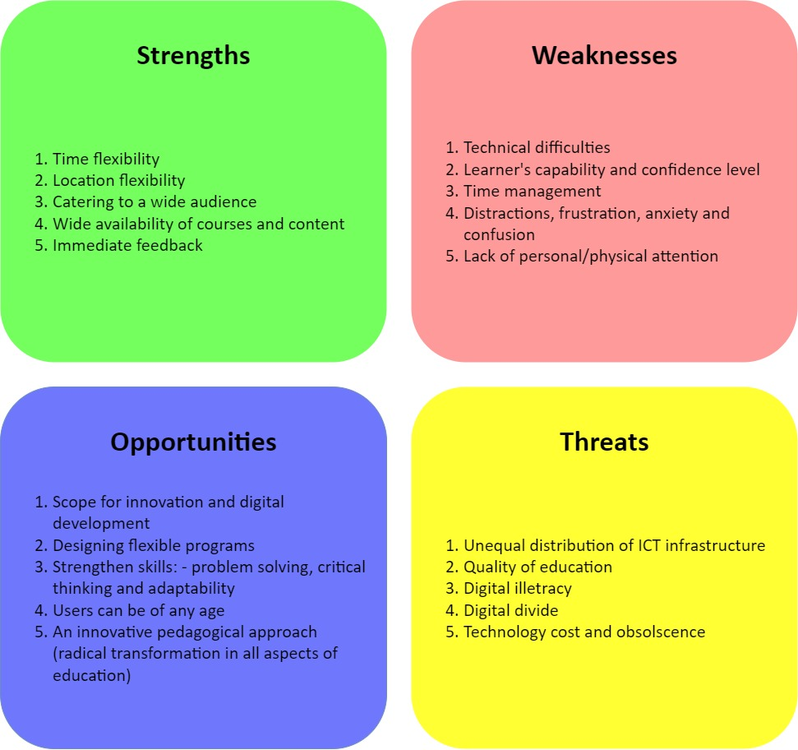

Figure 2: - SWOT Analysis of online learning (Dhawan, 2020)

### 2.2.3. Online learning’s impact on the mental health of students during the COVID-19 pandemic

During the COVID-19 pandemic, mental health has been a significant cause of concern worldwide. Although pandemics are rare natural disasters that lead to severe psychological and behavioral responses, the psychological impacts of natural disasters describe another area that can be scrutinized to assume how human behavior changes while responding to disasters and crises (Esterwood and Saeed, 2020). Before understanding how online learning affects students' mental health while utilizing such learning platforms during the COVID-19 pandemic, the concept of mental health needs to be comprehended from a general perspective. The meaning of mental health has been defined by the World Health Organization (2003), which states that: -

*“Mental health refers to the state of well-being wherein individuals recognize their abilities, can cope with the normal stresses of life, work productively and fruitfully, and make a contribution to their communities.”*

Hiremath et al. (2020) have stated that the challenges caused by the pandemic to reduce the hazards of infections have led to the implementation of several public health strategies, including isolation of infected individuals, minimization of social contact, and basic hygiene such as routine washing of hands. The World Health Organization (2022) has stated that the COVID-19 pandemic has given rise to a substantial degree of fear, worry, and concern within the population on a large scale. Among the affected were academic institutions that were forced to shut down face-to-face classes and shift students because of the deepening concerns of the pandemic; this may have potentially led to negative psychological circumstances among students (Zhai and Du, 2020). According to Chirikov et al. (2020), a Consortium survey conducted by the Student Experience in the Research University (SERU) has found that the COVID-19 pandemic has negatively affected the mental health of undergraduate and postgraduate students at various research universities. Out of the total responses of 46,071 students collected from the survey, 35% of undergraduates and 32% of postgraduate students were positively screened for a major depressive disorder; on the other hand, 39% of undergraduate and postgraduate students were positively screened for generalized anxiety disorder.

There have been various empirical studies that have been conducted in countries including Bangladesh (Khan et al., 2020), France (Essadek and Rabeyron, 2020), Greece (Kaparounaki et al. 2020), and the United Kingdom (Savage et al., 2020), which have noted that a significant number of students have suffered from mental disorders that differ in severity. However, there has been limited research based on online learning or distance learning affecting students' mental well-being (Lister, Seale and Douce, 2021). The bulk of research on student mental health emphasizes an environment on the university campus. Richardson (2015) has noted that more than 200,000 distance learning students in the United Kingdom are likely to experience mental health issues that affect their mental health. Statistics from the year 2017-18 have proven that 7.8% of students pursuing their relevant courses at the Open University in the United Kingdom revealed a mental health condition, in contrast to the United Kingdom higher education average of 2.02% (Lister, Seale and Douce, 2021). Despite this, the obstacles to the well-being of students in distance learning remain under-researched (Richardson, 2015).

The rise in telecommunication has led to individuals spending more time facing screens, tablets, and smartphones (Mheidly, Fares and Fares, 2020). The earlier surge in exposure to smart devices and screens has led to a rise in stress and burnout levels. According to Davis (2021), stress refers to the emotional, mental or physical reaction that leads to tension. These occur from social, environmental, or psychological situations. On the other hand, Maslach and Leiter (2017) have stated that burnout refers to the state of mental health that occurs from work-related stress, entailing a constant reaction to persistent interpersonal stressors. The primary causes of burnout include overwhelming exhaustion, feelings of cynicism, and detachment. Additionally, a sense of ineffectiveness and lack of accomplishment may stem.

Baltà-Salvador et al. (2021) have stated that despite the lack of research, opportunities may be opened for studies offering complementary evidence that may enable a better understanding of the effect of online learning on students’ mental health during the COVID-19 pandemic. However, there are differences in the results of such investigations. These differences may be due to the beginning and end of the academic years and school breaks, the stage and effect of the pandemic in each nation, and the comparable measures enforced to handle the health crisis (Baltà-Salvador et al., 2021). For instance, in several countries, the physical classes were brought to a halt from the pandemic's beginning. At the same time, other nations had limited restrictions and only minimized physical classes or delayed the begging of the semester (Gonzalez et al., 2020). The following points explain the reasons how the COVID-19 pandemic has impacted the mental health of students through online learning: -

1. **Quality of education: -**The quality of courses delivered through online learning is a significant aspect of students’ satisfaction and learning (Piccoli, Ahmad and Ives, 2001; Sun et al., 2008). The competent transition to online learning is determined through the discerned quality of classes (Ibrahim, Al-Kaabi and El-Zaatari, 2013). While online courses are being designed, it becomes difficult for lessons to be switched to online sessions from face-to-face sessions. The successful implementation of online sessions includes content, pedagogy, methodology, and technology (Aristovnik et al., 2020). The quality of learning through online sessions has attained much deliberation on higher education during the COVID-19 pandemic. Several studies conducted during the lockdown have pointed out that university students expressed lower satisfaction while utilizing online learning platforms (Al-Balas et al., 2020; Alnusairat, Al Maani and Al-Jokhadar, 2020). Moreover, students reported higher satisfaction through physical classes instead of distance learning (Amir et al., 2020; Dinh and Nguyen, 2020). On the other hand, the results of other studies have noted higher satisfaction among students while utilizing e-learning platforms offered through their university education (Aristovnik et al., 2020; Jacques, Ouahabi and Lequeu, 2020).
2. **Classes, exams, or support of teachers: -**There are significant variations in results obtained from studies concerning classes, exams, or teachers' support while incorporating online learning during the COVID-19 pandemic. On one end, Alnusairat, Al Maani and Al-Jokhadar (2020) have found lower satisfaction among students due to the lack of support received from teachers, while Dinh and Nguyen (2020) have noted that online learning had lower satisfaction with the classes and assessment methods than physical classes. The surge in the perceived workload is cited as a reason behind the lower satisfaction with online learning (Alnusairat, Al Maani and Al-Jokhadar, 2020; Gelles et al., 2020; Son et al., 2020). Moreover, Khalil et al. (2020) have noted that concerns related to the implementation and quality of online courses can become barriers to the engagement and acquisition of knowledge. On another end, Jacques, Ouahabi and Lequeu (2020) have found that students were satisfied with the support received from their teachers and the content of their online sessions during the COVID-19 pandemic. Furthermore, the assessment methods and resources utilized in students' classes during lockdown were customized to e-learning (Puljak et al., 2020).
3. **Isolation and disconnection: -** Another obstacle students face while utilizing online learning platforms is the feelings of isolation and disconnection because of the inability to interact with their peers and teachers (McInnerney and Roberts, 2004). Before the COVID-19 pandemic, several studies have found that student satisfaction is attained through interactions with other students and teachers and plays a crucial part in academic development and student achievement (Arbaugh, 2000; Sun et al., 2008). Therefore, the interaction structure must be contemplated while designing courses to enhance and flourish learning environments. Regarding the recognized connection with other students and teachers during the lockdown, prior research has noted that students felt a minimal connection with fellow students and teachers instead of face-to-face classes (Al-Balas et al., 2020; Son et al., 2020). Puljak et al. (2020) have stated that university students have missed in-person contact with other students and teachers during the lockdown. Moreover, communication has been more problematic than face-to-face learning (Alnusairat, Al Maani and Al-Jokhadar, 2020). During the COVID-19 pandemic, a high level of connection with society has been associated with significant self-efficacy and engagement and minimal academic stress (Luan et al., 2020).
4. **Learning environment conditions and ergonomics: -** Although it had not gained much consideration before the COVID-19 pandemic, the learning environment conditions and its ergonomics are essential aspects to be pondered in online learning. Parvez, Rahman and Tasnim (2019) have stated that a workspace that cannot provide the necessary conditions indicates a risk factor for comfort, well-being, and student's academic performance. During the COVID-19 pandemic, the sudden transition to online education has made researchers and educational personnel ponder if students were willing to take classes from their homes and if they had a suitable workplace, equipment, and facilities for effective learning. Moreover, during the lockdown period, students were restricted from visiting libraries or other places of study and, in numerous situations, compelled family members to share the spaces of their homes (Driessen et al., 2020). This may have deteriorated the student workplace conditions by a surging disturbance. Furthermore, environmental factors, including noise, temperature, and lighting, significantly impacted university students’ academic performance while attending online classes during the pandemic (Realyvásquez-Vargas et al., 2020). Son et al. (2020) have stated that these obstacles were linked with further challenges in focusing and concentrating during learning. This can limit knowledge acquisition through online learning (Khalil et al., 2020).

### 2.2.4. Improving students’ mental health while utilizing online learning platforms

The use of technology has grown during the COVID-19 pandemic, resulting in social and occupational changes that may last for a long time after the present crisis diminishes (Garfin, 2020). Accordingly, it is vital to make cautious and purposeful choices about influencing technology to improve people's lives, minimize stress and improve mental health. While developing distance or online learning or during the implementation of learning on campus, educational policymakers, responsible academic institutions, and other players that take part in the learning process, including psychologists are advocated to create programs to support teachers, parents, and students to conquer concerns that impact well-being and performance in the learning process (Duraku, 2021).

Mheidly, Fares and Fares (2020) have stated that the threat of psychological distress and safeguarding of well-being can be minimized by implementing efficient and valuable coping strategies. Various measures should be considered to enhance public awareness concerning the psychological consequences of telecommunication. Additionally, Mheidly, Fares and Fares (2020) have stated that to guide the public, including students, to cope with increasing stress and burnout levels during the COVID-19 pandemic, several health strategies need to be implemented. The following points have described these strategies: -

1. **Promoting awareness on stress and burnout occurring from the rising use of telecommunication during the pandemics through broadcasting and social media channels: -**The stress and burnouts concerning the pandemic need to be recognized by the traditional media and offer data supported by evidence on the pervasiveness and coping techniques to the general public.
2. **Enhancing the prevalence of breaks between online sessions to enable participants to release eye strain and avoid loss of interest and attention: -**Through the constant utilization of digital devices, an imminent public health issue is the digital eye strain. Varied blinking patterns, enormous exposure to strong lighting, closer working distance, and smaller font size are circumstances related to telecommunication using digital screens that cause eye strain and its ensuing impacts. To maintain interest and attention during online sessions, the frequency of breaks can be increased to release rising tension.
3. **Directing wellness campaigns at students to enhance their alertness on the physical and emotional repercussions of increased online time: -**Conducting awareness campaigns aimed at specific age groups while mulling over the cultural and ethnic differences can enhance compliance to healthy online habits.
4. **Establishing podcast-based communication and learning as an alternative to online visual interactions to minimize eye strain and restrict screen exposure: -**The provision of asynchronous education can be implemented using learning podcasts due to the lower barriers to entry and the easily available and affordable tools. More crucially, podcasts substitute seeing for listening, lowering the strain and stress that could occur from lengthy visual preoccupation on screens.
5. **Incorporating healthy practices in the middle of online sessions and during longer meetings, including breathing exercises, meditation, and yoga: -**There has been increasing evidence that yoga is a productive multi-component health intervention that minimizes stress, increases physical activity, and boosts well-being. Moreover, psychological techniques including mindfulness, self-compassion, and improved self and body awareness could reflect healthier lifestyle choices and more appropriate responses to stressors. Thus, stress and burnout can be dealt with by implementing healthier practices.
6. **Offering online participants the opportunity to disclose their feelings and mental struggles to ensure that adequate help and support can be delivered: -**While utilizing online platforms, specialists engaging in online communities need to be proactive to share their feelings and experiences with telecommunication. Users may convey their emotions and suggest dealing with the stress and burnout from extended online activity.
7. **Decreasing unhealthy habits that further cause a rise in stress levels, including smoking and caffeine consumption: -** During the COVID-19 pandemic, acutely stressed smokers were more likely to have increased smoking behavior. Depression, anxiety, suicidal thoughts, and weak learning outcomes have been associated with smoking. Moreover, caffeine consumption may also give rise to mental health disorders, for instance, anxiety. Reducing such habits can lower their additive impact on online-related stress and burnout.
8. **Organizing extensive cross-sectional surveys to derive the actual stress levels and burnouts within various online populations: -**Researching epidemiological patterns and trends concerning telecommunication and its corresponding stress and burnout can explain the risk factors and protective mechanisms that can be explored. Moreover, attempts must be devoted to financing communication studies. This would promote more satisfactory ways of communication between various components of the health industry and, after that, improve public health and people’s well-being.

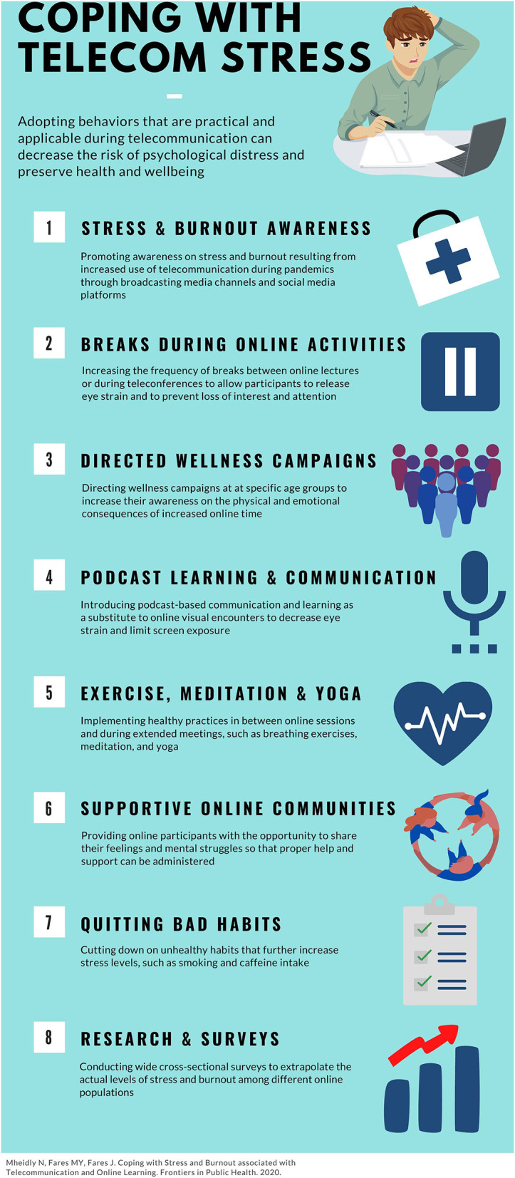

Figure 3: - Coping strategies to be implemented while attending extended online activities and learning sessions (Mheidly, Fares and Fares, 2020)

## 2.3. Conclusion of Literature Review

The topic of online learning affecting students' mental health during the COVID-19 pandemic is an evolving and relatively newer topic that needs to be extensively researched. The COVID-19 pandemic has hindered people's lives globally, and during the rise of infections, uncertainty and anxiety are created about what could arise (Lischer, Safi and Dickson, 2021). This has also impacted students who have immense levels of stress. Society has seen a surge in changes due to the COVID-19 pandemic, including the educational sector (Meulenbroeks, 2020). Online education may occur through online learning platforms, though it does not represent the best way to conduct learning sessions. The United Nations Sustainable Development Group (2020) has stated that the pandemic presents a risk of a downward spiral with iterative negative feedback of learning loss and exclusion. During the COVID-19 pandemic, discerning stress and burnout from telecommunication are essential to creating effective mitigation strategies (Mheidly, Fares and Fares, 2020). However, Hysaj and Hamam (2020) have stated that students would find online sessions valuable to provoke and develop their cognitive skills through sufficient instruction.

Based on the literature review, the essential aspects discussed include a specific definition of online learning stated by Singh and Thurman (2019) due to its confusion with other educational terms such as distance learning and e-learning. Moreover, extensive research enabled an understanding of a historical perspective of online education being implemented in the United Kingdom and the United States before the emergence of the World Wide Web in the 1990s. In addition, the SWOT analysis stated by Dhawan (2020) enabled identifying each of the strengths, weaknesses, opportunities, and threats of online learning during unforeseen events such as the COVID-19 pandemic.

More importantly, the mental health aspects that have been considered while implementing online modes of learning during a crisis, such as the COVID-19 pandemic, include the quality of education, classes, exams or support of teachers, isolation, and disconnection, and finally, the learning environment conditions and ergonomics. Moreover, to enable students and the general public to improve their mental health while utilizing online platforms, the health strategies suggested by Mheidly, Fares and Fares (2020) could prove beneficial.

Overall, the relevance of this literature review was to investigate the impact of online education on students' mental health during the pandemic due to factors such as stress and burnout. Subsequently, the research provided suggestions for improving students’ mental health during online learning sessions. However, a gap identified within the review is that most studies focus on the COVID-19 pandemic affecting the student’s mental health rather than online learning specifically impacting students’ mental health during the pandemic. As a result, future research would enable an understanding of online learning's impact on student's mental health during the COVID-19 pandemic in the upcoming years.

# Research Methodology

## 3.1. Research Design and Population of study

In the context of this research, the focus is to understand how online learning affects students' mental health during the COVID-19 pandemic. Before proceeding and carrying out any form of data collection from participants, the project as a whole required ethical approval in the form of an application to ensure that the research was being conducted appropriately and integrally. The research methodology applied to investigate the research question is the exploratory research methodology that enables an understanding of the impact of online learning on students' mental health. According to George (2021), exploratory research refers to the methodology approach to exploring research questions that have not been studied beforehand. Generally, exploratory research is considered to be qualitative. However, a study with a more significant sample performed in an exploratory approach can also be quantitative. The topic of online learning and mental health has previously not been researched in-depth due to the recent widespread utilization of online learning platforms by educational institutions worldwide during the COVID-19 pandemic.

Within the exploratory research methodology of investigating how online learning affects students' mental health during the COVID-19 pandemic, a survey was designed, representing the research's primary data. Previous research by Muthuprasad et al. (2021) and Baltà-Salvador et al. (2021) have also utilized surveys to understand how students perceive learning through online learning platforms during the COVID-19 pandemic. From the perspective of this research, the target population for the survey is the students of Middlesex University Dubai who pursue their relevant courses at the foundational, undergraduate, or postgraduate level. The sample population of the survey was 200 participants, i.e., students. Within this research, the sampling technique that has been applied to recruit students for the survey is the random sampling method, as part of probability sampling, as students from Middlesex University had an equal chance of taking part in the survey.

Before answering the questions, the students were with the participant information sheet, which takes approval from the students for participating in the research study. The participant information sheet contains: -

* The research title,
* The purpose of conducting the study, and
* The contact details of both the researcher and supervisor if students wished to withdraw from the study at any point in time.

The survey was conducted on an online basis. The survey contains a total of 28 qualitative questions that have been grouped into five question areas, that have been collected from students, as described by the following points: -

1. **Demographics of students: -** Within the survey, the first group of questions, focus on the student's characteristics that define them, including gender, age group, subject area pursued by them, and the current year of study. Moreover, no personally identifiable information was collected from students (such as name, email address) such that the confidentiality of participants is ensured.
2. **Technical aspects of online learning: -**The next group of survey questions enables an understanding of which platforms and devices students have used while attending online classes. Additionally, students were asked how they found using online platforms while attending online classes after the COVID-19 pandemic forced them to attend classes online.
3. **Student experiences with online learning: -**This group of questions enables identifying how students find the quality of education using online learning platforms instead of traditional face-to-face classes and the challenges of using online learning platforms. These questions also explore the advantages of using online learning over physical classes.
4. **Students' mental health: -**This group of questions is the most important within the survey, with the vast majority of survey questions coming under this group. These questions facilitate finding out the mental health of students at the time of answering the survey questions, the impact of the COVID-19 pandemic on the general university experiences of students, and the impact of online learning on the mental health of students after the rapid transition from physical to online learning during the COVID-19 pandemic. The mental health questions also help understand if students have attended online classes regularly, the possible causes of not attending online classes, and how students manage themselves with Zoom Fatigue after getting distressed using online learning platforms.
5. **Student experiences with university and tutors: -**Finally, the last group of questions emphasizes finding out how students find pursuing their relevant courses with the support of the university and its faculty while attending online classes. This includes learning materials, feedback related to module coursework, and online examinations.

## 3.2. Tools utilized

To conduct the data collection through an online survey, the web-based software Qualtrics has been utilized. Within Qualtrics, various features have been utilized based on students' responses, such as skip logic and display logic. Moreover, to collect data from the survey, students were recruited through the messaging platform WhatsApp due to the situation of the COVID-19 pandemic at the time of carrying out the research and the inability to meet a large number of students physically due to distancing measures.

After collecting primary data from students, the online survey results have been analyzed and visualized using the business intelligence software Tableau. Tableau enables big and small data analysis to get insightful information from the data collected through surveys. Within the context of this research, the results obtained from the survey have been analyzed to understand how students find using online platforms and whether using these platforms has impacted their mental health during the COVID-19 pandemic. Moreover, the survey results are later visualized using a dashboard and a dashboard story; the former displays the survey results, while the latter also shows the survey results along with communicating the insights from the information obtained from the survey results.

# Data Collection, Data Analysis, and Visualizations

## 4.1. Introduction to Visualizations

Data visualization is the graphical representation of information and data (Tableau, 2022). Data visualization tools offer an accessible way to view and comprehend trends, outliers, and patterns in data through visual elements such as charts, graphs, and maps. Ko and Chang (2017) have stated that data visualization is a visceral way for users to quickly read and understand data, mainly in big data analysis. While creating visualizations on Tableau, it is essential to contemplate which type of graph or chart is the most appropriate for the data (Hoelscher and Mortimer, 2018). While various types of visualizations (graphs and charts) can be selected, a few of the most prevalent visualizations include bar charts, line graphs, pie charts, and maps. The data enables establishing which visualizations would help communicate the information most reliably. For instance, bar charts are suitable when data is broken down into various categories, while line graphs are valuable to display changes in data over time. Furthermore, pie charts exhibit categories as a segment of a total, and maps illustrate data geographically and must be used only if the data comprises location information (Hoelscher and Mortimer, 2018). Additionally, Tableau can recommend a suggestion according to the types of fields that have been chosen.

As previously discussed in the research methodology chapter, to collect primary data, groups of five question areas were created within the survey to comprehend how online learning impacts students' mental health during the COIVD-19 pandemic. After implementing all 28 survey questions on Qualtrics and distributing this survey to the sample population of 200 students pursuing their relevant courses in different years at Middlesex University, Dubai, 116 responses were collected. However, after conducting the data cleaning process on Microsoft Excel in which incomplete or unfilled responses were deleted, 100 responses were obtained. Using Tableau, these responses have been analyzed through relevant charts and later visualized using a dashboard and a dashboard story to understand how online learning impacts students' mental health during the COVID-19 pandemic, where classes have been conducted wholly or partially through online platforms.

## 4.2. Data Analysis and Presentation of Results

### 4.2.1. Individual analysis of variables

**a. Demographics of students**

**1. Gender of students**

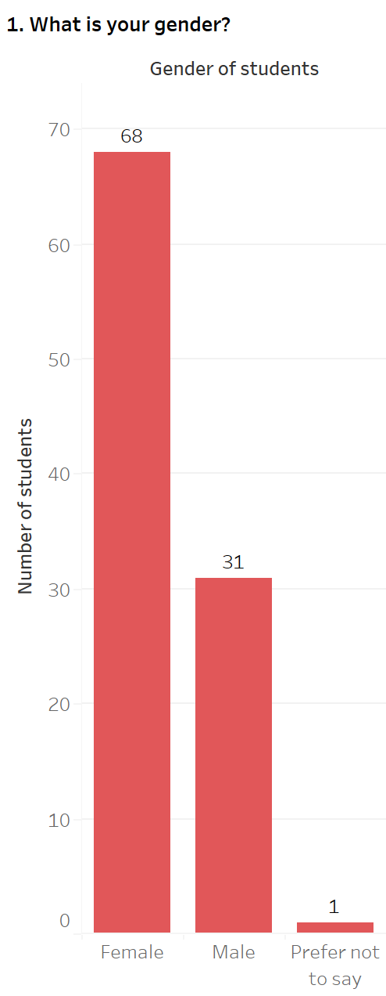

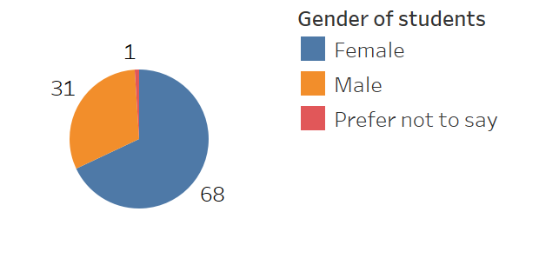

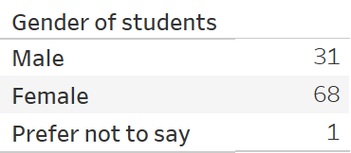

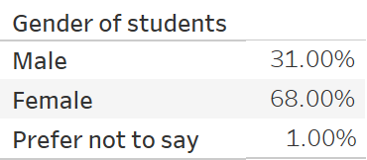

Figure 4: - Gender of students

From the survey responses collected from students studying at Middlesex University, Dubai, the gender of students has been represented in the form of a bar chart and a pie chart. Upon analyzing the survey responses, it has been found that out of 100 responses collected from students, the vast majority of these responses are from female students who have chosen the option of *Female*, which comprises 68 (68.00%) students as compared to 31 (31.00%) male students who have selected the option of *Male*. Only 1 (1.00%) student has chosen not to reveal his/her gender and has selected the option of *Prefer not to say.*

**2. Age group of students**

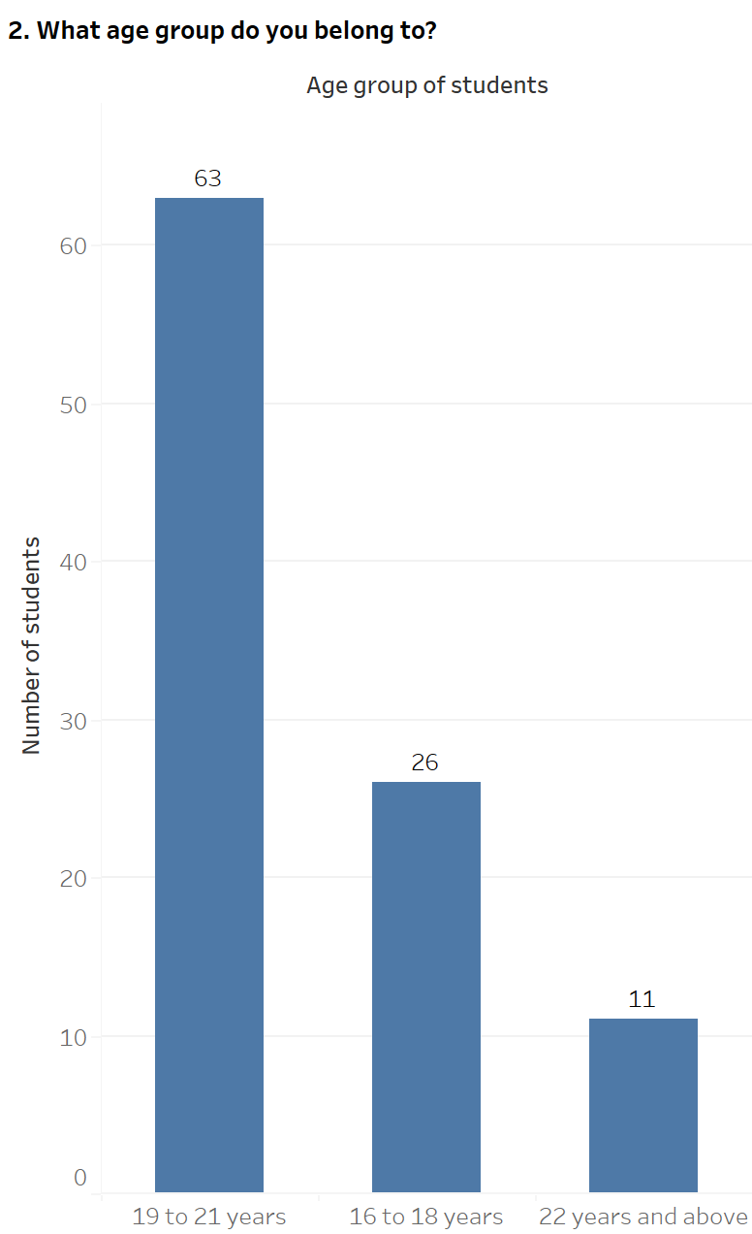

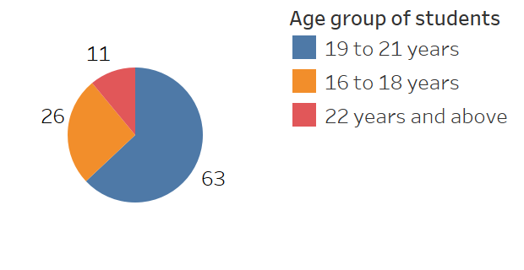

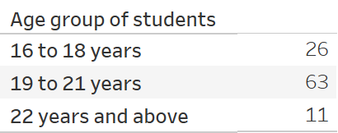

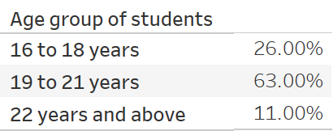

Figure 5: - Age group of students

The age group of students studying at Middlesex University, Dubai, from whom the survey responses have been collected, has been analyzed through a bar chart and a pie chart. Both the bar chart and pie chart reveal that out of the 100 students who participated in the survey, most students are between the age group of 19 and 21 years and have selected the option of *19 to 21 years*, containing 63 (63.00%) responses. In contrast, 26 (26.00%) students are between 16 and 18 years and have chosen the option of *16 to 18 years*. Finally, 11 students (11.00%) have revealed that their age is above 22 years by selecting the choice of *22 years and above*.

**3. Subject area of students**

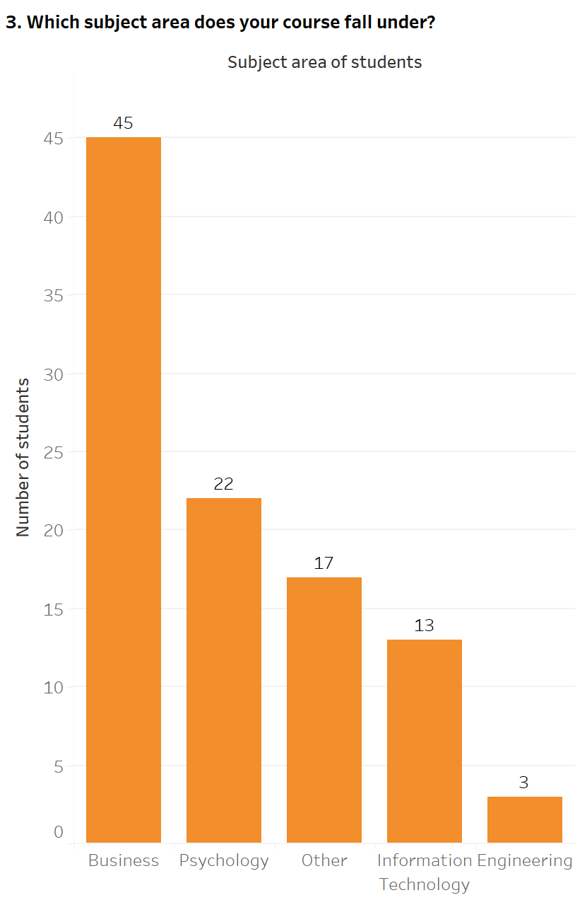

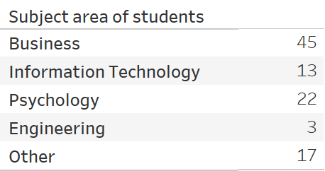

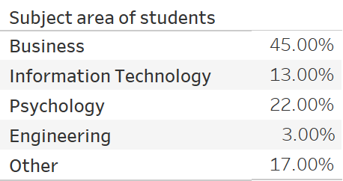

Figure 6: - Subject area of students

The subject area of students pursuing their degrees at Middlesex University, Dubai, has been depicted through a bar chart. The bar chart discloses that out of 100 students who have filled in their responses in the survey, most students are undertaking a degree in the Business subject area, with 45 (45.00%) of students choosing the option of *Business*. The subsequent highest responses of 22 (22.00%) students pursue a Psychology course and have selected the choice of *Psychology*. A comparable figure exists between students pursuing a degree not specified within the survey as part of the option *Other* and an Information Technology degree as part of the choice of *Information Technology*, with 17 (17.00%) and 13 (13.00%) responses, respectively. Students who have chosen their answer as *Other* pursue degrees that have not been mentioned directly in the survey, including Accounting and Finance, Business Information Systems, Education, Data Science, Creative Writing and Journalism, and Law. The least number of responses is present in the subject area of Engineering, containing only 3 (3.00%) responses of students that have selected the choice of *Engineering*.

**4. Year of study**

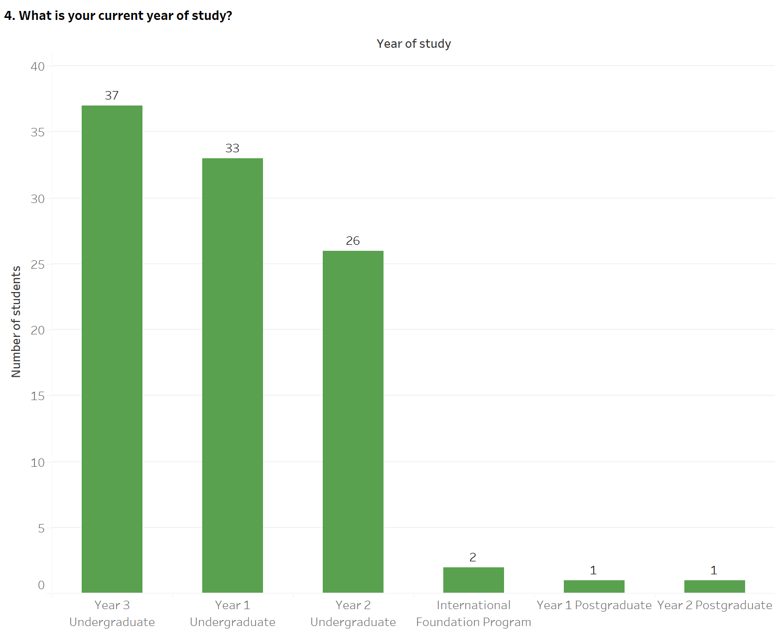

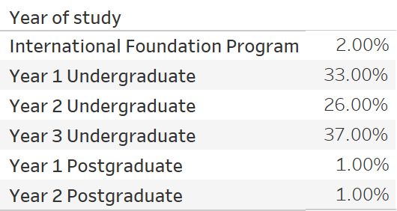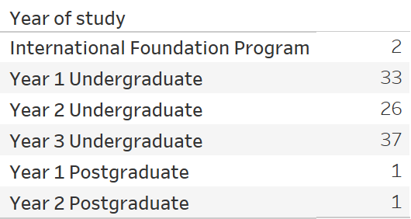

The year of study has been revealed by the students of Middlesex University, Dubai, at the time of carrying out the survey and is represented through a bar chart. Out of the 100 students who have taken part in the survey, a comparable figure exists between third-year undergraduate students who have chosen the option of *Year 3 Undergraduate* and first-year undergraduate students who have selected the choice of *Year 1 Undergraduate*, with 37 (37.00%) and 33 (33.00%) responses respectively. Furthermore, 26 (26.00%) students are in the second-year of their undergraduate degree and have selected the option of *Year 2 Undergraduate*. In contrast, only 2 (2.00%) students pursue a foundation program before their undergraduate studies and have chosen the choice of *International Foundation Program*. This represents a nearly similar figure with students in either the first-year of their postgraduate degree as part of the choice of *Year 1 Postgraduate* or the second-year of their postgraduate studies as part of the option of *Year 2 Postgraduate*, containing 1 (1.00%) response each.

Figure 7: - Year of study

**b. Technical aspects of online learning**

**5. Platforms accessed while attending online classes**

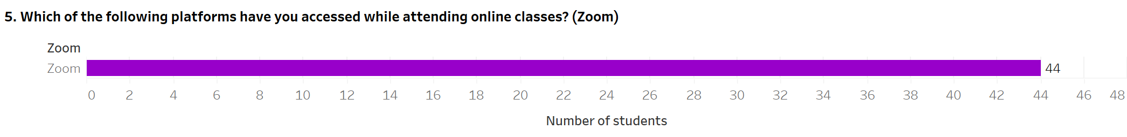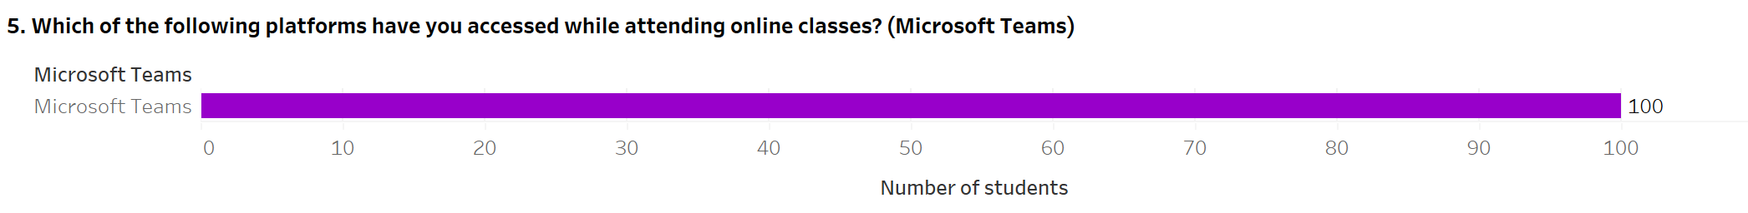

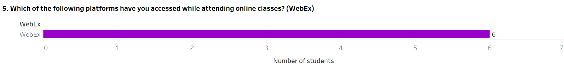

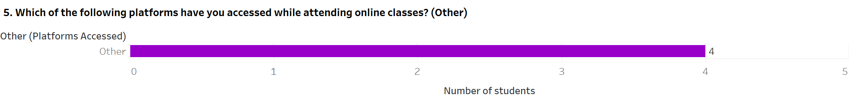

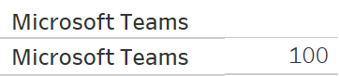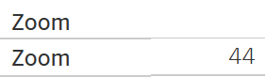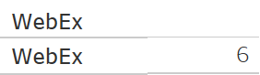

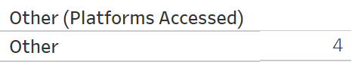

Figure 8: - Platforms accessed while attending online classes

The students of Middlesex University, Dubai, were asked to reveal the online platforms they have used while attending module classes in a remote setting. The students were presented with multiple options for the online platforms used, and each of these responses has been illustrated through separate bar charts. Out of 100 students who have participated in the survey, all 100 students have utilized Microsoft Teams to attend their online classes and have chosen the option of *Microsoft Teams*. However, the other platforms have lesser student responses; 44 students have selected the choice of *Zoom*, implying that they attend their module classes using Zoom. Furthermore, a comparative figure exists between students attending online classes who use either WebEx or other platforms that have not been specified as part of this survey question. There are 6 students that have used WebEx and have chosen the choice of *WebEx*. On the contrary, 4 students have selected the option of *Other* in the survey; these students have specified platforms, including GoToMeeting and Google Classroom.

**6. Devices utilized while attending online classes**

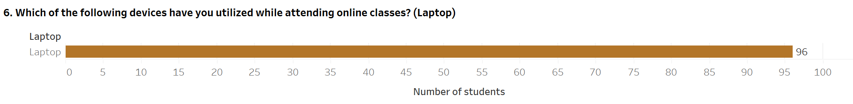

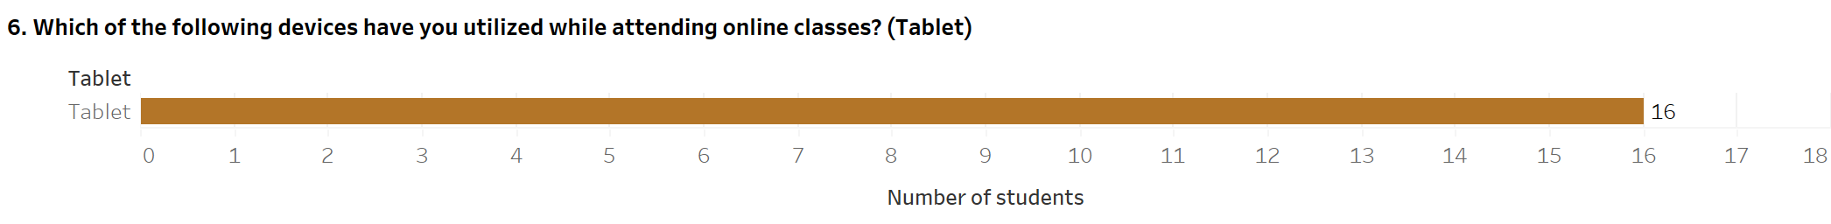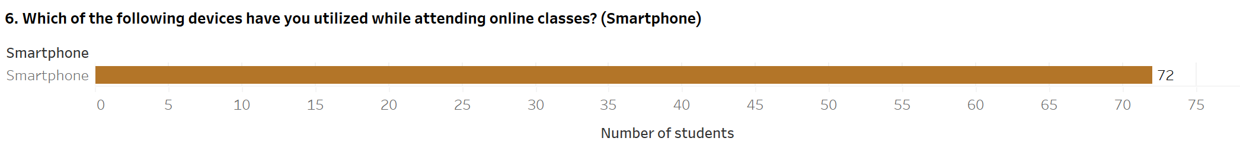

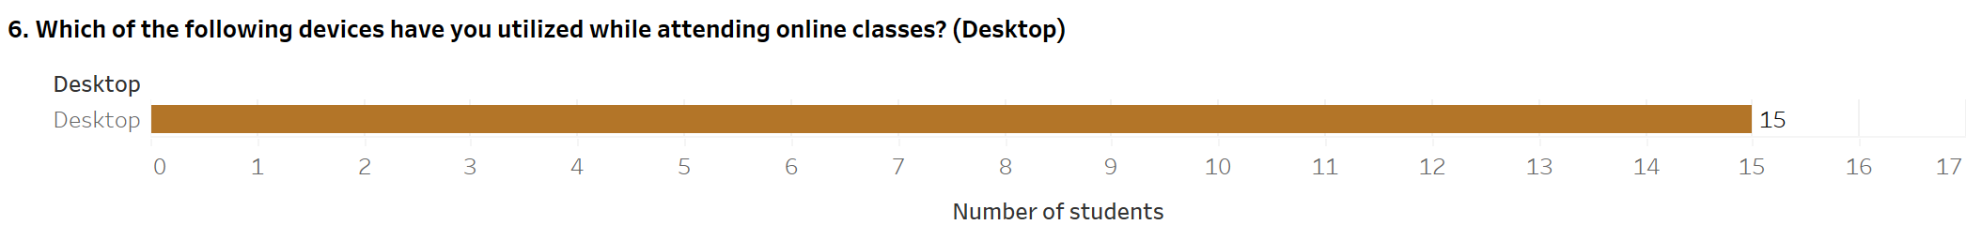

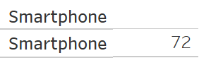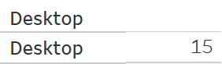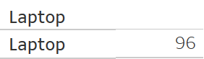

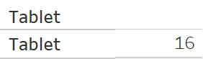

Figure 9: - Devices utilized while attending online classes

The students of Middlesex University, Dubai, were asked to divulge the devices they used while attending module classes in an online format. The students were given multiple choices for the devices utilized, and each of these responses has been depicted through separate bar charts. Among the 100 students who have participated in the survey, a prominent figure of 96 students has selected the choice of *Laptop*, implying that these students use laptops while attending online classes. Moreover, 72 students utilize smartphones for attending online classes and have chosen the option of *Smartphones*. The other two choices of *Tablet* and *Desktop* have the least responses and comparable figures. Students using tablets to attend module classes online contain 16 responses, while 15 students use desktops to attend online classes.

**7. Easiness or difficulty of using online platforms during the COVID-19 pandemic lockdown**

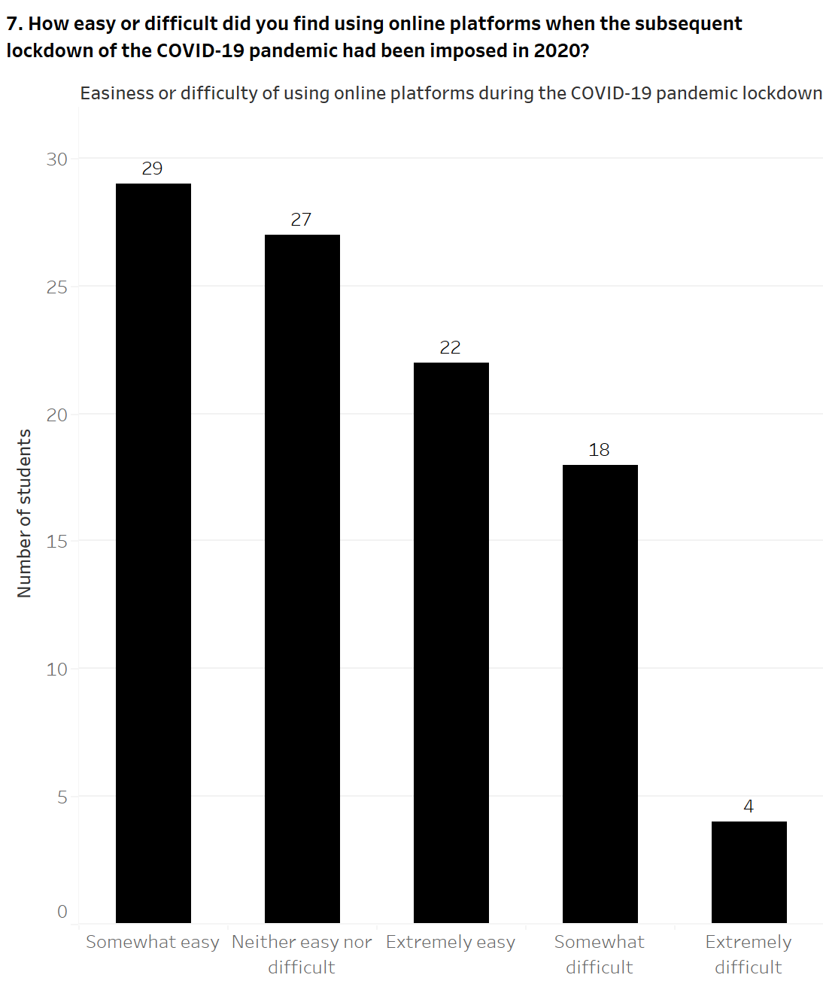

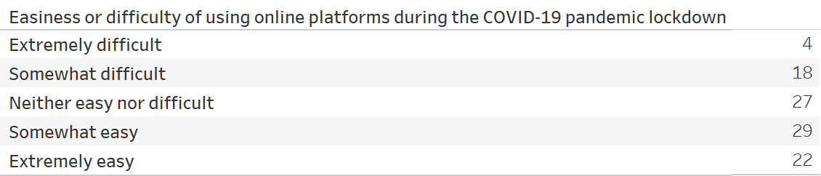

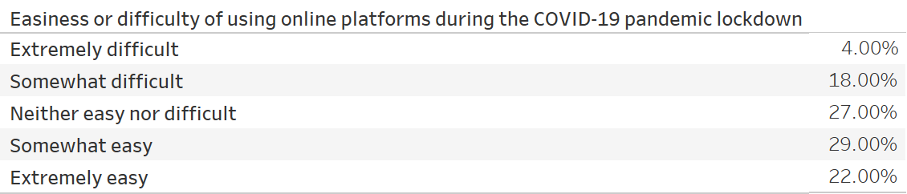

Figure 10: - Easiness or difficulty of using online platforms during the COVID-19 pandemic lockdown

The students of Middlesex University, Dubai, were questioned about expressing the level of easiness or difficulty while using online learning platforms when every academic institution worldwide, including those in the United Arab Emirates, was forced to suspend their operations due to the imposition of the national lockdown by governments to minimize the spread of the COVID-19 pandemic in March 2020. However, some students, such as foundation programand first-year undergraduate students, may have been studying at Middlesex University, Dubai, before or during the COVID-19 pandemic lockdown. In this situation, it is assumed that they were using online learning platforms within their secondary schools. The level of easiness or difficulty of using online learning platforms has been represented using a bar chart. The bar chart reveals that out of the 100 students who have taken part in the survey, a comparable figure between students who found using online platforms either relatively easy, as part of the choice of *Somewhat easy* or neither challenging nor straightforward as part of the option of *Neither easy nor difficult*. The selection of *Somewhat easy* comprises 29 (29.00%) responses and the choice of *Neither easy nor difficult* consists of 27 (27.00%) responses. Similarly, a comparable figure exists among students who have found using online platforms either extremely simple as part of *Extremely easy* or a bit difficult as part of the selection of *Somewhat difficult*, with 22 (22.00%) and 18 (18.00%) of responses, respectively. On the contrary, only 4 (4.00%) of students have found using online learning platforms very challenging by choosing *Extremely difficult*.

**c. Student experiences with online learning**

**8. Quality of education delivered through online learning platforms**

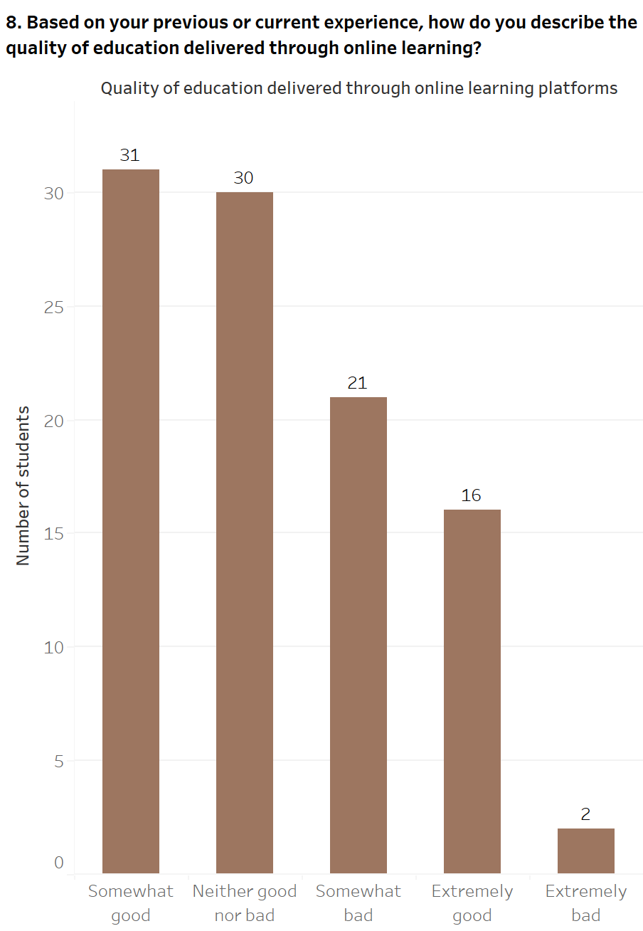

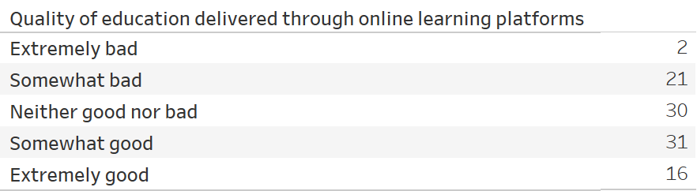

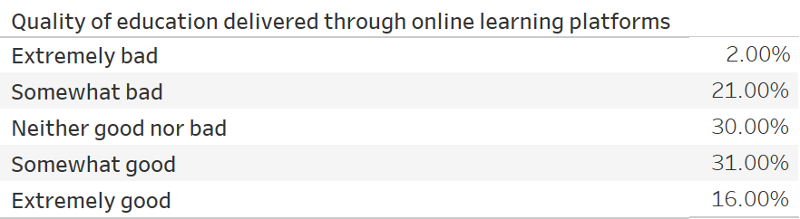

Figure 11: - Quality of education delivered through online learning platforms

The students of Middlesex University, Dubai, were asked to express the quality of education delivered through online learning sessions. The responses to the quality of education have been depicted through a bar chart. This bar chart reveals that within the 100 students who have taken part in the survey, a comparable figure exists among students who have found the quality of education through online learning as relatively positive by choosing the option of *Somewhat good* or neither positive nor negative by selecting the option of *Neither good nor bad*. The choice of *Somewhat good* contains 31 (31.00%) responses, and the *Neither good nor bad option* comprises 30 (30.00%) responses. Furthermore, 21 (21.00%) of students have found the quality of education delivered by online learning asslightly negative by choosing the option as *Somewhat bad,* and 16 (16.00%) of students have recognized the quality of education as highly favorable as part of the option of *Extremely good*. The remaining 2 (2.00%) students have found the quality of education conducted through online learning as highly unfavorable by choosing the option of *Extremely bad*.

**9. Perception of studying through online learning platforms instead of traditional face-to-face classes**

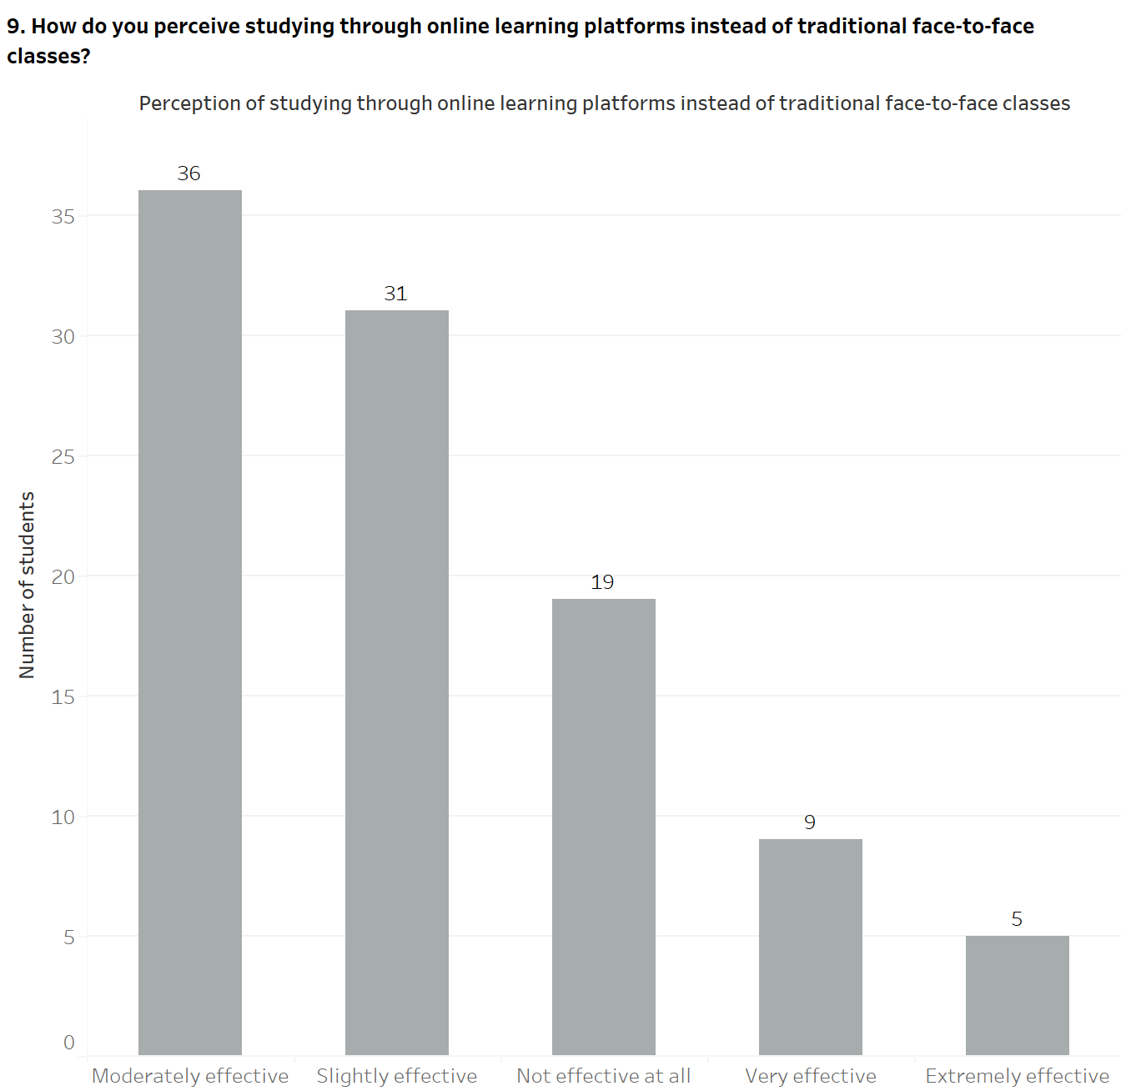

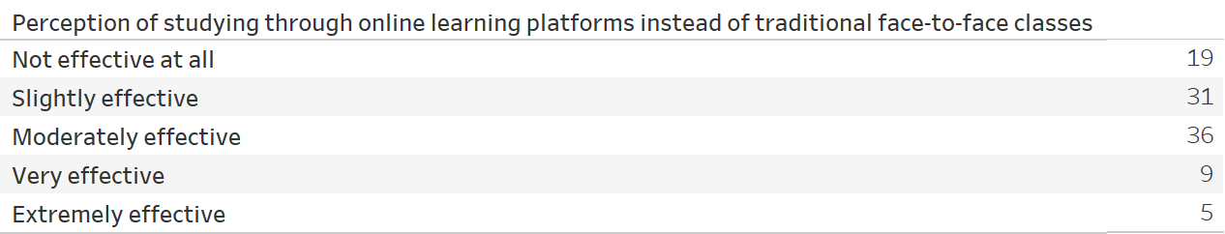

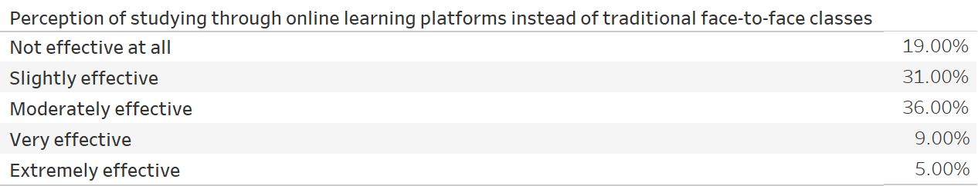

Figure 12: - Perception of studying through online learning platforms instead of traditional face-to-face classes

The students of Middlesex University, Dubai, were questioned about conveying their opinions of using online learning platforms rather than the standard face-to-face classes while attending classes and is represented through a bar chart. The bar chart reveals that out of the 100 responses present in the survey, 36 (36.00%) of students feel that online learning platforms are reasonably beneficial compared to attending in-person classes and have chosen the option of *Moderately effective*. Furthermore, within the survey, 31 (31.00%) of students believed that studying through online learning platforms is marginally beneficial instead of in-person classes and have chosen the choice of *Slightly effective*. Students who consider online sessions unreliable instead of physical classes comprise 19 (19.00%) students who have selected the option of *Not effective at all*. On the contrary, a comparable figure exists among students who recognize using online platforms rather than being on-campus for classes as either mostly valuable by choosing the option of *Very effective* or hugely beneficial by selecting the option of *Extremely effective*, with 9 (9.00%) and 5 (5.00%) responses, respectively.

**10. Challenges faced while attending online classes**

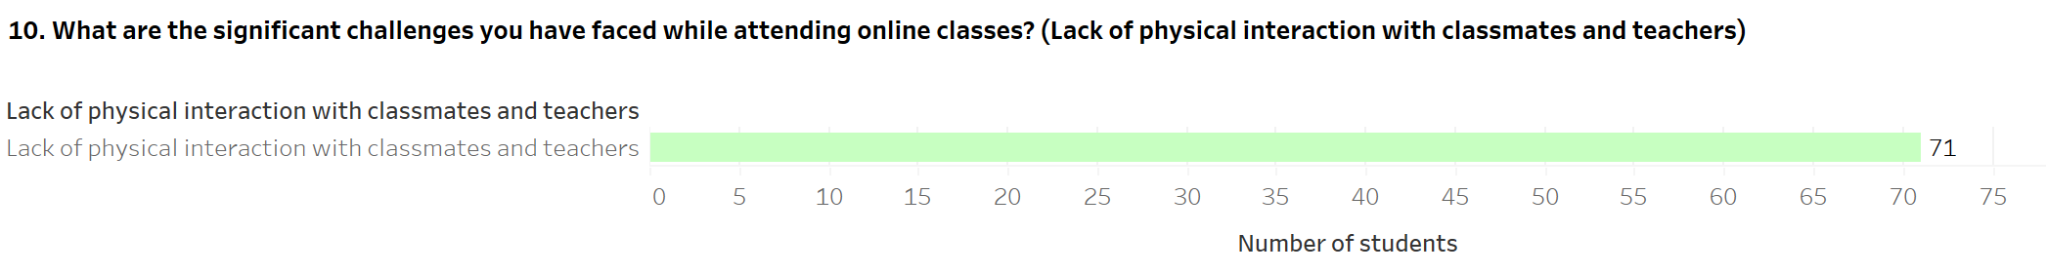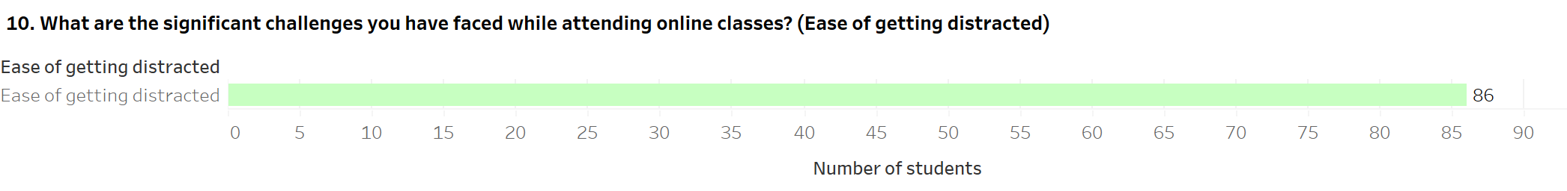

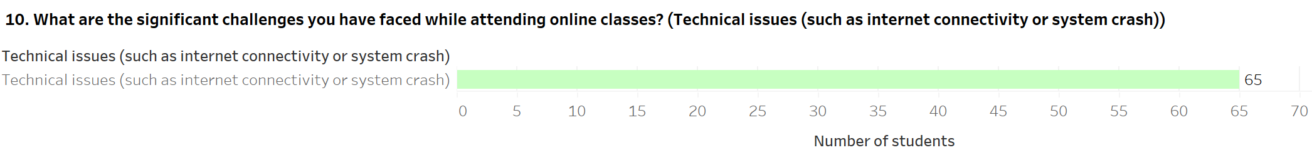

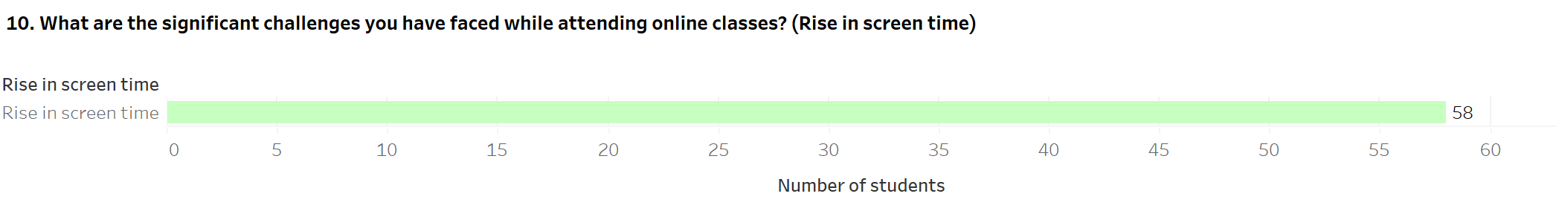

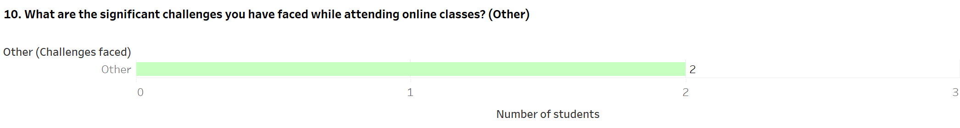



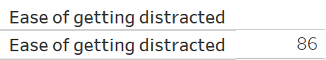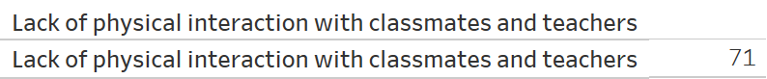

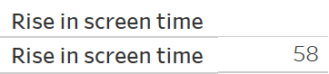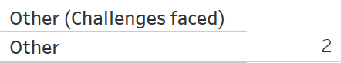

Figure 13: - Challenges faced while attending online classes

The students of Middlesex University, Dubai, were questioned about the various difficulties while attending module classes through online platforms. Multiple options were presented to students concerning the problems encountered during online classes and have been depicted through separate bar charts. Within 100 responses present in the survey, 86 students believe that they quickly get inattentive during online classes and have selected the option of *Ease of getting distracted*. There are 71 students who have chosen the choice of *Lack of physical interaction with classmates and teachers*, implying that these students have been unable to interact with their fellow module classmates and tutors personally. Furthermore, 65 responses are present within the option of *Technical issues (such as internet connectivity or system crash)*; these students have dealt with technical problems, including poor internet connectivity or systems shutting down during online classes. Moreover, 58 students have chosen the choice of *Rise in screen time*, indicating that students have been unable to cope with online classes due to spending a significant amount of time in front of their devices. Finally, only 2 students have selected the choice of *Other*, with the responses presented by these students concerning challenges of online learning including getting tired quickly and minimal practical skills.

**11. Advantages of online learning as compared to a traditional class**

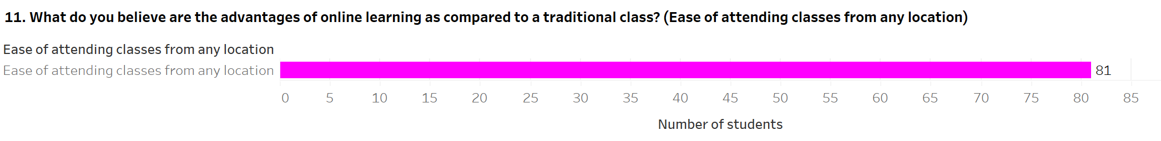

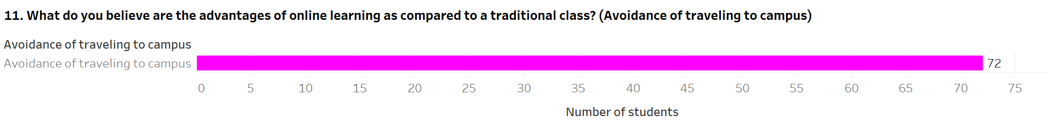

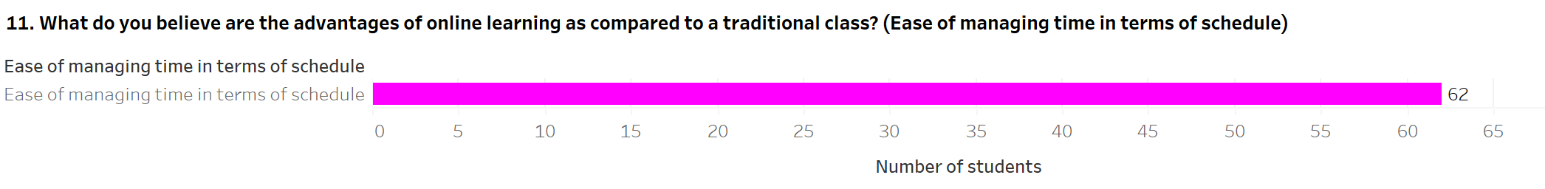

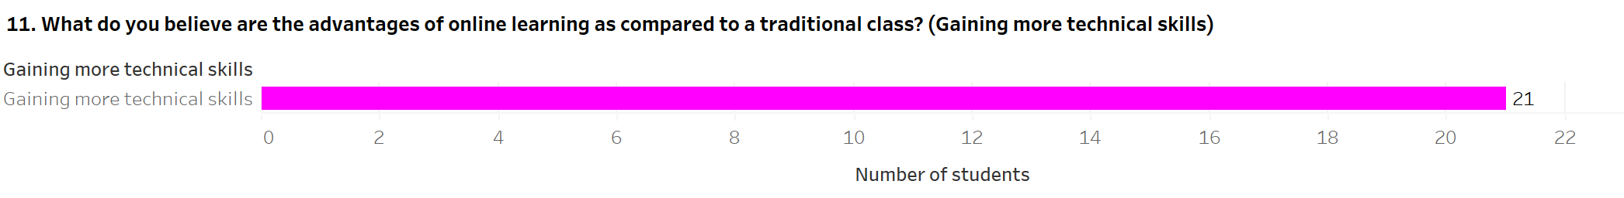

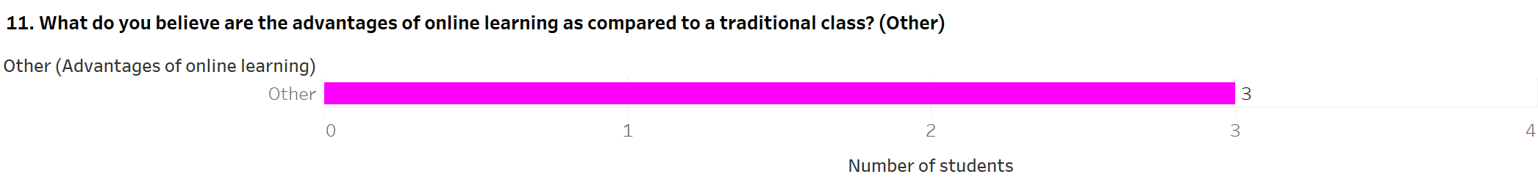

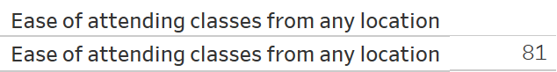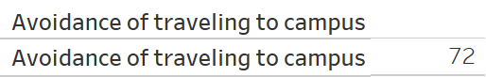

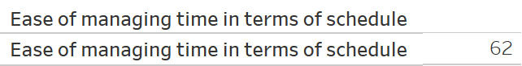

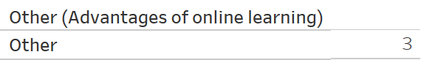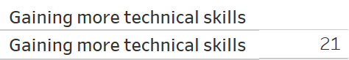

Figure 14: - Advantages of online learning as compared to a traditional class

The students of Middlesex University, Dubai, were queried about the benefits of attending module classes in an online setting instead of a face-to-face class. The students were presented with multiple choices regarding the positive aspects of online learning, which have been depicted through separate bar charts. Within the 100 responses collected through the survey, 81 students have selected the choice of *Ease of attending classes from any location*; these students believe that online classes benefit from attending online classes at any site, irrespective of their place of living. There are 72 students who feel that online learning enables them to attend module classes without going to campus and have chosen the choice of *Avoidance of traveling to campus*. Furthermore, 62 students recognize that online learning enables them to organize their time through proper scheduling and have selected the option of *Ease of managing time in terms of schedule*. The other two responses have lower figures from the survey. On one end, students who recognize that online learning allows them to learn more technical skills, such as utilizing conferencing tools and its features, contain 21 students who have chosen the choice of *Gaining more technical skills*. On the other end, only 3 students have selected the option of *Other*, with students specifying the other advantages of online learning, including the ability to pay more attention, benefits provided to chronically ill people, and the comfort of students not being conscious of their selves, their clothing, and their behavior in classes.

**12. Maintaining time with academic work, social life, and extracurricular activities while attending online classes**

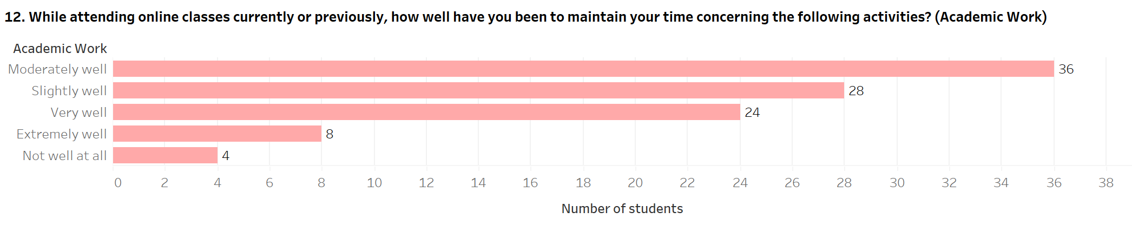

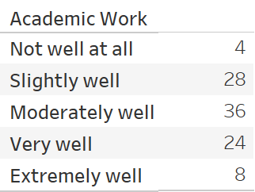

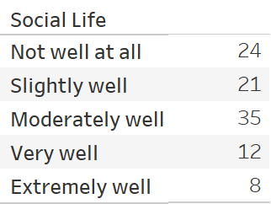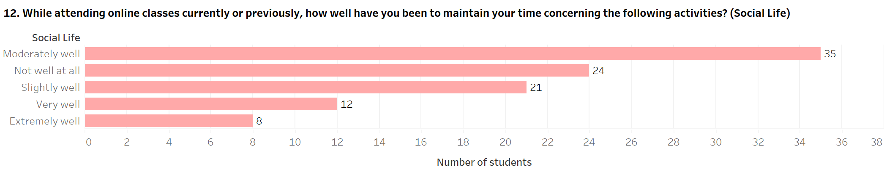

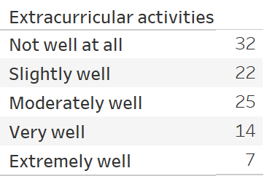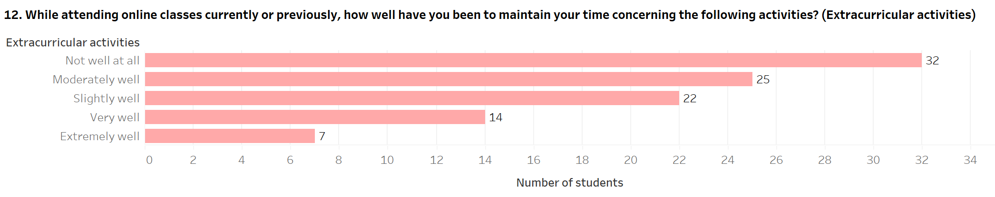

Figure 15: - Maintaining time with academic work, social life, and extracurricular activities while attending online classes

The students of Middlesex University, Dubai, were asked to divulge whether they have been able to preserve their time with academic work (attempting courseworks and preparing for examinations), social life (interacting with their friends), and extracurricular activities (taking part in club and sports activities) while attending module classes in an online setting. This question was presented to students in a Likert-scale format with the statements of academic work, social life, and extracurricular activities specified negatively or positively. Each statement has been depicted using a separate bar chart that contains all 100 student responses.

Within the statement of academic work, 36 (36.00%) students have selected the choice of *Moderately* well, meaning that they have been able to maintain their studies reasonably while attending module classes online. This response is followed by comparable figures between the *Slightly well* and *Very Well* options. There are 28 (28.00%) students who, to some degree, have been unable to cope with their academic work while attending online classes and have chosen the option of *Slightly well*. On the contrary, 24 (24.00%) students have been able to cope with their academic work in a vastly positive manner during online classes and have selected the choice of *Very well*. The remaining two question choices, *Extremely well* and *Not well at all,* also have closer figures. The option of *Extremely well* comprises 8 (8.00%) responses, meaning that these students have been able to handle their academics in a hugely positive way during online classes. On the contrary, the choice of *Not well at all* contains 4 (4.00%) students who have been unable to persist with their academic work while attending online classes.

From the perspective of the statement of social life, 35 (35.00%) students have reasonably been able to cope with their social life during online classes and have selected the choice of *Moderately well*. Subsequently, the options, *Not well at all* and *Slightly well*, have comparable figures. The choice of *Not well at all* contains 24 (24.00%) responses, signifying that these students have been unable to cope with their social life during online classes. On the contrary, 21 (21.00%) students have chosen the choice *Slightly well*; these students, to some degree, have been unable to maintain their social life while attending online classes. The remaining two question choices, *Very well* and *Extremely well*, also have similar figures. The option of *Very well* has been chosen by 12 (12.00%) students, indicating that these students have handled their social life in a vastly favorable fashion during classes. In contrast, 8 (8.00%) students have been able to deal with their social life hugely while attending online classes and have selected the choice of *Extremely well*.

The final statement on Extracurricular activities contains a significant figure of 32 (32.00%) students who believe that attending module classes online has seen them unable to deal with their extracurricular activities and have chosen the option of *Not well at all*. This is followed by similar figures among students who have discerned that they have dealt with their extracurricular activities reasonably or fairly during online classes. Of students who have recognized that they have reasonably been able to cope with their extracurricular activities during online classes, 25 (25.00%) students have selected the option of *Moderately well*. On the contrary, 22 (22.00%) students, to some degree, have fairly been able to handle their extracurricular activities during online classes and have chosen the option of *Slightly well*. Finally, the remaining choices, *Very well* and *Extremely well*, contain the least number of student responses. The choice of *Very well* comprises 14 (14.00%) students; these students have recognized that they have vastly been able to cope with their extracurricular activities during online classes. On the other hand, the option of *Extremely well* contains 7 (7.00%) students, meaning that they have dealt with their extracurricular activities in a highly positive fashion.

**d. Students' mental health**

**13.** **State of mental health**

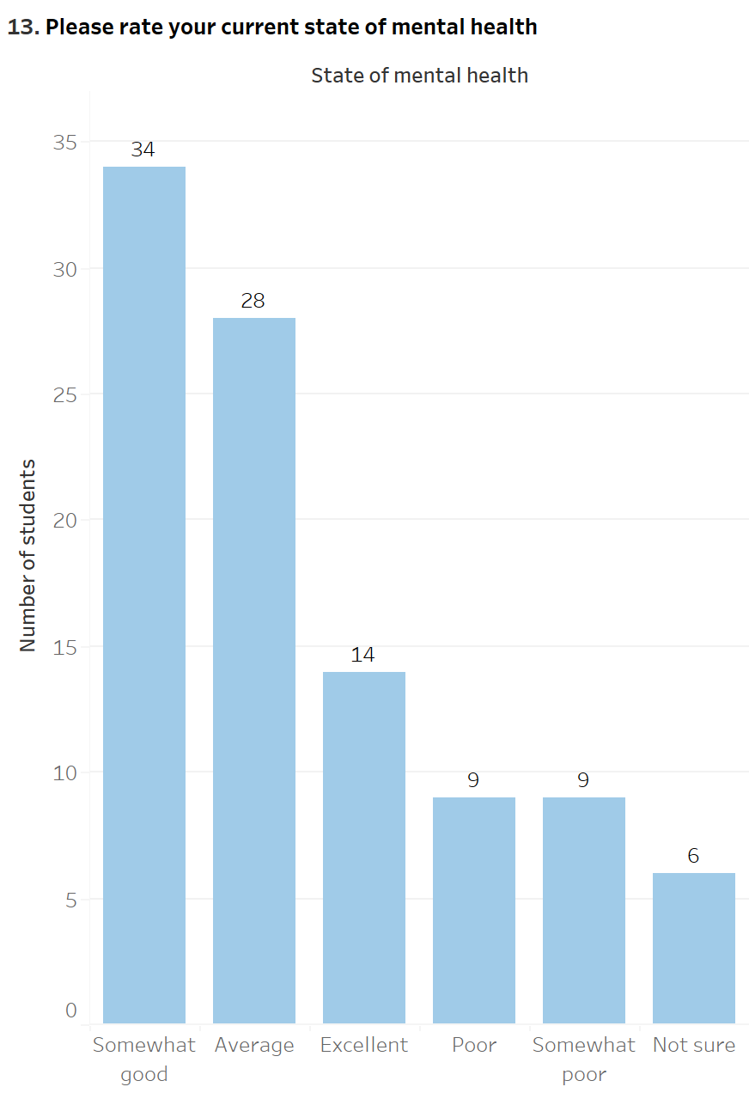

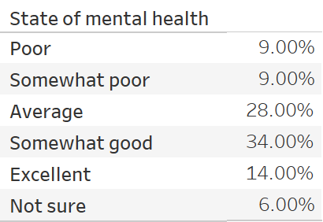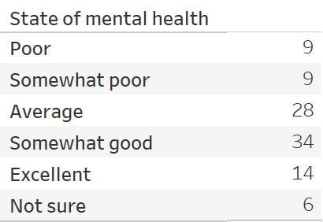

Figure 16: - State of mental health

The students of Middlesex University, Dubai, were asked to reveal their state of mental health when taking part in the survey which is depicted through a bar chart. Out of 100 responses present in the survey, most students had graded their mental health as fairly positive by selecting the option of *Somewhat good*, comprising 34 (34.00%) students. This is followed by students who have rated their mental health as satisfactory by choosing the option of *Average;* 28 (28.00%) students belong to this category. Furthermore, 14 (14.00%) students have selected the choice of Excellent, implying that these students' mental health is outstanding. The remaining responses contain comparable figures; the students who rated their mental health as either slightly bad, i.e., *Somewhat poor,* or below par, i.e., *Poor*, comprise 9 (9.00%) responses each. Finally, only 6 (6.00%) of students have chosen the option of *Not sure*; these students were undefined about their state of mental health while participating in the survey.

**14.** **Disturbance of the COVID-19 pandemic on the normal university experience**

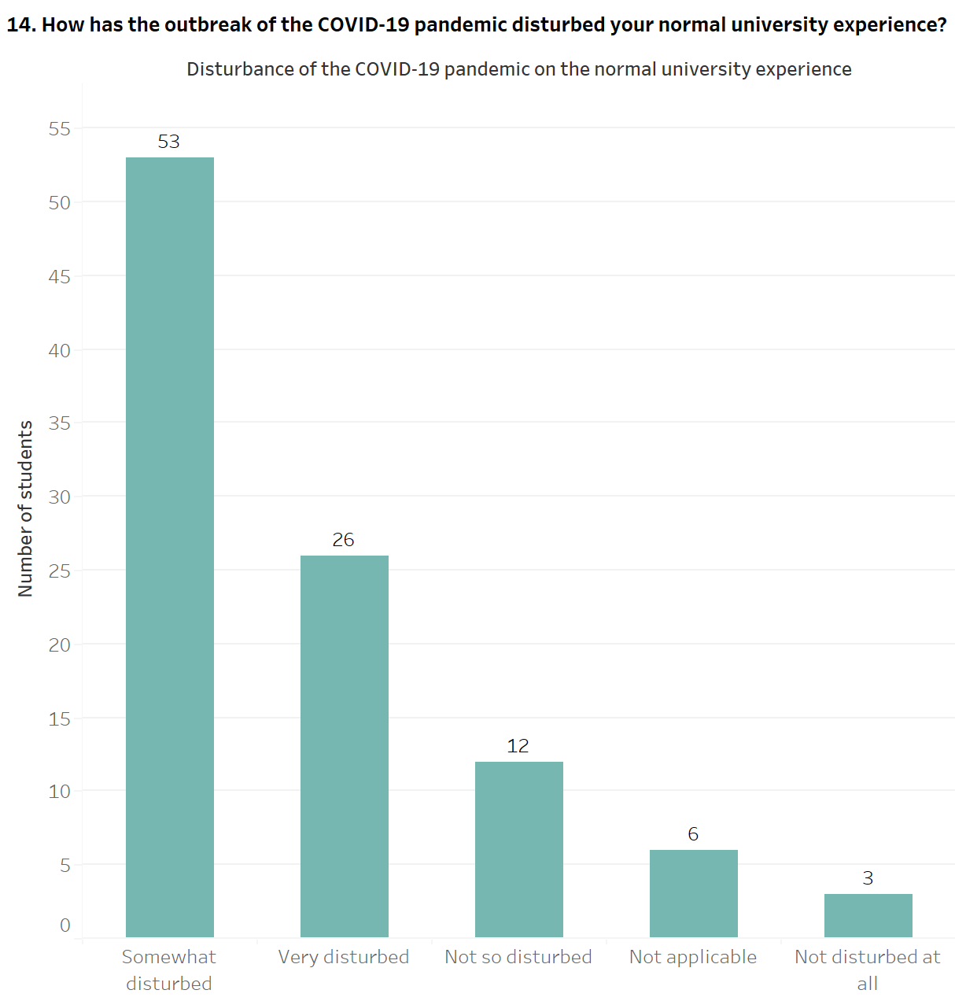

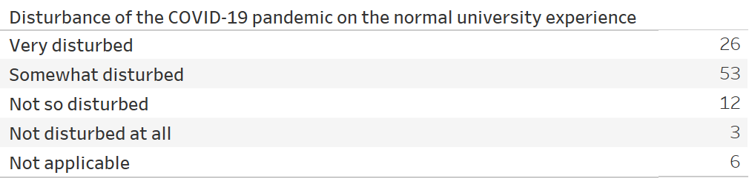

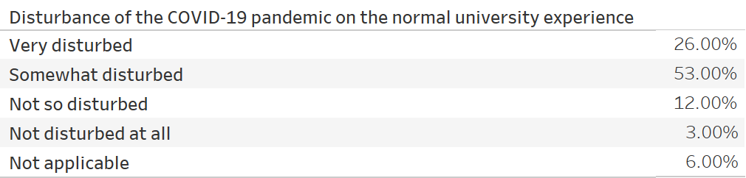

Figure 17: - Disturbance of the COVID-19 pandemic on the normal university experience

The students of Middlesex University, Dubai, were questioned about how the COVID-19 pandemic impacted their regular university experience, illustrated through a bar chart. Out of 100 students who have taken part in the survey, 53 (53.00%) students believe that the COVID-19 pandemic has slightly disturbed their typical university experience; these students have chosen the option of *Somewhat disturbed*. The subsequent most significant response contains 26 (26.00%) students who have admitted that their university experience has been vastly troubled due to the COVID-19 pandemic and have selected the option of *Very disturbed*. Furthermore, 12 (12.00%) students have chosen the choice of *Not so* disturbed, signifying that the COVID-19 pandemic has not completely troubled their university experience. There are 6 (6.00%) students unaware of the COVID-19 pandemic plaguing their typical university experience by choosing their choice of *Not applicable*. Finally, only 3 (3.00%) students believe that their university experience has not been troubled by the COVID-19 pandemic and have chosen the choice of *Not disturbed at all*.

**15. Online learning affecting mental health at the beginning of the COVID-19 pandemic**

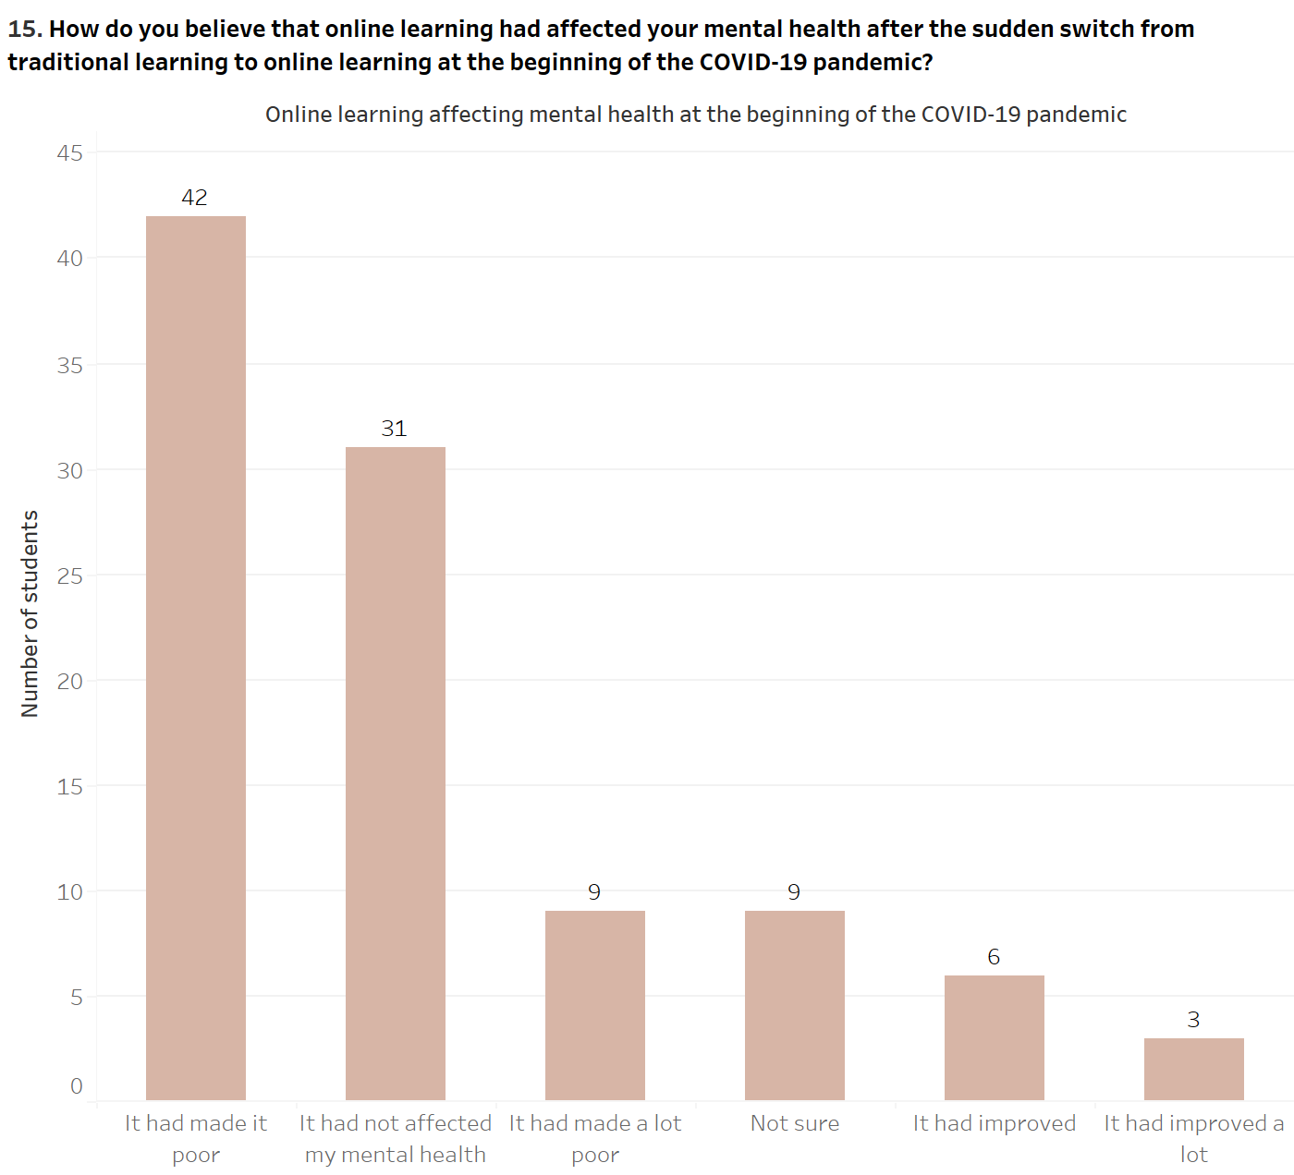

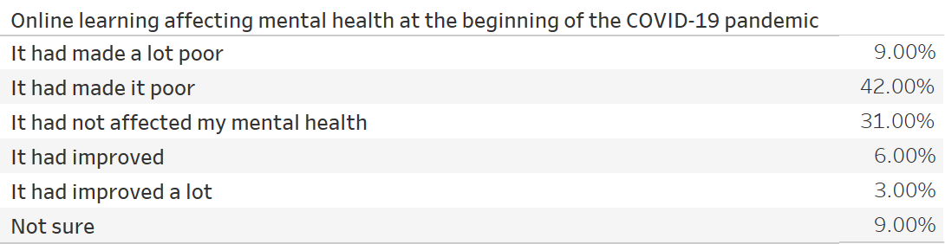

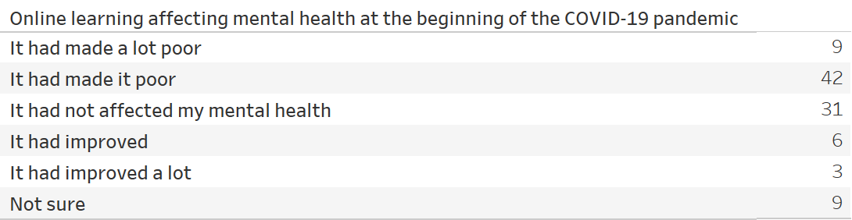

Figure 18: - Online learning affecting mental health at the beginning of the COVID-19 pandemic

The students of Middlesex University, Dubai, were asked to disclose whether online learning had impacted their mental health when the COVID-19 pandemic forced educational institutions worldwide, including the United Arab Emirates, to continue providing education through online platforms instead of in-person classes. The responses have been depicted using a bar chart which reveals that out of 100 students who have participated in the survey, 42 (42.00%) students believed that online learning had made their mental health bad at the start of the COVID-19 pandemic by choosing the option of *It had made it poor*. This response is followed by 31 (31.00%) students who have discerned that online learning had not impacted their mental health at the start of the COVID-19 pandemic by selecting the option *It had not affected my mental health*. Furthermore, 9 (9.00%) students have recognized that online learning had worsened their mental health at the start of the COVID-19 pandemic by choosing the option of *It had made a lot poor*. This response is equal to 9 (9.00%) students who are unsure if online learning had made their mental health either poor or improved at the start of the COVID-19 pandemic and have selected the option of *Not sure*. Additionally, there are 6 (6.00%) students who have admitted that online learning had made their mental health good by choosing the option of *It had improved*; this represents a comparable figure with 3 (3.00%) students who have recognized that online learning made their mental health better at the beginning of the COVID-19 pandemic by choosing the option of *It had improved a lot*.

**16. Anxiousness while attending online classes**

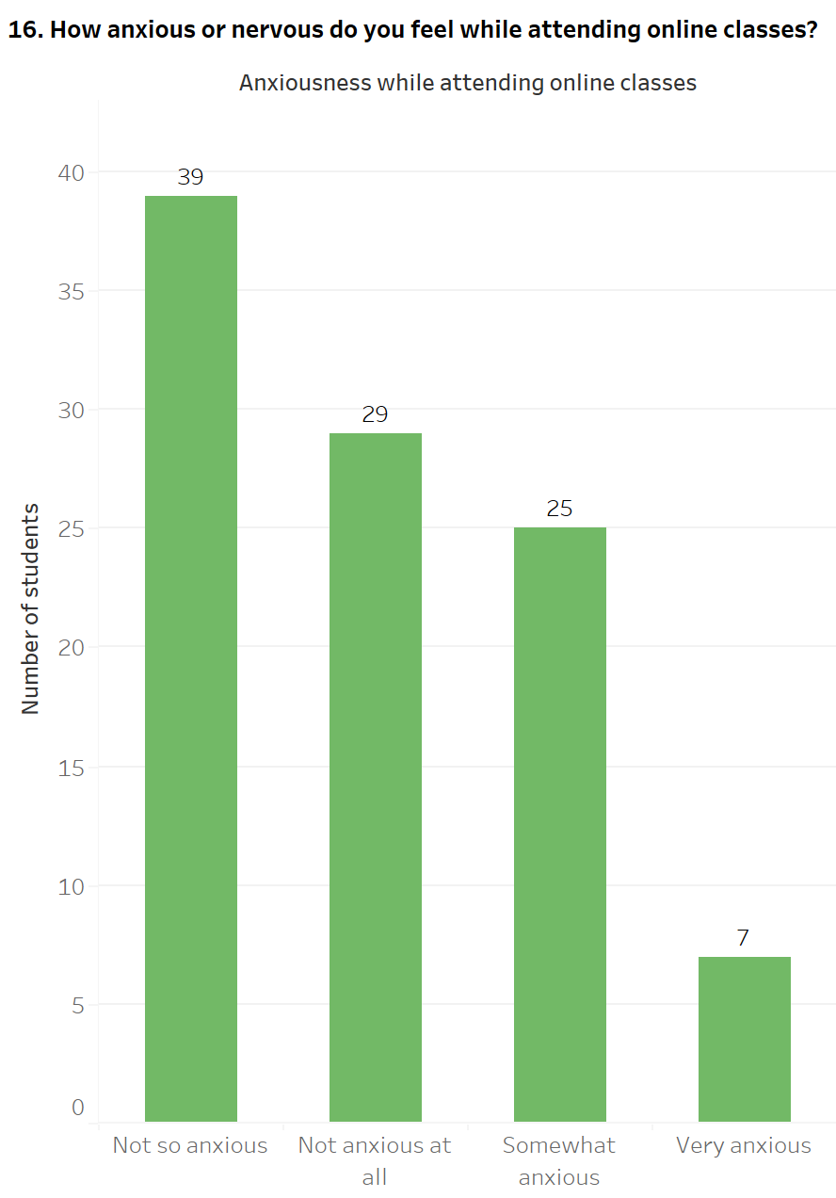

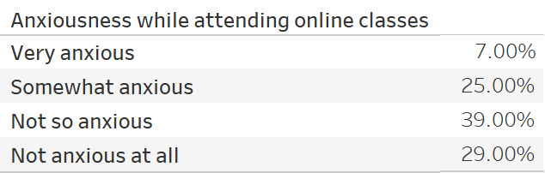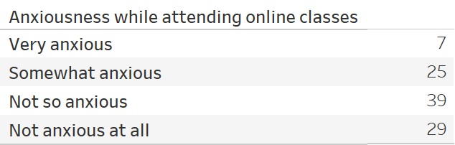

Figure 19: - Anxiousness while attending online classes

The students of Middlesex University, Dubai, were questioned about their level of restlessness while attending module sessions through online platforms and depicted through a bar chart. The bar chart reveals that out of 100 students who have chosen to participate in the survey, 39 (39.00%) students do not feel much restless while attending online classes and have selected *Not so anxious*. The subsequent two highest responses have comparable figures; 29 (29.00%) students believe that there is no level of restlessness during online classes and have selected the option of *Not anxious at all*. This figure is similar to 25 (25.00%) students who believe that online classes make them marginally restless and have chosen the response of *Somewhat anxious*. Finally, the response of *Very anxious* contains only 7 (7.00%) students who have discerned that attending classes through online platforms makes them vastly restless.

**17. Regular Attendance during online sessions**

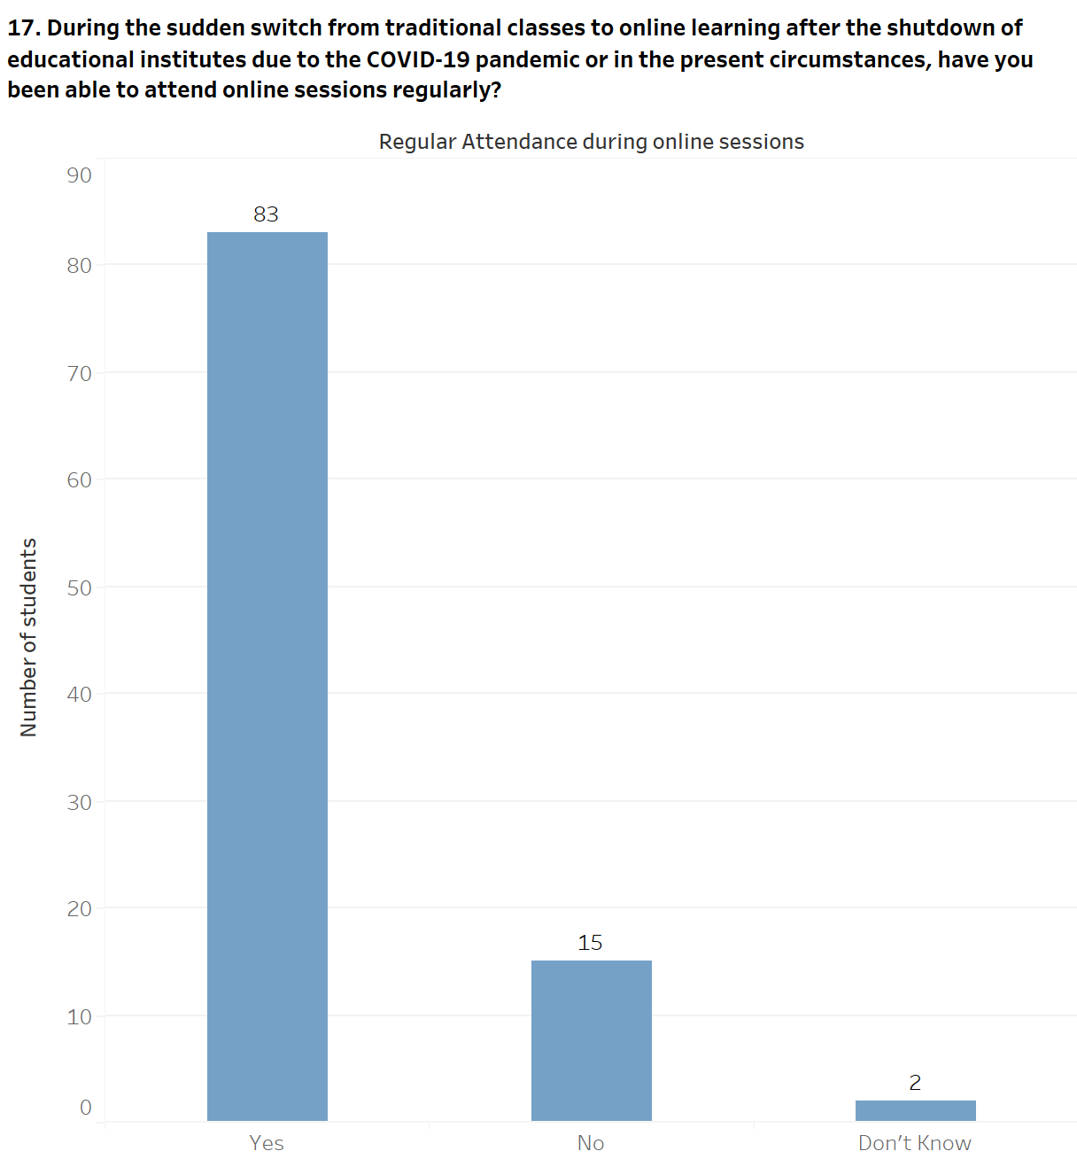

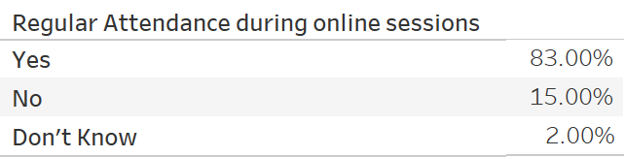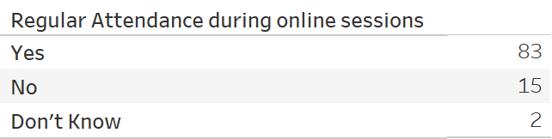

Figure 20: - Regular Attendance during online sessions

The students of Middlesex University, Dubai, were asked to disclose if they could attend their classes consistently through online sessions and have been illustrated through a bar chart. The bar chart divulges that out of 100 responses present in the survey, 83 (83.00%) students have stated that they have attended module classes through online platforms frequently and have selected the option of *Yes*. On the contrary, there are only 15 (15.00%) students who have not been able to attend module sessions consistently and have chosen the option of *No*; this response subsequently provided these students with the question of the reasons behind not attending online classes consistently. Finally, there are only 2 (2.00%) of students who are unaware of whether they have been able to attend their module classes regularly and have chosen the response of *Don’t Know*.

**18. Reasons behind not attending online classes**

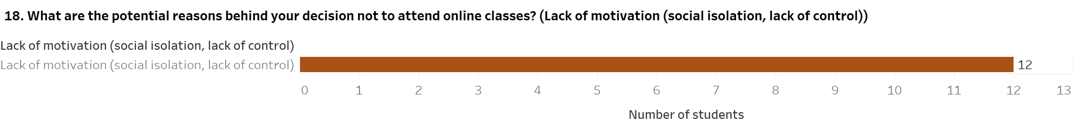

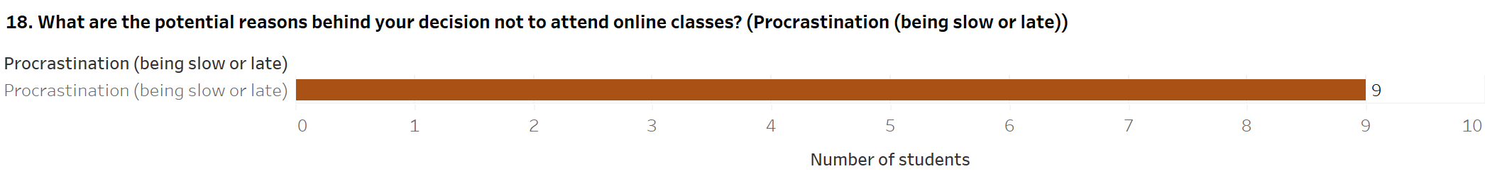

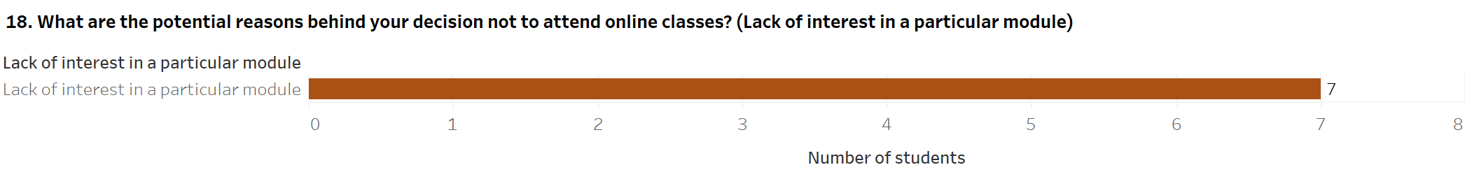

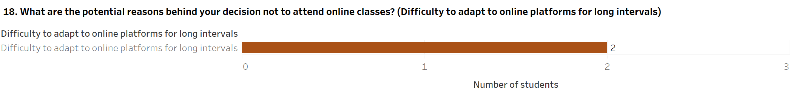

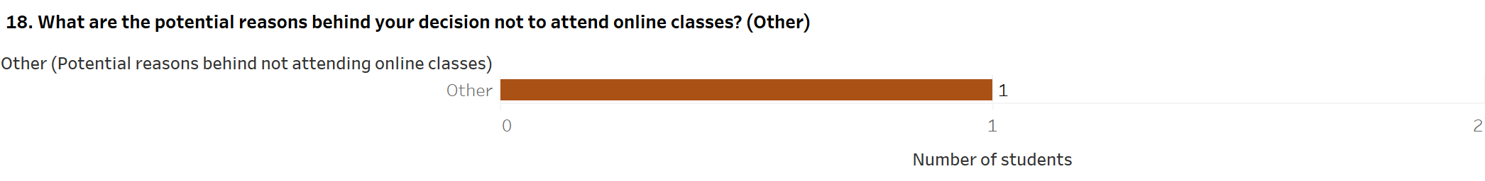

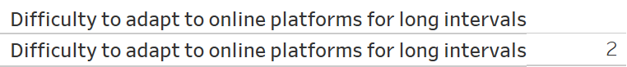

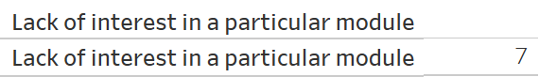

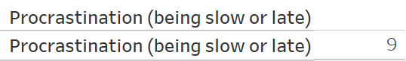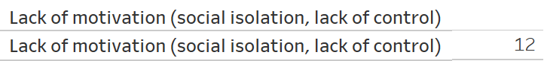



Figure 21: - Reasons behind not attending online classes

The students of Middlesex University, Dubai, were queried about the possible causes of not being able to attend their module classes in an online setting. This question was only displayed to those students who had chosen their response as *No* in the previous question of whether they could attend online classes consistently, comprising 15 students. Moreover, within this question, the students were presented with multiple choices concerning the possible reasons for not attending online classes. Each of the student responses has been depicted using separate bar charts. Of the 15 students who have been unable to attend online classes regularly, 12 students believe that they do not have the inclination or enthusiasm to take part in online classes, such as loneliness and lack of control and have selected the option of *Lack of motivation (social isolation, lack of control)*. The responses of *Procrastination (being slow or late)* and *Lack of interest in a particular module* contain comparable responses. At one end, there are 9 students who have chosen the option of *Procrastination (being slow or late)*; these students believe that they delay or are hesitant to attend online classes regularly. On the contrary, 7 students have discerned that they are not interested in a specific module through online classes and have selected the choice of *Lack of interest in a particular module*. Identically, a comparable figure also exists between the remaining responses, *Difficulty to adapt to online platforms for long intervals,* and *Other*. There are 2 students who believe that they have not been able to attend module classes through online platforms due to the challenge of adjusting to online platforms for an extended period and have chosen the option *Difficulty to adapt to online platforms for long intervals*. On the other hand, only 1 student has selected the choice *Other*; this student revealed that not attending module classes is due to the online learning platforms causing frequent fever and creating a lack of mental peace.

**19. Zoom Fatigue during online classes**

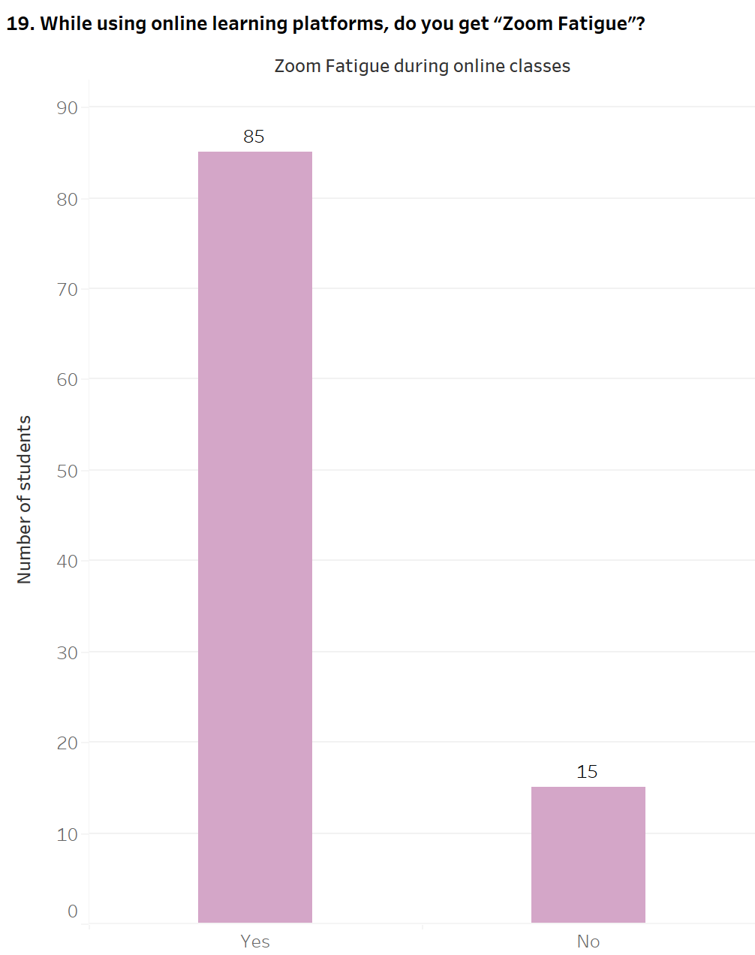

**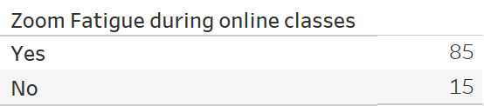**

**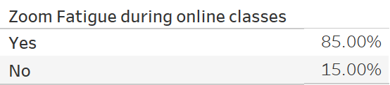**

Figure 22: - Zoom Fatigue during online classes

The students of Middlesex University, Dubai, were asked to reveal if they have experienced Zoom Fatigue while attending module sessions through online learning platforms. Zoom Fatigue has been described as the mental exhaustion associated with online video conferencing (Hines and Sun, 2020). Zoom Fatigue also applies to fatigue created by other platforms such as Microsoft Teams, WebEx, and more. The responses to Zoom Fatigue have been illustrated using a bar chart. The bar chart reveals that of 100 students from whom the data has been collected in the survey, 85 (85.00%) students have indicated that they have experienced Zoom Fatigue while attending classes using online learning platforms and have selected the option of *Yes*. This response subsequently provided students with the question of their approaches to dealing with Zoom Fatigue. On the contrary, only 15 (15.00%) students have selected the option of *No*, implying that they have not encountered Zoom Fatigue while using online learning platforms.

**20.** **Approaches used to deal with Zoom Fatigue**

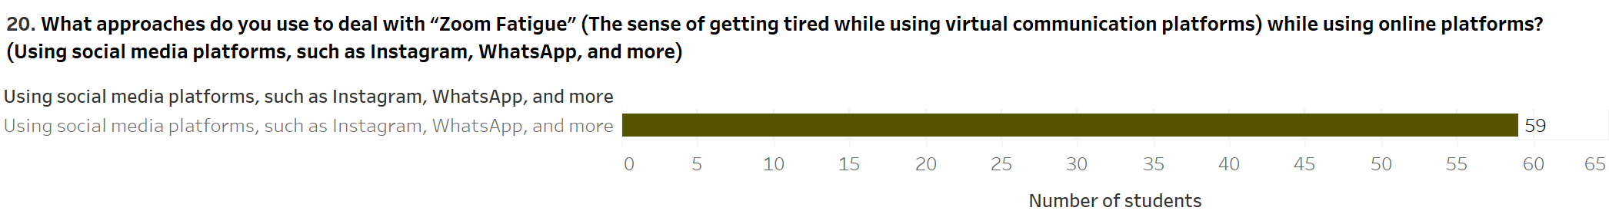

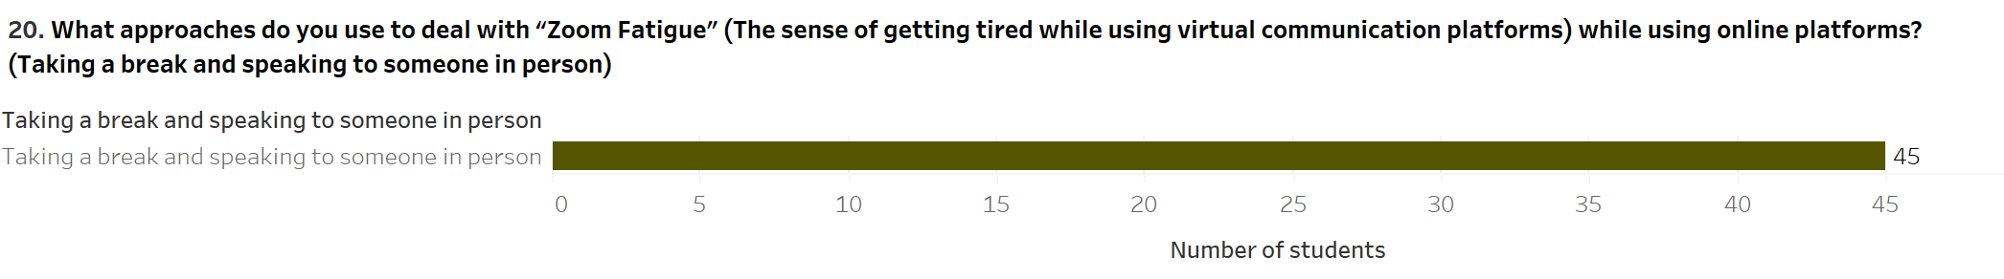

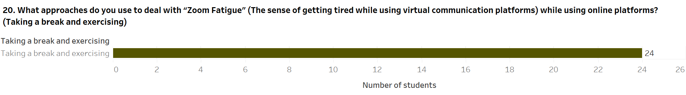

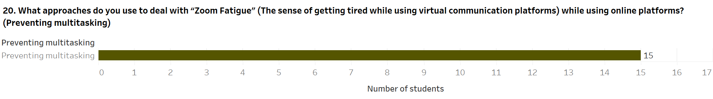

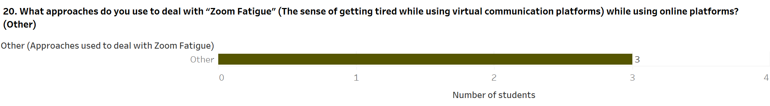



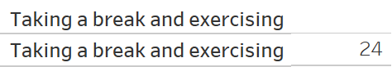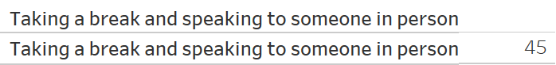

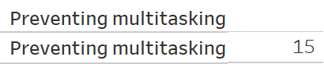

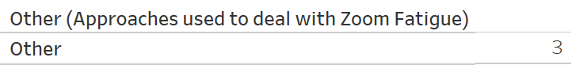

Figure 23: - Approaches used to deal with Zoom Fatigue

The students of Middlesex University, Dubai, were queried about how they cope with Zoom Fatigue within module classes in an online format. This question was only presented to those students who had selected their response as *Yes* in the initial question of whether they have experienced Zoom Fatigue, which contains 85 students. Furthermore, within this question, the students were given multiple choices regarding coping with Zoom Fatigue during online classes; each student's responses have been illustrated using separate bar charts. Of 85 students who have encountered Zoom Fatigue while attending online classes, a prominent figure of 59 students makes use of social platforms like Instagram, WhatsApp and other platforms to deal with Zoom Fatigue created by online classes and have selected the option of *Using social media platforms, such as Instagram, WhatsApp, and more*. The following highest figure of 45 responses contains students who have chosen the option of *Taking a break and speaking to someone in person*; this indicates that these students pause to take a break and meet another person face-to-face to cope with Zoom Fatigue created online classes. The following highest figure of 24 students has discerned that they take pause to take some amount of time and utilize this time to stay fit to minimize Zoom Fatigue arising out of online classes and have selected the choice *Taking a break and exercising*. The remaining two options, *Preventing multitasking* and *Other*,comprise the least number of student responses. At one end, 15 students deal with online classes creating Zoom Fatigue by avoiding multitasking, such as working on multiple assignments simultaneously; these students have selected the choice *Preventing multitasking*. On another end, only 3 students use other methods for coping with Zoom Fatigue created by online classes and have chosen the option *Other*. The alternative techniques suggested by students include hydration through eating and having salty or sugary foods, playing video games, and having good amounts of sleep.

**21. Course performance affecting mental health**

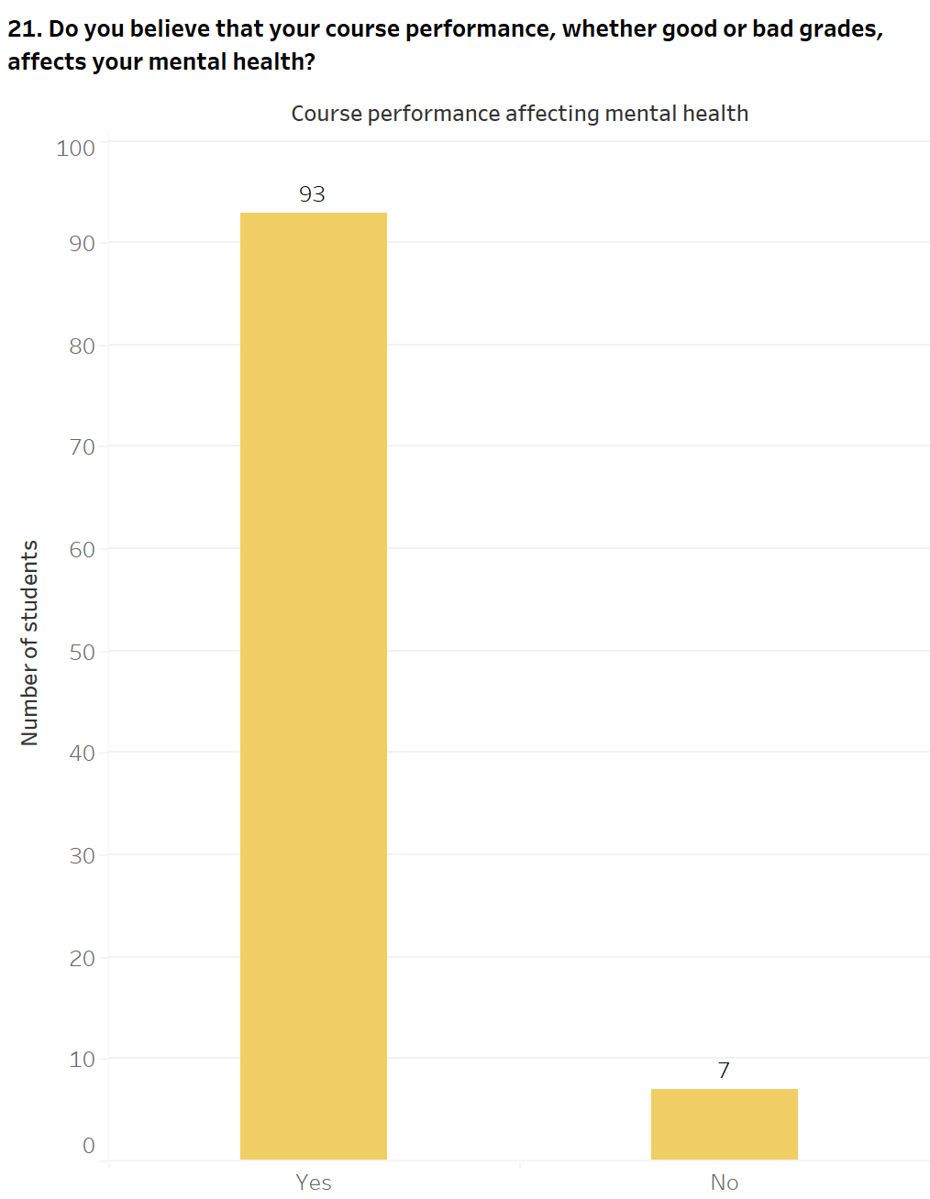

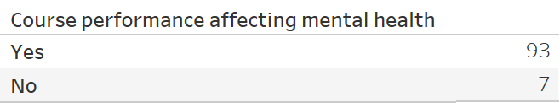

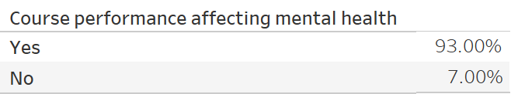

Figure 24: - Course performance affecting mental health

The students of Middlesex University, Dubai, were questioned whether their successful or unsuccessful performance in course modules impacts their mental health; this applies to a student attending his/her classes either in-person or on online learning platforms. This question has been depicted through a bar chart which reveals that out of 100 students who have participated in the survey, 93 (93%) students have selected the option of *Yes*, implying that course performance impacts their mental health. On the contrary, only 7 (7%) of students recognize that course performance affects their mental health and have selected their response as *No*.

**22. Difficulty in attaining a good grade through online learning platforms instead of traditional classes**

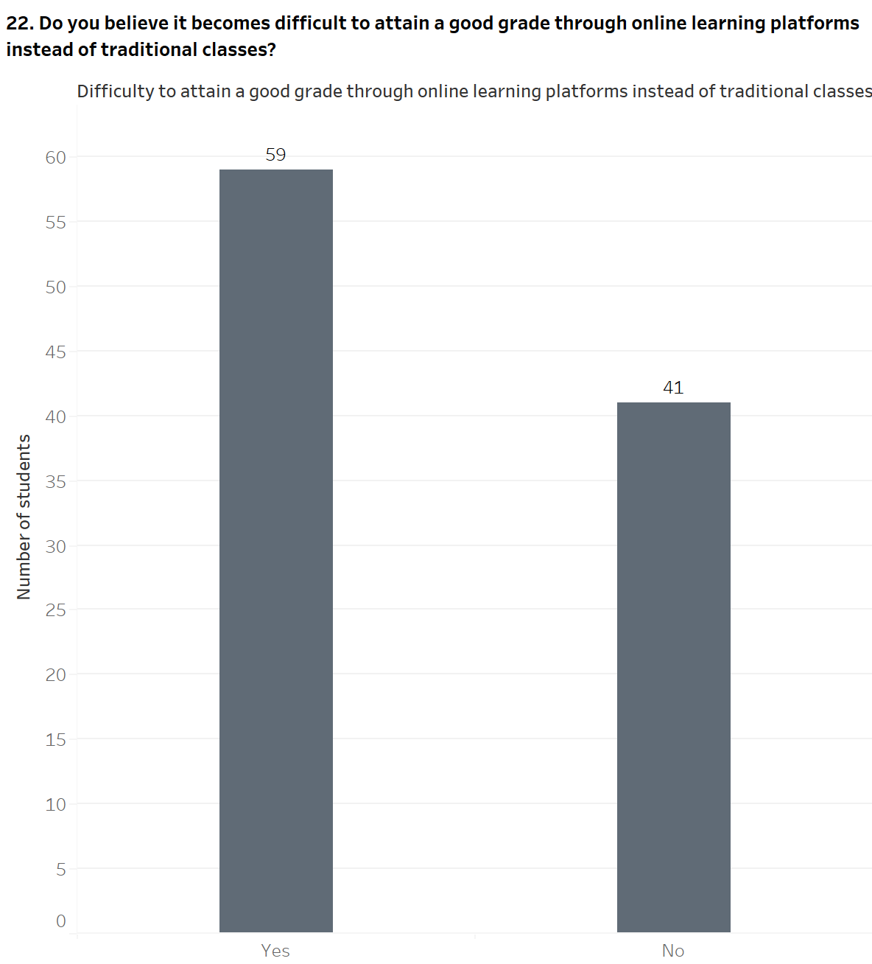





Figure 25: - Difficulty in attaining a good grade through online learning platforms instead of traditional classes

The students of Middlesex University, Dubai, were asked to reveal if they find it tough to score a good grade while studying through online learning platforms illustrated using a bar chart. Out of 100 students who have taken part in the survey, 59 (59.00%) students have recognized that it becomes challenging to achieve a good grade through online learning platforms and have selected the option of *Yes*. In contrast, 41 (41.00%) students have chosen the option of *No*, entailing that these students do not find it challenging to achieve a good grade by attending classes through online learning platforms.

**e. Student experiences with university and tutors**

**23. Relevant learning resources provided during online classes**

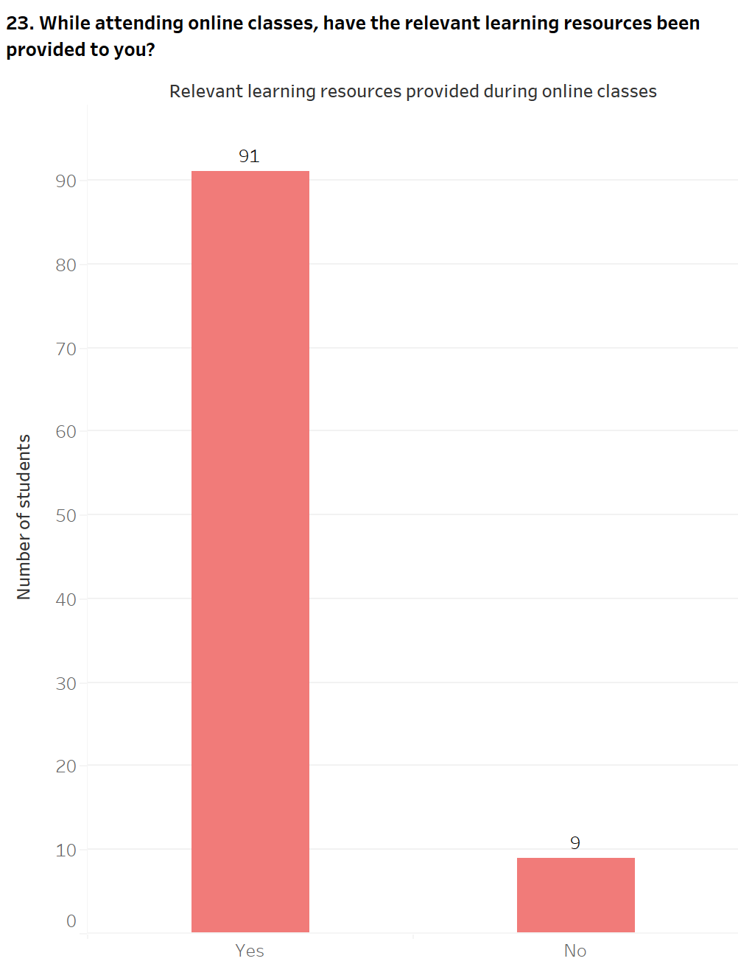

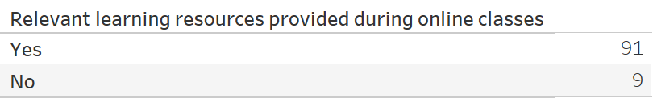

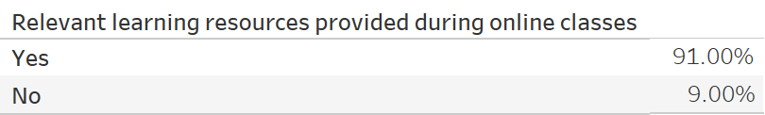

Figure 26: - Relevant learning resources provided during online classes

The students of Middlesex University, Dubai, were questioned if they had the necessary learning materials while attending module classes through online learning platforms and is represented through a bar chart. Of the 100 responses from the survey present in the bar chart, 91 (91.00%) students have divulged that they have been given the required resources while attending online classes and have selected the option of *Yes*. On the other hand, only 9 (9.00%) students have chosen option *No*; this means that these students have not been presented with a suitable amount of learning material while attending module classes through online learning platforms.

**24. Helpfulness of tutors while attending online classes**

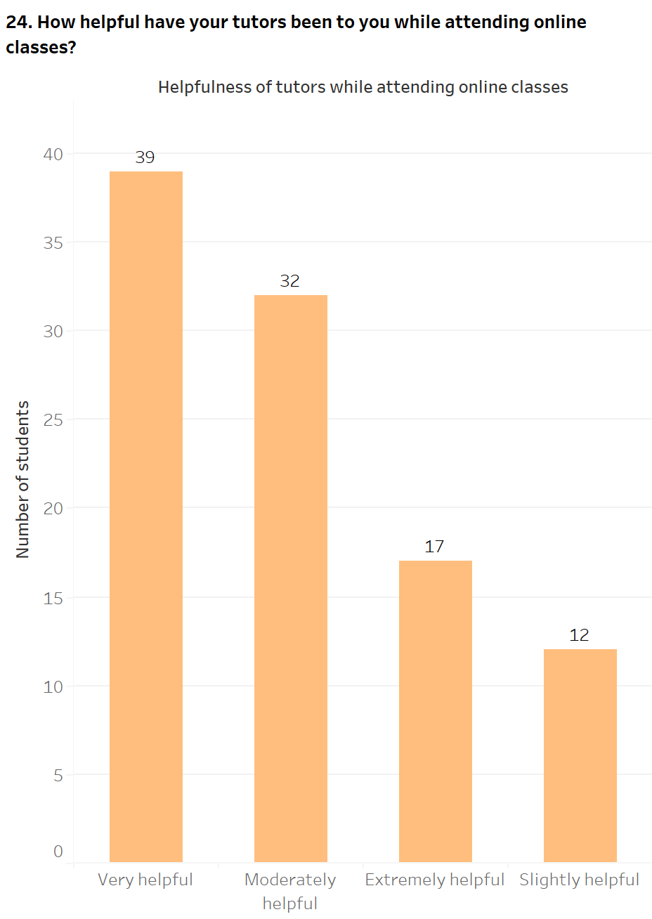

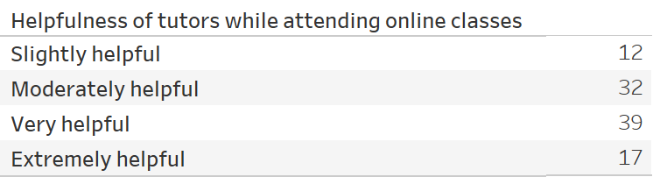

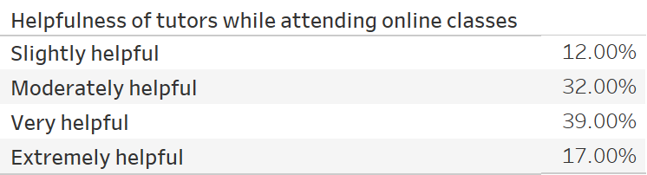

Figure 27: - Helpfulness of tutors while attending online classes

The students of Middlesex University, Dubai, were questioned about how supportive or cooperative the university tutors have been to them while attending module classes through online platforms. This has been illustrated through a bar chart; within 100 survey responses, 39 (39.00%) students believe that their module tutors have been very cooperative during online classes and have chosen the option of *Very helpful*. The following most prominent figure of 32 (32.00%) students have selected the option of *Moderately helpful*, entailing these students have found their module tutors reasonably cooperative while attending online classes. Moreover, 17 (17.00%) students believe that their module tutors have been hugely supportive through classes conducted on online platforms and have selected the option of *Extremely helpful*. Finally, 12 (12.00%) students have noted that their module tutors, to some degree, have been cooperative during online classes and have chosen the option of *Slightly helpful,* which represents the lowest figure of responses present within this question in the survey. This is due to no students selecting the option of *Not helpful at all*, implying that the module tutors have been cooperative with students while attending online classes in some form or another.

**25. One-to-one discussions with tutors for assignment feedback while attending online classes**

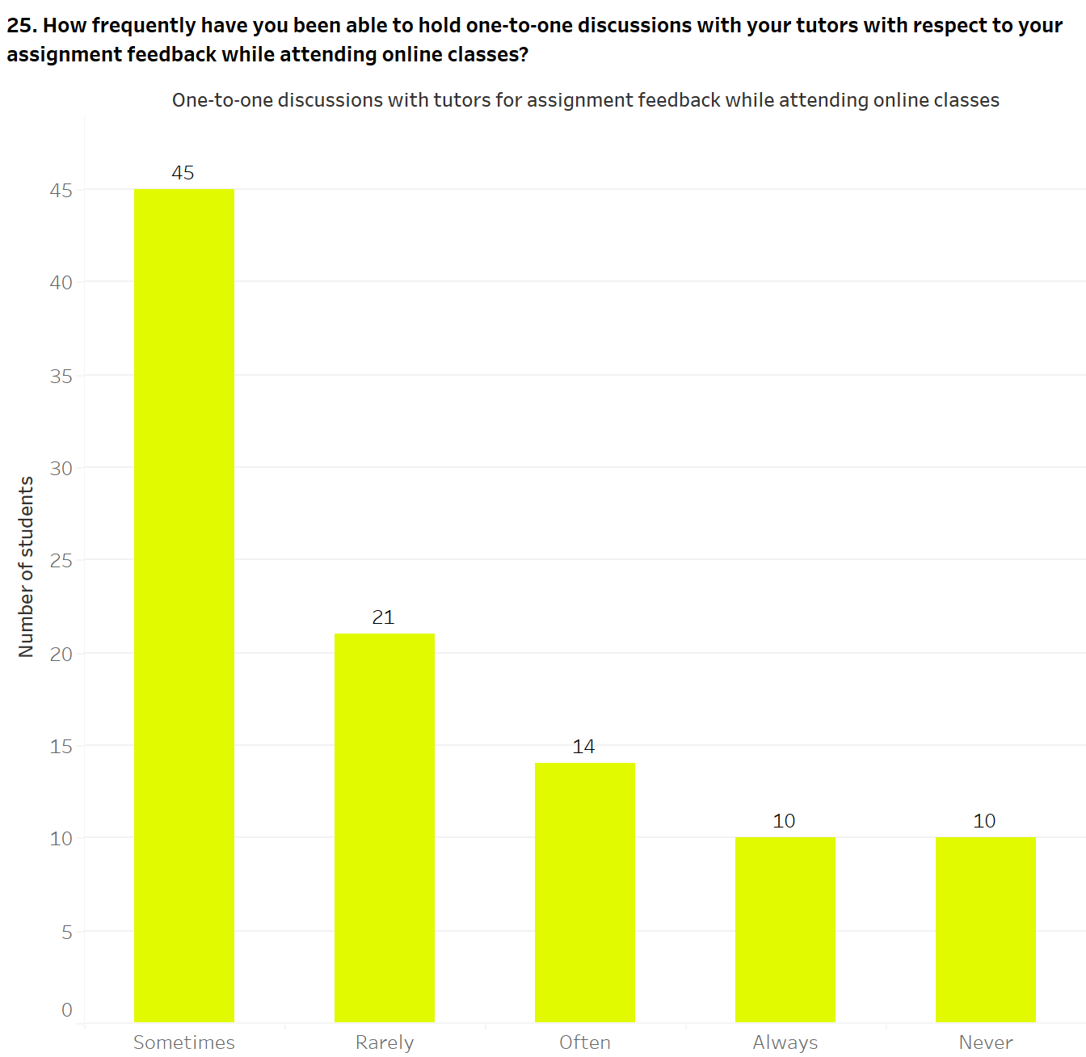

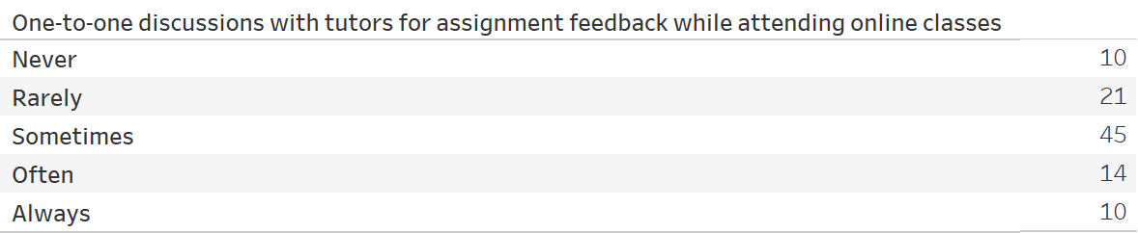

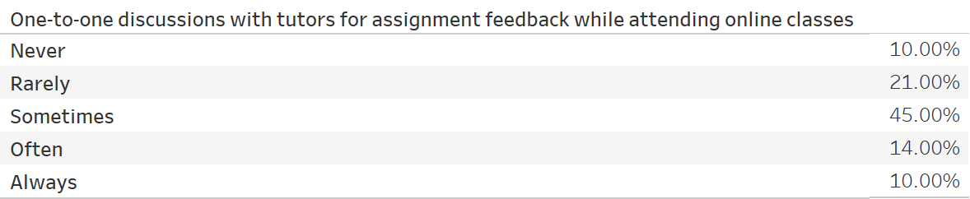

Figure 28: - One-to-one discussions with tutors for assignment feedback while attending online classes

The students of Middlesex University, Dubai, were asked to divulge whether they have attained individual feedback for module coursework based on the material taught by module tutors through classes conducted with online learning platforms and has been depicted using a bar chart. The bar chart reveals that out of 100 students who have taken part in the survey, a large number of 45 (45%) students have occasionally been able to take individual coursework feedback with their module tutors while attending online classes and have chosen the option *Sometimes*. The following high figure of 21 (21.00%) responses contain students who have selected the option of *Rarely*; these students have seldom been able to take individual feedback for coursework with their tutors. The remaining responses have comparable figures; 14 (14%) students have selected the option *Often*, entailing that they have generally been able to take individual coursework feedback with their tutors but have also missed a few feedbacks. The responses of *Always* and *Never* contain 10 (10%) students each, the former implying those students who have been able to take individual coursework feedback at all times while the latter signifies those students who have been unable to attain individual coursework feedback at any time.

**26. Online examinations held while utilizing online modes of education**

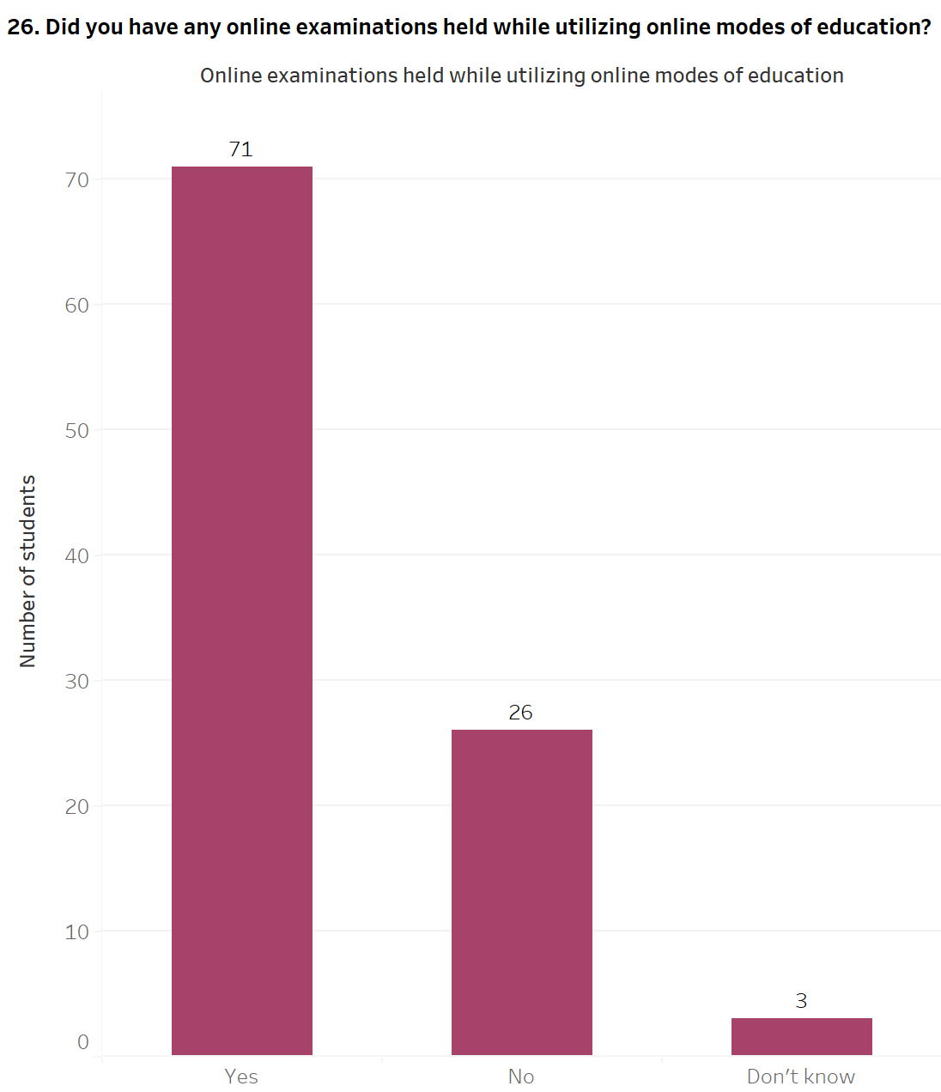

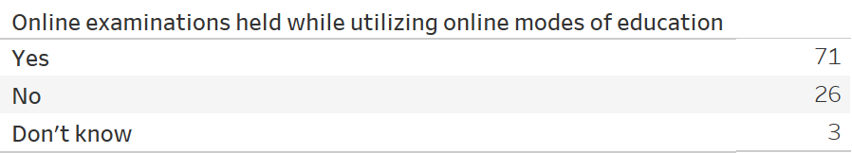

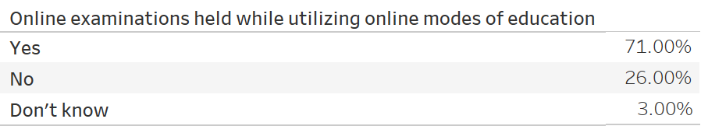

Figure 29: - Online examinations held while utilizing online modes of education

The students of Middlesex University, Dubai, were questioned if they had module examinations conducted using online learning platforms. This has been illustrated through a bar chart; within 100 survey responses, a large number of 71 (71.00%) students have specified that they have taken part in online examinations through online learning platforms and have selected the choice of *Yes*. On the contrary, 26 (26.00%) students have chosen the option of *No*; these students have not had online examinations through online modes of education. Finally, only 3 (3%) of students are unsure whether they have had online assessments through online learning platforms and have selected the option of *Don’t know*.

**27. Leniency of marking scale for students attending online classes**

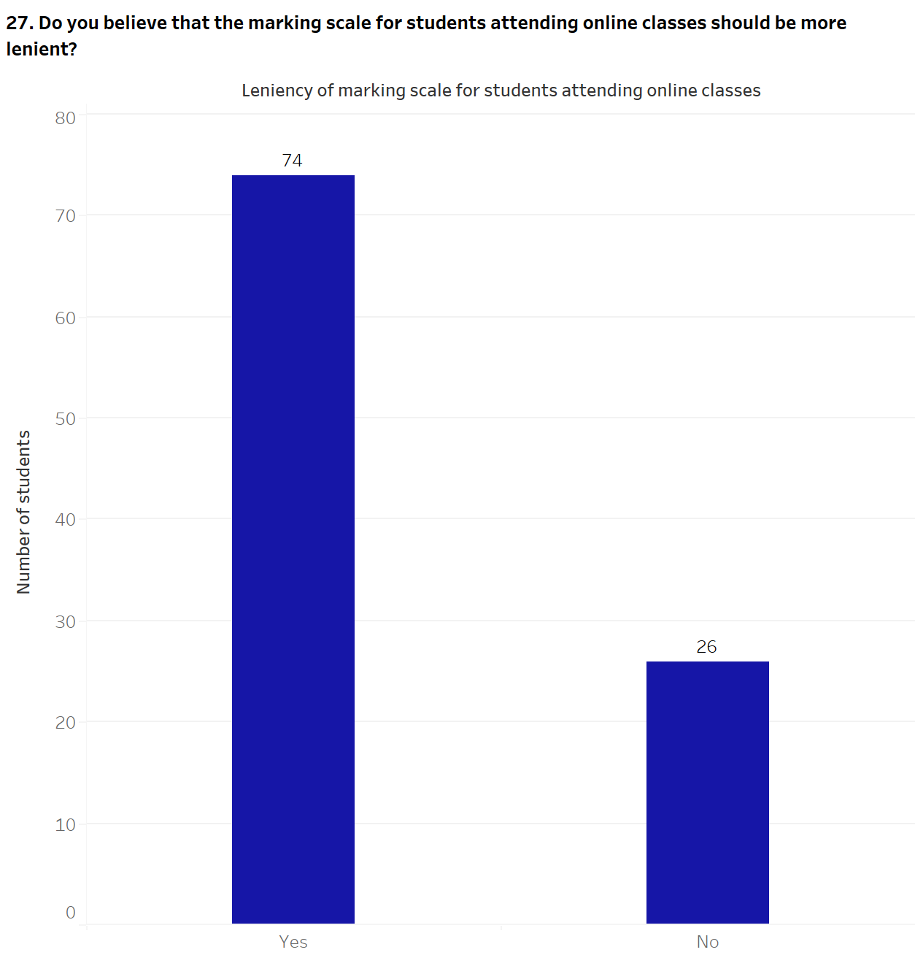

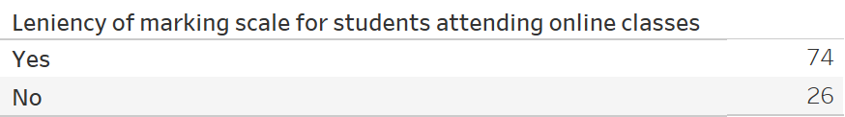

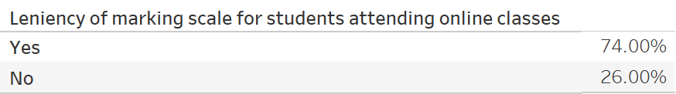

Figure 30: - Leniency of marking scale for students attending online classes

The students of Middlesex University, Dubai, were questioned whether the grading criteria for courseworks and examinations should be fair for students while attending module classes through online platforms and have been represented using a bar chart. The bar chart reveals that out of 100 students who have taken part in the survey, 74 (74.00%) students have selected the option of *Yes*, signifying that these students believe that the grading criteria for courseworks and examinations must be fair while attending online classes. On the other hand, 26 (26.00%) students have selected the option of *No*, entailing that the grading criteria for courseworks and assignments should not be fair and must be corrected more strictly for students while attending online classes.

**28. Online learning replacing traditional mode of classes**

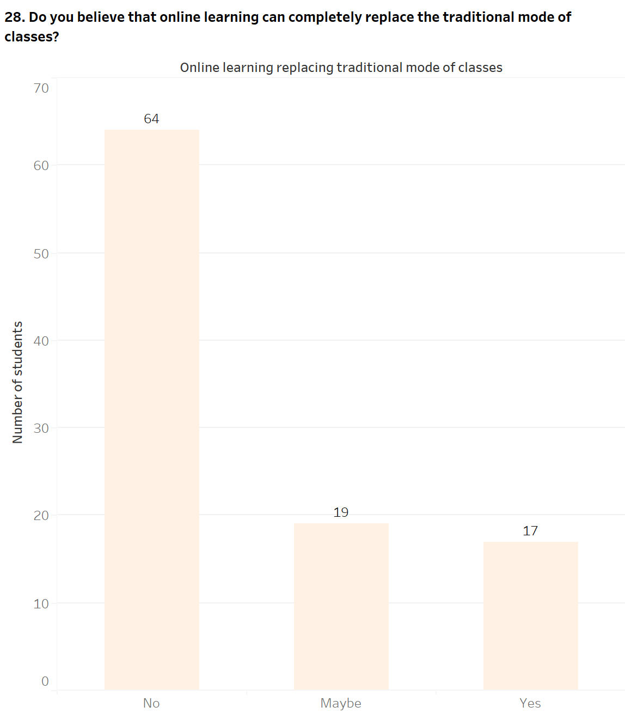

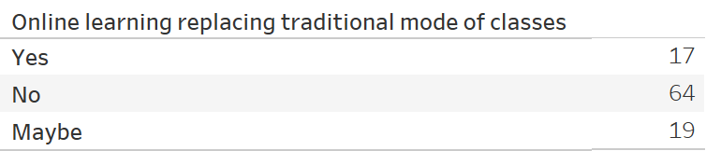

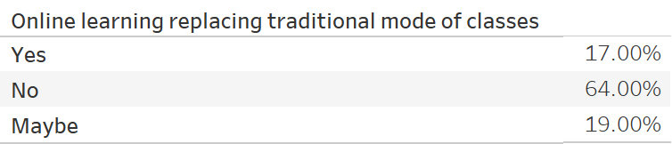

Figure 31: - Online learning replacing traditional mode of classes

The students of Middlesex University, Dubai, were asked to divulge if online learning could replace in-person classes in the upcoming years and has been depicted through a bar chart. Within the 100 responses present in the survey, a significant number of 64 (64%) students think that in-person classes cannot replace classes conducted through online learning platforms and have chosen the option of *No*. The remaining choices contain comparable figures; 19 (19%) students have selected the option of *Maybe*, implying that these students feel that online learning may or may not replace face-to-face classes. On the other hand, 17 (17%) students think that online learning will replace traditional classes and have chosen the option of *Yes*.

### 4.2.2. Further analysis and findings

**1. Relationship between mental health and year of study of students**

Figure 32: - Relationship between mental health and year of study of students

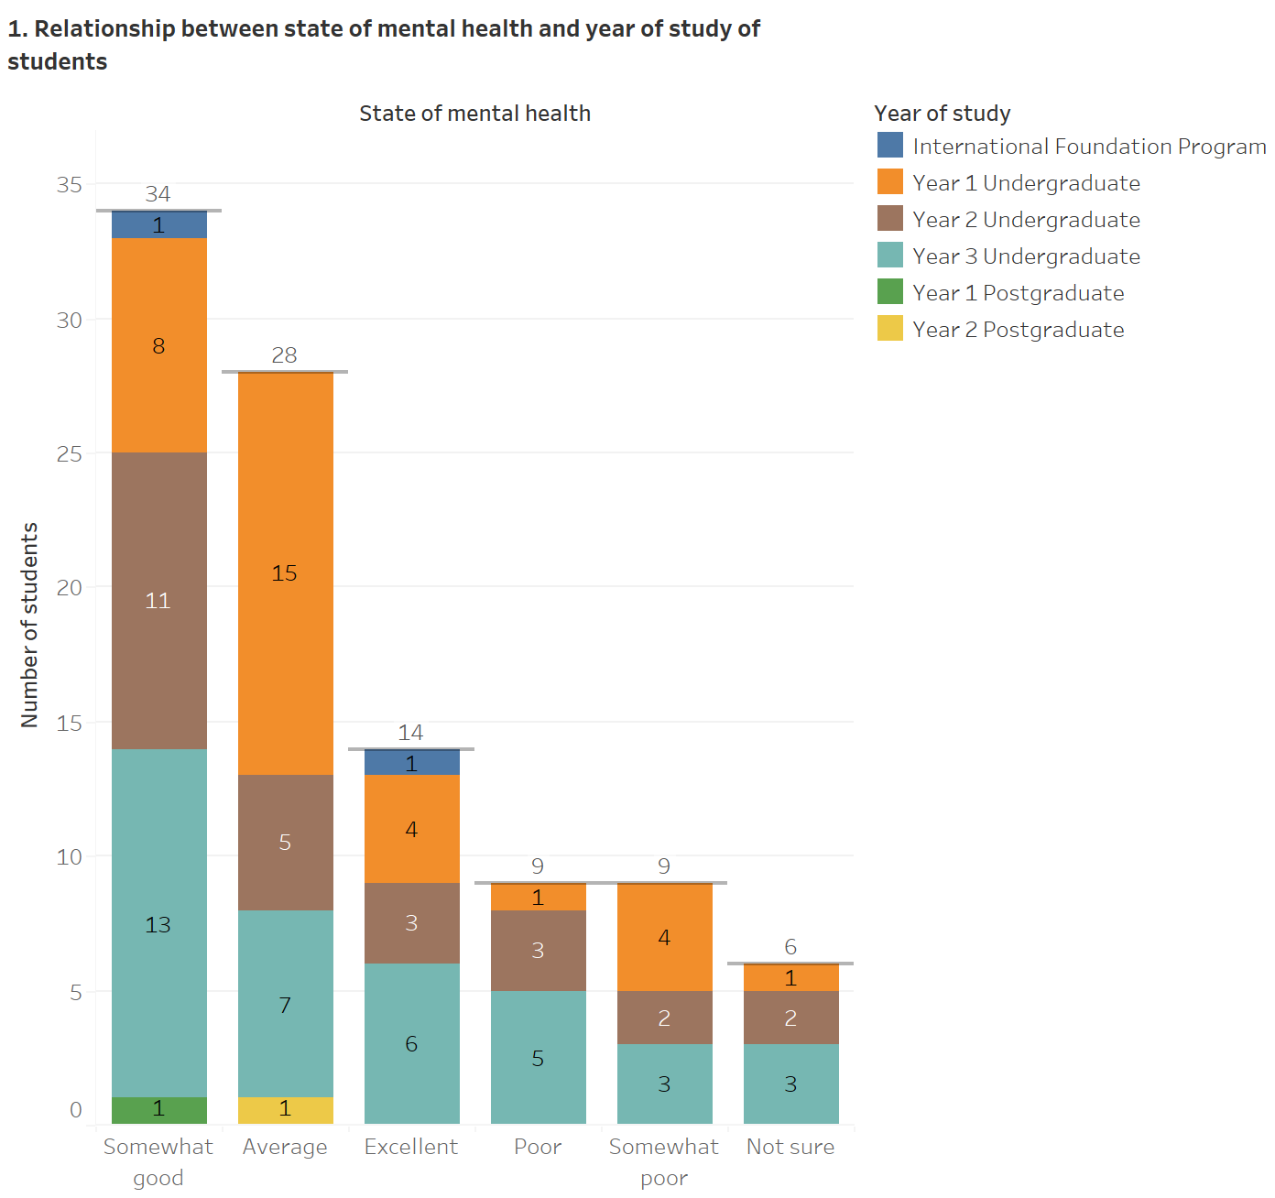

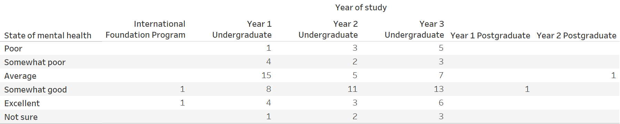

The students' mental health and year of study are compared to understand how the year of study generally impacts students’ mental health in their respective years of study while attending module classes, either in a physical or online session. A stacked bar chart has been created to understand the relationship between the year of study and the state of mental health of students. Within the bar chart, the X-axis represents the student’s mental health, classified into *Poor*, *Somewhat poor*, *Average*, *Somewhat good*, *Excellent,* and *Not sure*. On the other hand, the Y-axis represents the number of students studying in different years, i.e., *International Foundation Program*, *Year 1 Undergraduate*, *Year 2 Undergraduate*, *Year 3 Undergraduate*, *Year 1 Postgraduate,* and *Year 2 Postgraduate*. Each color of the stacked bar chart depicts the student’s year of study.

Upon analyzing the 100 survey responses of students, it has been found that a prominent figure of 34 students has stated that their mental health is marginally positive by selecting the option *Somewhat good*. Within this response, third-year undergraduate students contain 13 responses, followed by second-year undergraduate students comprising 11 responses and first-year undergraduate students having 8 students*.* Both foundation and first-year postgraduate programs contain 1 student; these students believe that their mental health is relatively positive. There are no responses from second-year postgraduate students belonging to the category *Somewhat good.*

On the contrary, barring the 6 students unaware of their level of mental health by choosing the option *Not sure*, students who have rated their mental health as either relatively bad, i.e., *Somewhat poor,* or below par, i.e., *Poor* comprises only 9 students each. From the perspective of students who have described their mental health as *Somewhat poor*, first-year undergraduate students include 4 responses, followed by third-year undergraduatestudents, which comprises 3 responses, and second-year undergraduate students, which contain 2 responses. From the perspective of students who have rated their mental health as *Poor*, there are 5 students in third-year undergraduate, followed by 3 students in their second-year undergraduate studies and only 1 third-year undergraduate student. Additionally, the options of *Somewhat poor* and *Poor* comprise no responses from foundation program and postgraduate students.

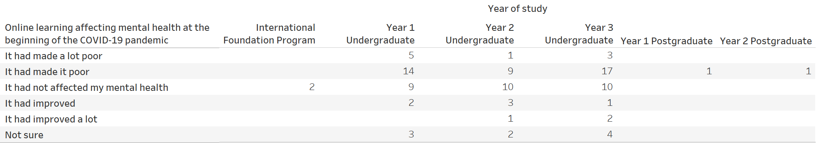**2. Relationship between online learning affecting mental health at the beginning of the COVID-19 pandemic and year of study of students**

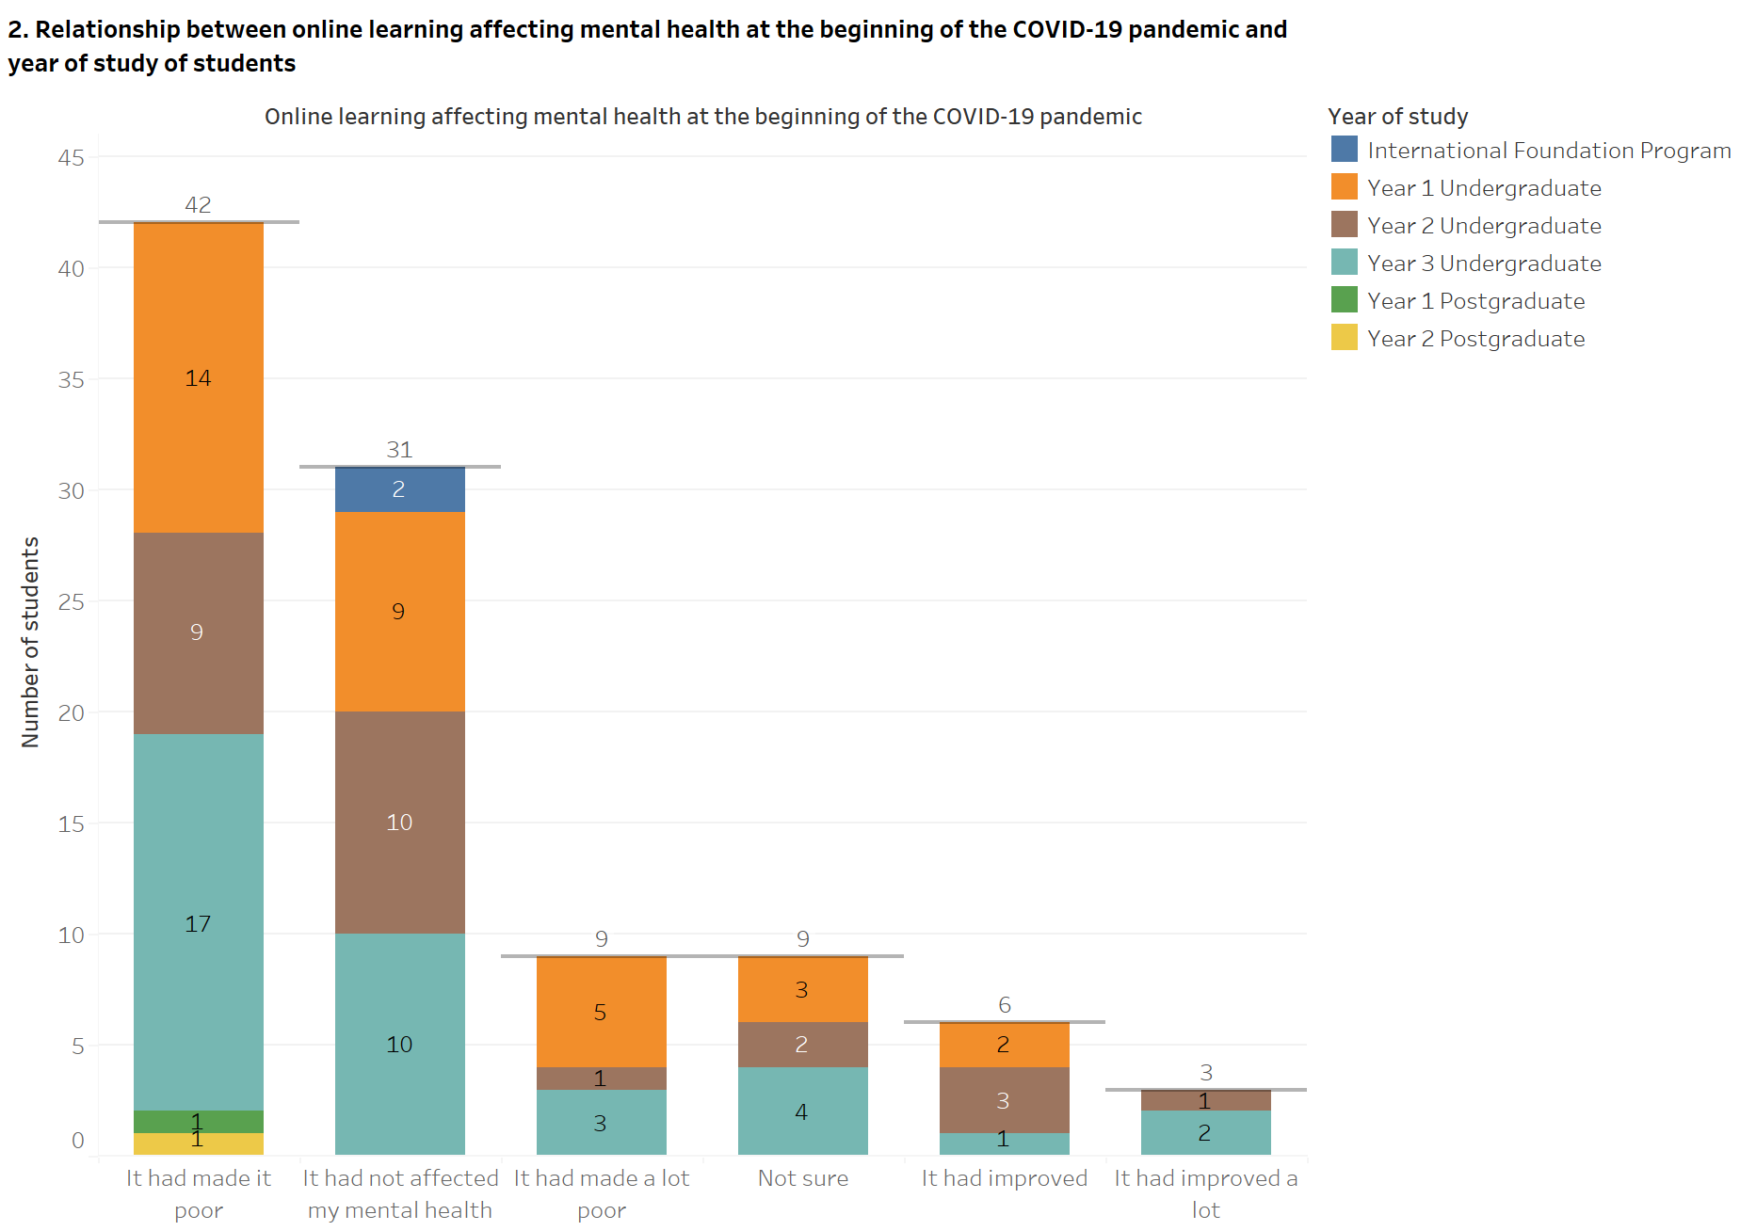

Figure 33: - Relationship between online learning affecting mental health at the beginning of the COVID-19 pandemic and year of study of students

At the beginning of the COVID-19 pandemic, the student’s mental health may or may not have been affected by using online learning platforms for an extended period. This element has been compared with the student’s year of study; however, as previously stated, foundational program and first-year undergraduate students may not have been part of Middlesex University, Dubai, at the start of the COVID-19 pandemic. As a result, the student's experiences with online learning in their high school have been considered in this situation. The effect of online learning on mental health during the COVID-19 pandemic and students' years of study has been compared using a stacked bar chart. The X-axis of the stacked bar chart depicts the student responses to online learning impacting their mental health; the responses are split into *It had made it a lot poor*, *It had made it poor*, *It had not affected my mental health*, *It had improved*, *It had improved a lot* and *Not sure*. The Y-axis of the stacked bar chart represents the number of students in different years of study, i.e., *International Foundation Program*, *Year 1 Undergraduate*, *Year 2 Undergraduate*, *Year 3 Undergraduate*, *Year 1 Postgraduate,* and *Year 2 Postgraduate*. Each color of the stacked bar chart represents the student’s year of study.

Out of 100 responses present in the survey, a large number of 42 students have revealed that online learning made their mental bad at the start of the COVID-19 pandemic by selecting the choice of *It had made it poor*. Within these 42 responses, 17 third-year undergraduate students believe that online learning negatively impacted their mental health. This is followed by 14 first-year undergraduate students and 9 second-year undergraduate students whose mental health had been badly affected by online learning at the beginning of the COVID-19 pandemic. The least number of responses are from first-year and second-year postgraduate students,with only a single response each. No foundation program student has chosen the option of *It had made it poor*.

On the contrary, only 3 students selected the choice of *It had improved a lot*, implying that online learning improved their mental health at the start of the COVID-19 pandemic. This is due to no response from foundation program students, first-year undergraduate students, and postgraduate students. However, there are 2 students in their third-year undergraduate studies recognizing that online learning had improved their mental health more positively at the start of the COVID-19 pandemic. Finally, only a solitary second-year undergraduate student discerned that online learning had improved her mental health at the beginning of the COVID-19 pandemic.

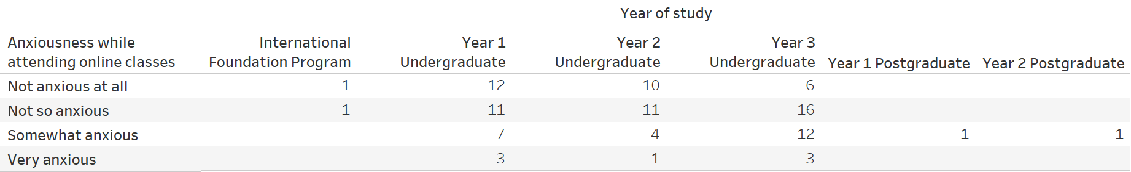**3. Relationship between anxiousness while attending online classes and year of study of students**

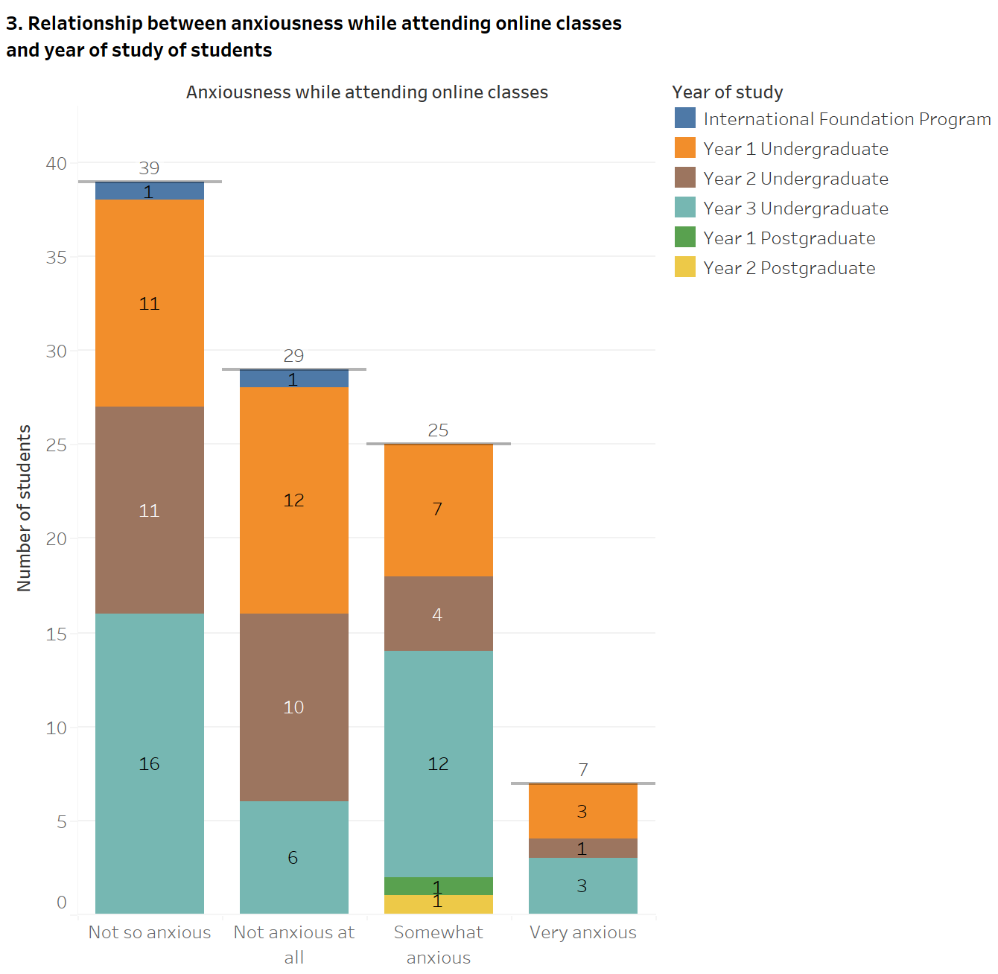

Figure 34: - Relationship between anxiousness while attending online classes and year of study of students

The anxiousness felt by students during online classes and the year of study are compared to find out whether the students in their particular year of study have been facing struggling with stress during online sessions of modules. A stacked bar chart has been created to determine the relationship between anxiousness created by online learning and students' year of study. Within the stacked bar chart, the X-axis depicts the student responses of anxiousness created by online classes split into *Very anxious*, *Somewhat anxious*, *Not so anxious,* and *Not anxious at all*. The Y-axis of the stacked bar chart depicts the number of students who are pursuing a course in different years of study, i.e., *International Foundation Program*, *Year 1 Undergraduate*, *Year 2 Undergraduate*, *Year 3 Undergraduate*, *Year 1 Postgraduate,* and *Year 2 Postgraduate*. Each color of the stacked bar chart represents the student’s year of study.

Within the 100 responses present in the survey, 39 students believe that online classes do not cause much restlessness and have selected the option of *Not so anxious*. Of these 39 students, there are no responses from first-year and second-year postgraduate students, the most significant being from third-year undergraduate students with 16 responses. This is followed by 11 responses each by first-year and second-year undergraduate students who face anxiousness from online classes. Only a solitary foundational program student has hardly felt restless while attending online classes.

On the other hand, out of the 100 survey responses, the least number of responses come from students who have selected the option of *Very anxious*, which contains 7 students. These students feel highly restless while attending online classes. While there are no responses from the foundational program students and both first-year and second-year postgraduate students, both first-year and third-year undergraduate students contain 3 responses each. Only a single second-year undergraduate student believes that online learning has created high anxiety. The choice of *Very anxious* includes no responses from foundational program students and first-year and second-year postgraduate students.

**4. Relationship between regular attendance during online sessions and year of study of students**

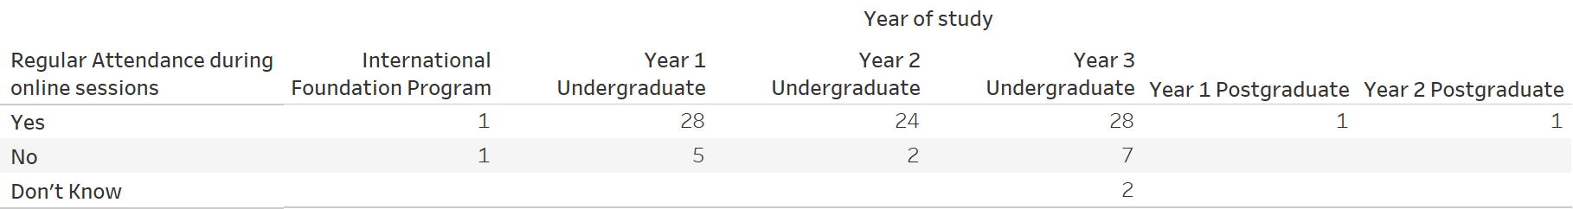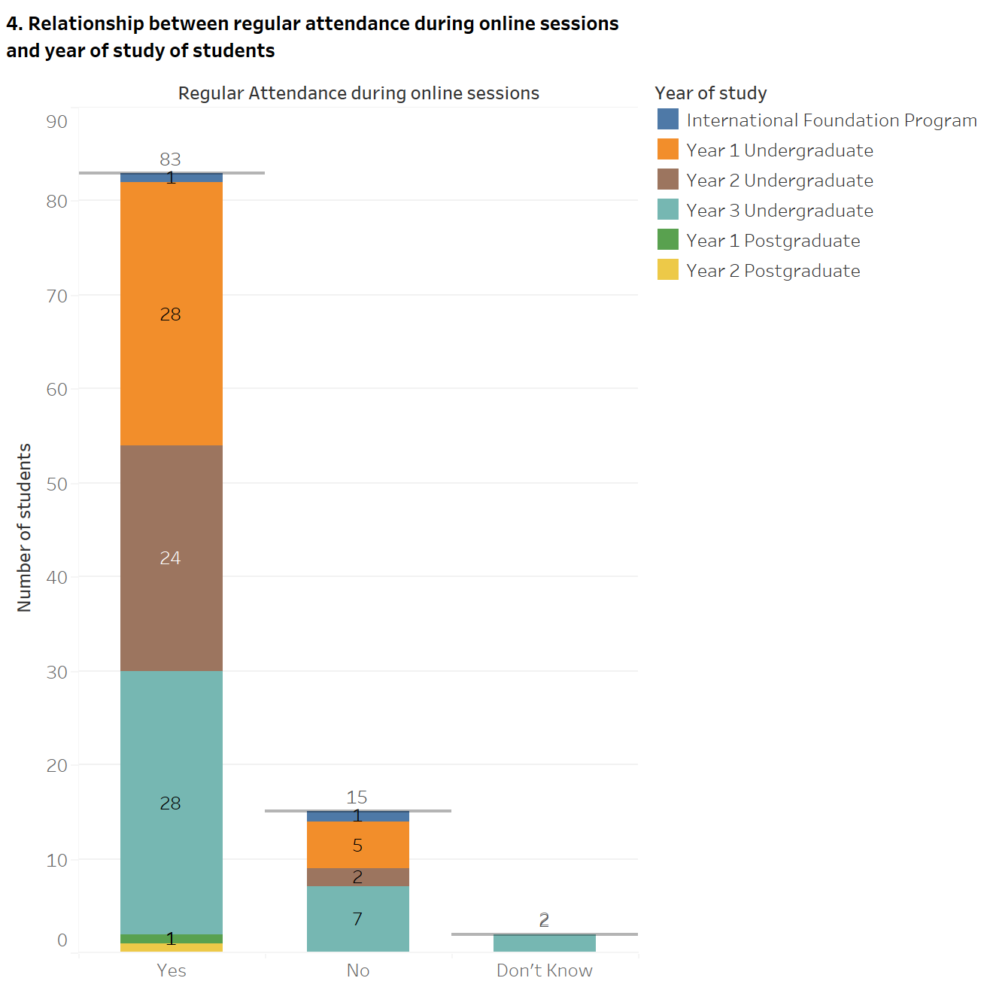

Figure 35: - Relationship between regular attendance during online sessions and year of study of students

The regular attendance of students and their year of study have been compared to determine whether students have been able to attend module classes through online platforms consistently. A stacked bar chart has been created to comprehend the relationship between the regular attendance of students and their year of study. The X-axis depicts the student responses to their regular attendance within the stacked bar chart, broken down into *Yes*, *No,* and *Don’t Know*. On the other hand, the Y-axis of the stacked bar chart illustrates the number of students in the various year of study, divided into *International Foundation Program*, *Year 1 Undergraduate*, *Year 2 Undergraduate*, *Year 3 Undergraduate*, *Year 1 Postgraduate,* and *Year 2 Postgraduate*. Each color of the stacked bar chart shows the student’s year of study.

Of the 100 students who have participated in the survey, a significant figure of 83 students have been able to attend in online classes regularly and have selected the response *Yes*. Out of these 83 students, 28 students are in their first-year and third-year undergraduate programs. These responses are comparable to 24 second-year undergraduate students who have been able to attend online classes continuously. The remaining students in their foundation year and first-year and second-year postgraduate programs comprise 1 student each, who have regularly attended their online classes.

Excluding the responses of students who are not aware of whether they have regularly taken part in online classes by selecting the option *Don’t Know*, only 15 students have not been able to attend their module classes through online platforms regularly. Of 15 students choosing option the *No*, a comparable figure exists among students in their third-year undergraduate and first-year undergraduate program, with 7 and 5 students, respectively, who have not been able to attend classes regularly. Similarly, the figures for second-year undergraduate and foundation program studentswho have not been able to attend online classesare comparable, with 2 and 1 students, respectively. The choice of *No* contains no responses from both first-year and second-year postgraduate students.

**5. Relationship between Zoom Fatigue and year of study of students**

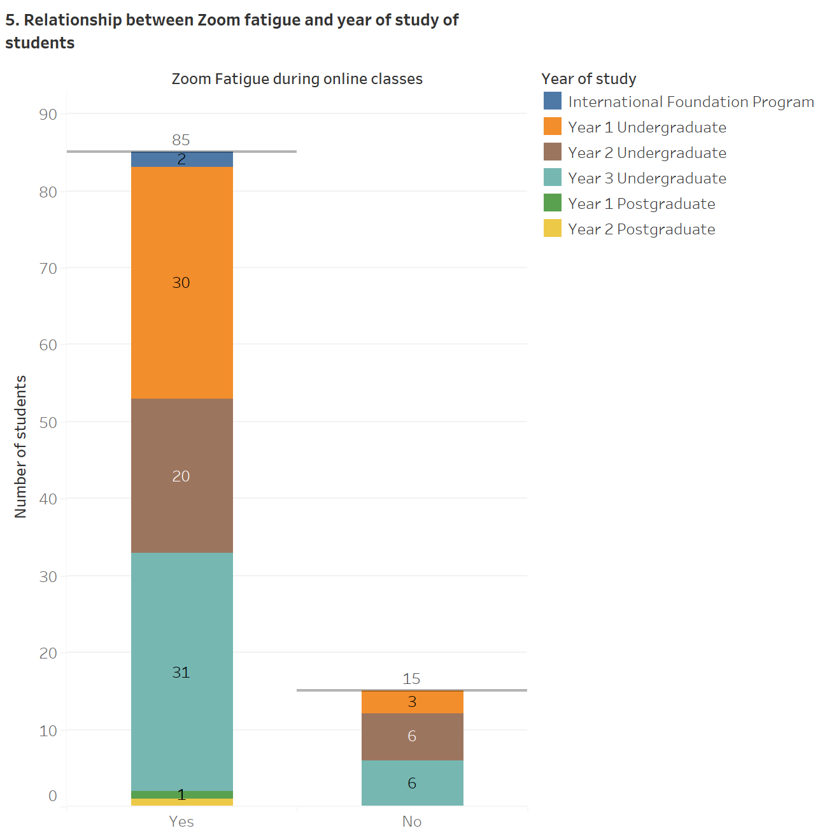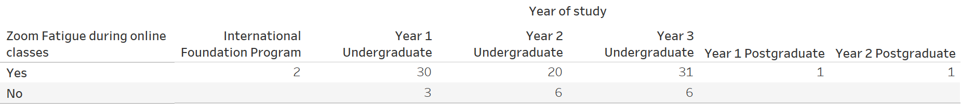

Figure 36: - Relationship between Zoom Fatigue and year of study of students

The students’ experiences with Zoom Fatigue and their respective years of study are compared to comprehend if they have been viewing screens for an extended period as the level of academic difficulty increases, primarily from the transition of education from the foundation program to the 3rd year of undergraduate studies. A stacked bar chart has been created to understand the relationship between Zoom Fatigue and the year of study, with the X-axis depicting the responses of Zoom Fatigue as *Yes* and *No*. The Y-axis of the stacked bar chart illustrates the number of students in different years of study, i.e., *International Foundation Program*, *Year 1 Undergraduate*, *Year 2 Undergraduate*, *Year 3 Undergraduate*, *Year 1 Postgraduate,* and *Year 2 Postgraduate*. Each color of the stacked bar chart depicts the student’s year of study.

Out of 100 students who have taken part in the survey, a significant figure of 85 students believes that they encounter Zoom fatigue while attending classes online and have chosen their responses as *Yes*. Out of these 85 responses, the highest number of students who have experienced Zoom Fatigue are in their third-year undergraduate and first-year undergraduate programs, with 31 and 30 responses, respectively. Moreover, 20 second-year undergraduate students encounter Zoom Fatigue while attending online classes. The other students facing Zoom Fatigue are in their foundational studies comprising of 2 responses. Additionally, both first-year and second-year postgraduate students containa single response each.

On the contrary, within the 100 survey responses, the least number of 15 students have selected the choice as *No*, implying that they have not experienced Zoom Fatigue during online learning. While none of the foundation program and postgraduate students have chosen the option of *No*, both second-year undergraduate students and third-year undergraduate students comprise 6 responses each within this option. On the other hand, a sole first-year undergraduate student has not encountered Zoom Fatigue while attending online classes.

### 4.2.3. Implementation of dashboard and story

A dashboard and story have been created using Tableau based on the further analysis and findings explained in the previous section that has been carried out to understand how various mental health aspects affect students’ mental health in their respective years of study. A dashboard refers to the visual presentation of the most critical information required to attain one or more objectives; integrated and arranged on a solitary screen to monitor the information at a glance (Few, 2007). Rahman, Adamu and Harun (2017) have stated that a dashboard is a way to visualize the data collected from an organization's activity. This information can be quickly delivered to the user, thus empowering them to make fundamental decisions. Every dashboard aspires to tell a story by providing a clear picture of a specific set of information (Milligan, 2015). Before creating a dashboard, it is essential to comprehend what story the data tells; the way the story is told revolves around various factors, including the audience, how the audience would access the dashboard, and what response is to be obtained from the audience.

As part of the visualizing how online learning impacts the mental health of students at Middlesex University, Dubai, during the COVID-19 pandemic, the primary objective of creating the dashboard and dashboard story is to enable any user, irrespective of whether they have a technical background or not, to quickly understand the critical insights of how students, in their respective years of study, have been affected by numerous aspects of online learning during the COVID-19 pandemic. The dashboard and story were tested with two users, which showed successful results in all the testing processes. Within the dashboard and dashboard story, each of the five aspects of student’s mental health compared with the student’s year of study, as previously done in the section on the further analysis and findings, have been described by the following points: -

1. The mental health of students in their respective years of study
2. Online learning impacting student's mental health at the start of the COVID-19 pandemic in their respective years of study
3. The anxiousness faced by students while attending online classes in their respective years of study
4. The level of attendance of students during online classes in their respective years of study
5. Zoom Fatigue encountered by students while using online learning platforms in their respective years of study

#### 4.2.3.1. Components of the dashboard

The survey analysis dashboard comprises five separate pages containing the above five analyses of online learning affecting students' mental health, enabling users to move from one analysis sheet to another. Within these dashboards, the users are presented with filters that can be checked or unchecked based on what they wish to ascertain within the organized data of the stacked bar charts. Each of these sheets present in the survey analysis dashboard has been described by the following points: -

1. 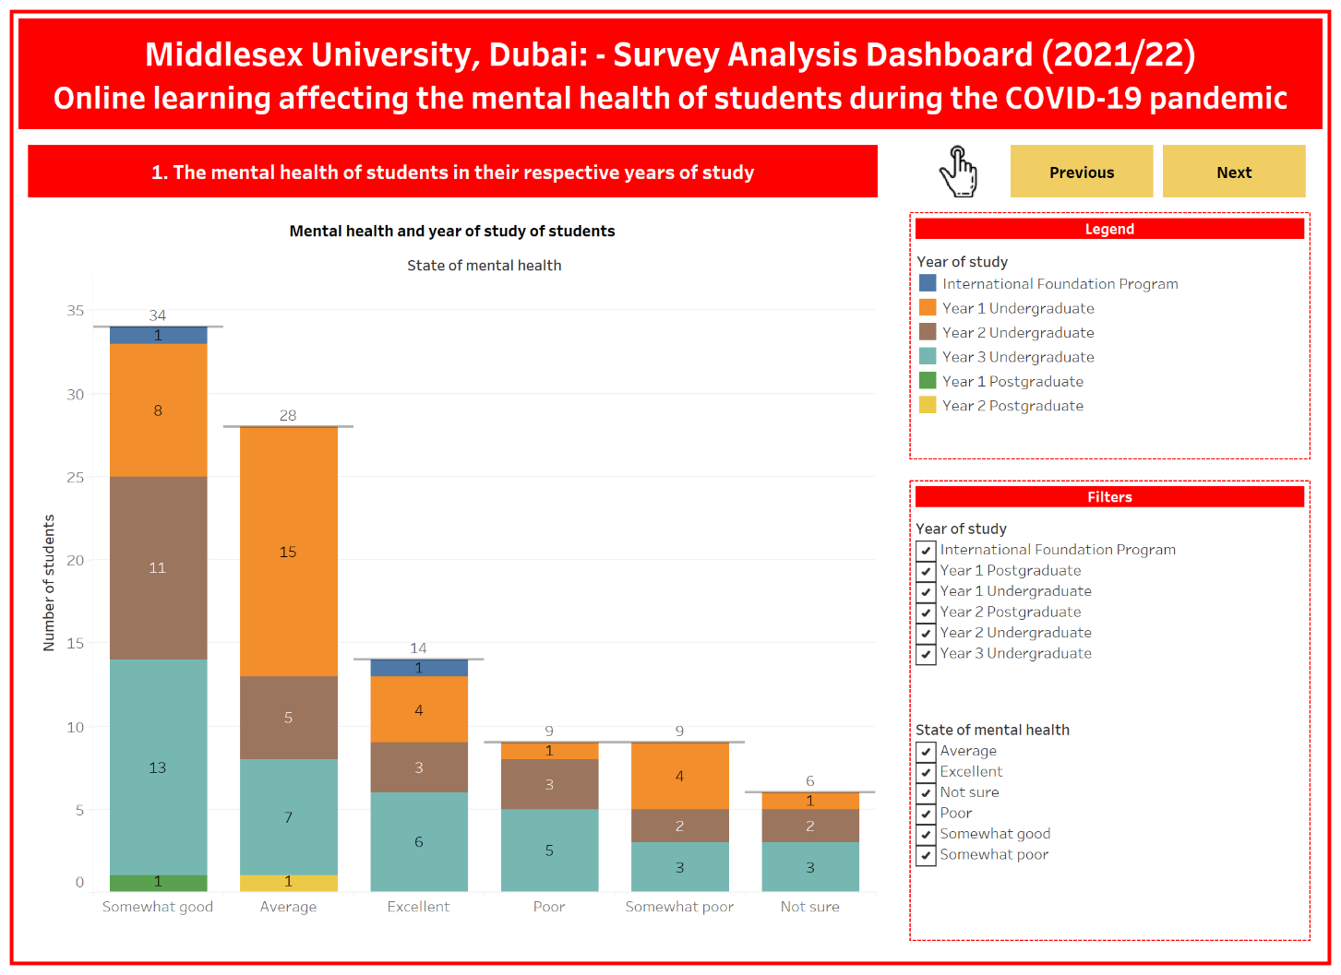**The mental health of students in their respective years of study: -** The first sheet of the survey analysis dashboard allows discovering the student's state of mental health at the time of participating in the survey in numerous years of study at Middlesex University, Dubai. Within this sheet of the dashboard containing an overall figure of 100 students, the highest number of responses are present in the option of *Somewhat good*, comprising 34 students. On the other hand, excluding 6 students who have selected the choice of *Not sure*, only 9 students are present in the options of *Somewhat poor* or *Poor*.

Figure 37: - Survey Analysis Dashboard (Sheet 1)

1. **Online learning impacting student's mental health at the start of the COVID-19 pandemic in their respective years of study: -** The second sheet of the survey analysis dashboard enables to comprehend whether online learning had impacted students’ mental health when educational institutions, including Middlesex University, Dubai, were forced to utilize online learning platforms at the beginning of the COVID-19 pandemic. Out of 100 students present in this sheet of the survey analysis dashboard, a prominent number of 42 students have selected the choice of *It had made it poor*. In contrast, only 3 students have chosen the option of *It had improved a lot*.
2. **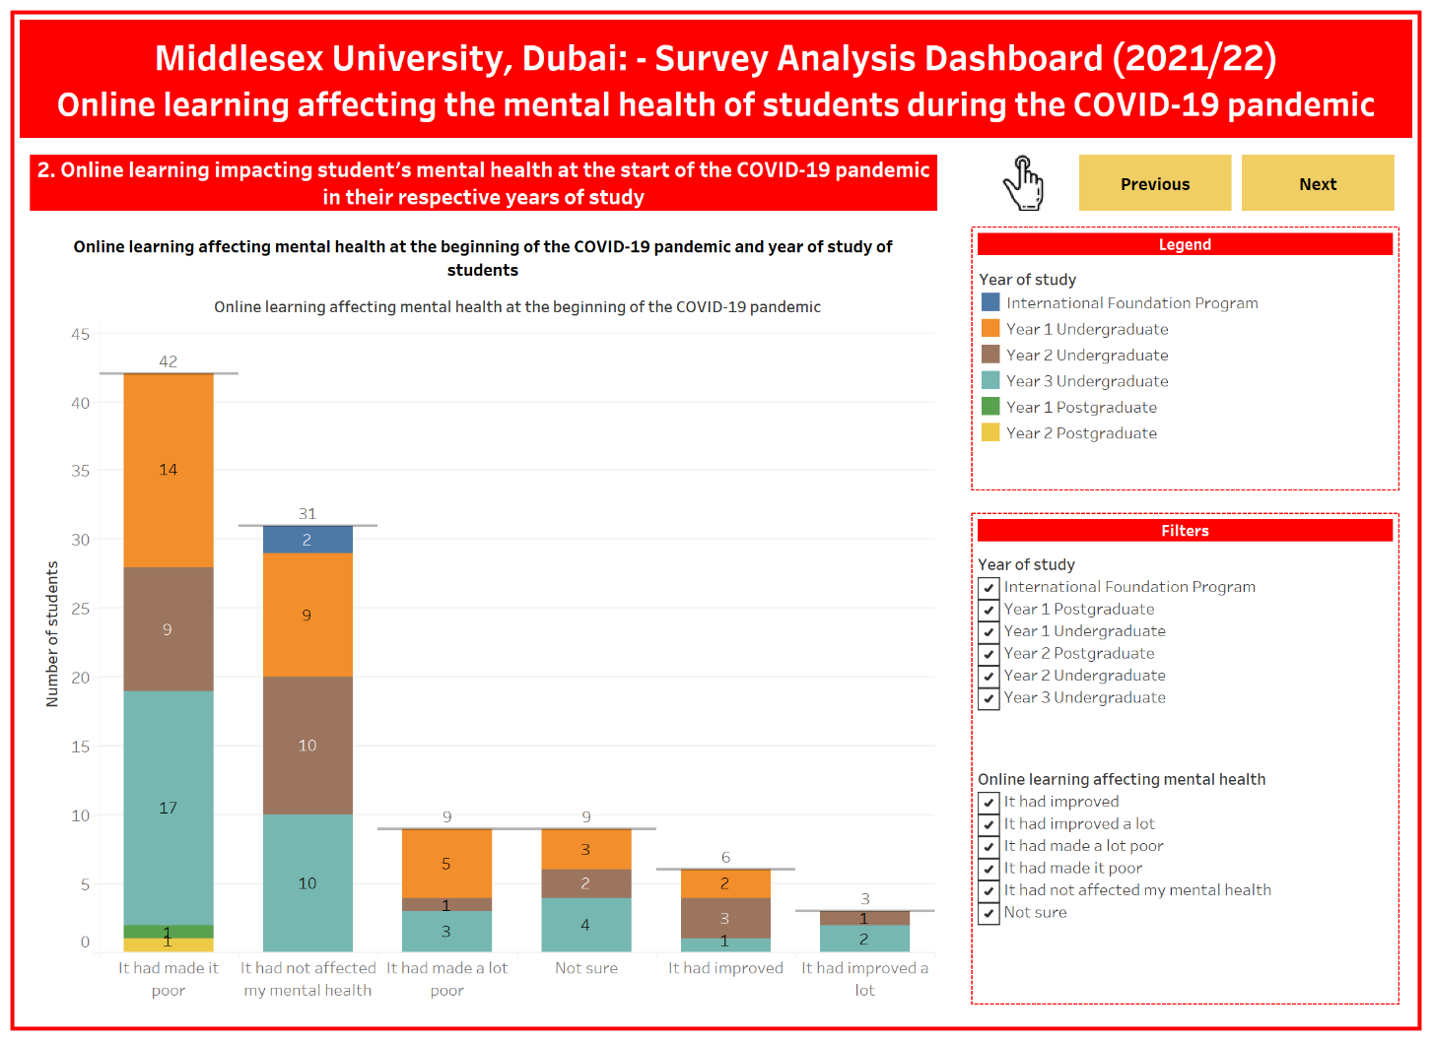The anxiousness faced by students while attending online classes in their respective years of study: -** The third sheet of the survey analysis dashboard empowers in discovering the anxiousness among students at Middlesex University, Dubai, in different years of study while attending online classes of modules. Of 100 students present in this sheet of the survey analysis dashboard, 39 students have chosen the choice of *Not so anxious*. On the contrary, the lowest number of responses are present in the option of *Very anxious*, comprising only 7 students.

Figure 38: - Survey Analysis Dashboard (Sheet 2)

1. 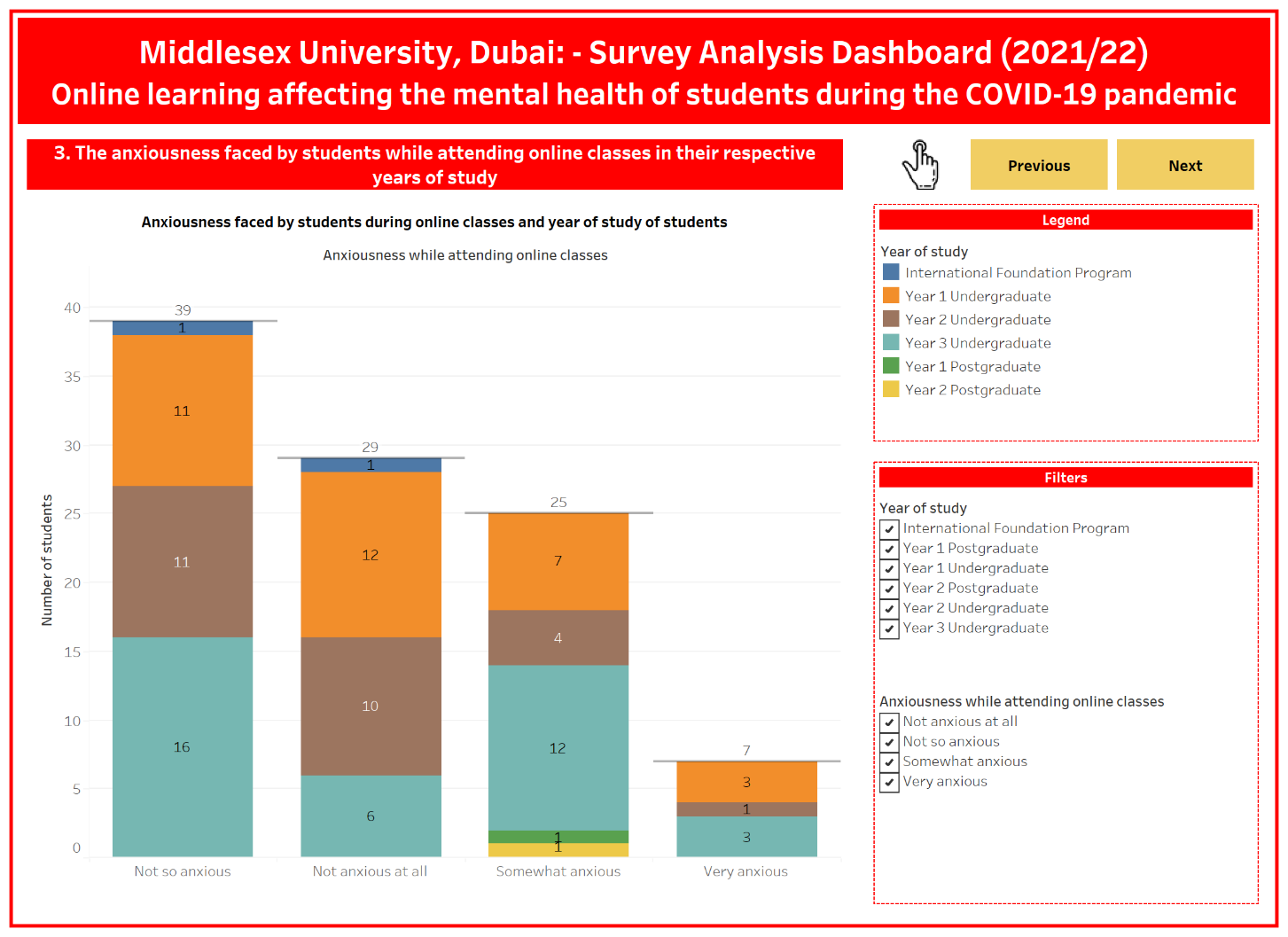**The level of attendance of students during online classes in their respective years of study: -** The fourth sheet of the survey analysis dashboard facilitates an understanding of whether the students of Middlesex University, Dubai, have consistently taken part in online classes of modules. Within this sheet of 100 student responses from whom the data has been collected, a substantial number of 83 students have chosen the option of *Yes,* 15 students have selected the choice of *No,* and only 2 students have chosen the option of *Don’t Know*.

Figure 39: - Survey Analysis Dashboard (Sheet 3)

1. 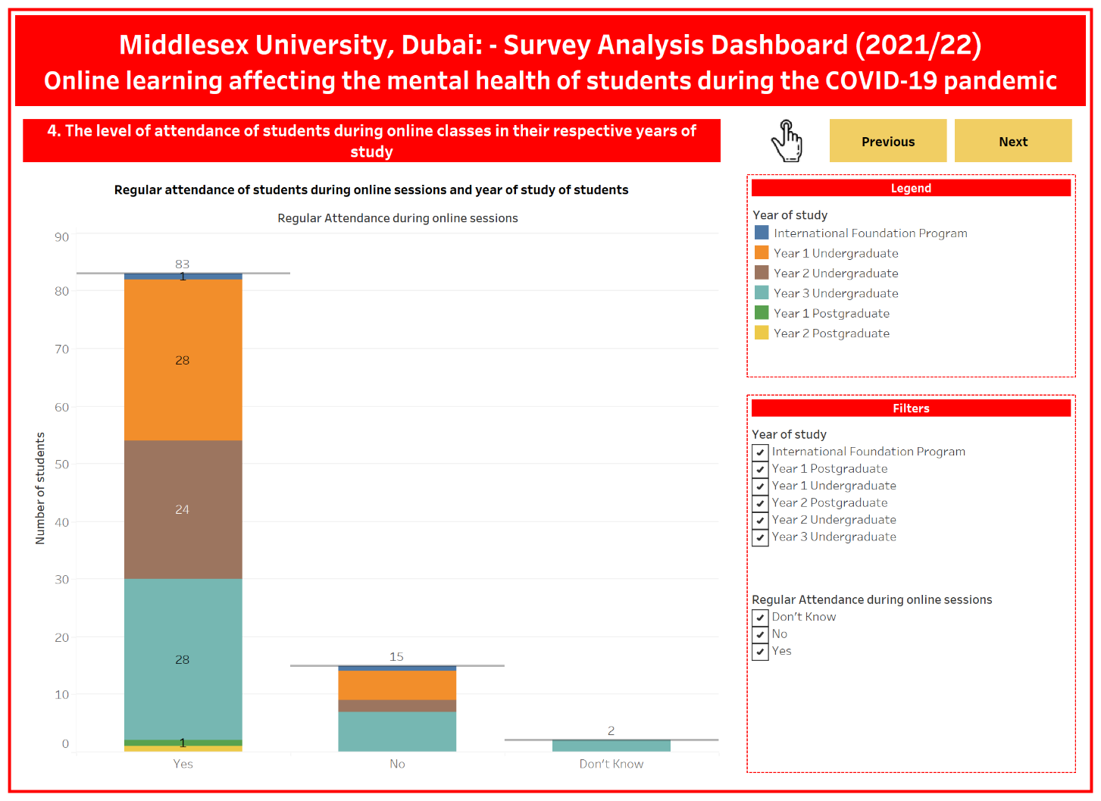**Zoom Fatigue encountered by students while using online learning platforms in their respective years of study: -** The fifth and final sheet of the survey analysis dashboard enables to ascertain whether the students of Middlesex University, Dubai, have experienced Zoom Fatigue while attending online classes in different years of study. Within this dashboard sheet comprising 100 responses, a prominent figure of 85 students have selected the choice *Yes,* and only 15 students have chosen the option of *No*.

Figure 40: - Survey Analysis Dashboard (Sheet 4)

#### Dashboard 5 (ZoomFatigue_YearOfStudy)4.2.3.2. Components of the dashboard story

Figure 41: - Survey Analysis Dashboard (Sheet 5)

Like the survey analysis dashboard, a dashboard story has also been created, with the story points also containing bar charts that can also be filtered according to what the user wishes to examine out of the collected student responses on online learning impacting students' mental health at different years of study during the COVID-19 pandemic. However, unlike the dashboard, the dashboard story enables a user to view the insights of the survey analysis comprehensively in the form of a narration containing a short paragraph that quickly explains the findings of the comparison between the mental health aspects of online learning and the year of study. Moreover, the dashboard story also contains a story point summarizing the entire data collection process within the research of online learning impacting students' mental health during the COVID-19 pandemic. The user can then navigate to different story points containing each of the comparisons between the mental health aspects of online learning with students' years of study. Each of the six story points that are present in the dashboard story of online learning impacting the mental health of students during the COVID-19 pandemic has been described by the following points: -

1. **Summary of online learning impacting the mental health of students during the COVID-19 pandemic: -** The first story point within the dashboard story summarizes how the data collection process of online learning affecting the mental health of students during the COVID-19 pandemic has been carried out along with a few quick insights comprising the number of survey questions, the overall number of student responses and the number of key comparisons that have been established.

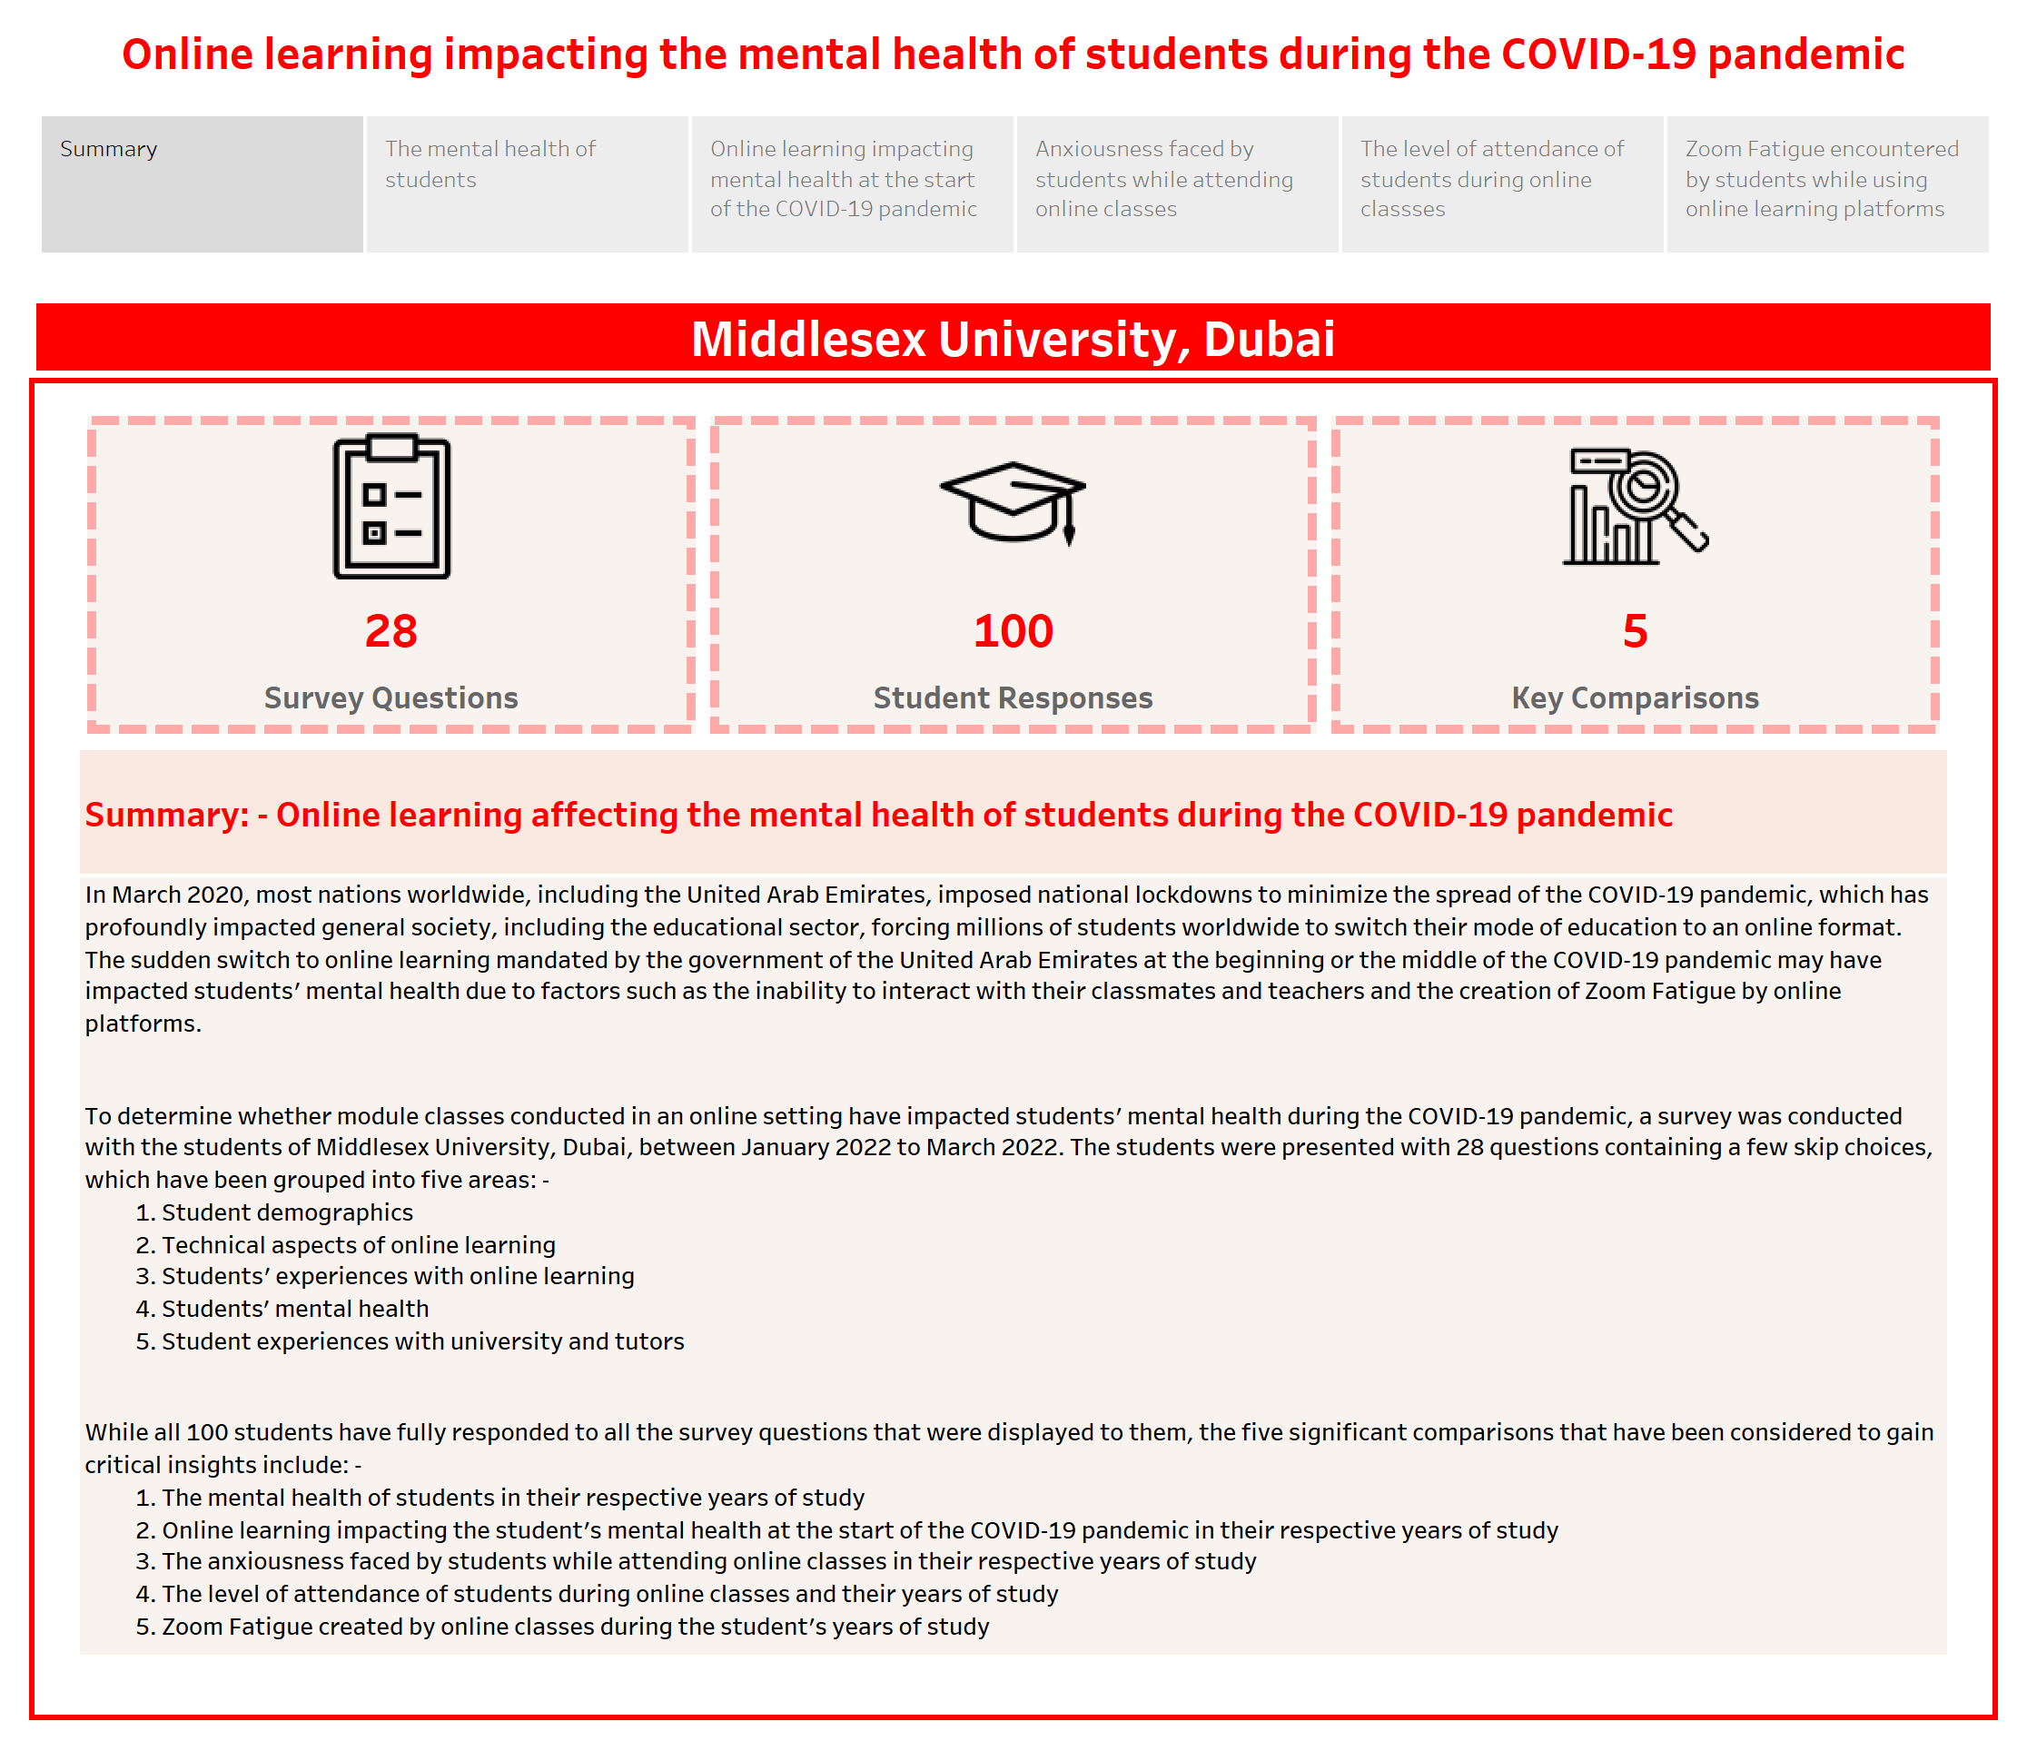

Figure 42: - Survey Analysis Dashboard Story (Sheet 1)

1. **The mental health of students in their respective years of study: -** The second story point of the dashboard story briefly explains the mental state of students in different years of study at the time of participating in the survey. A stacked bar chart also graphically depicts the student’s mental health in different years of study.
2. 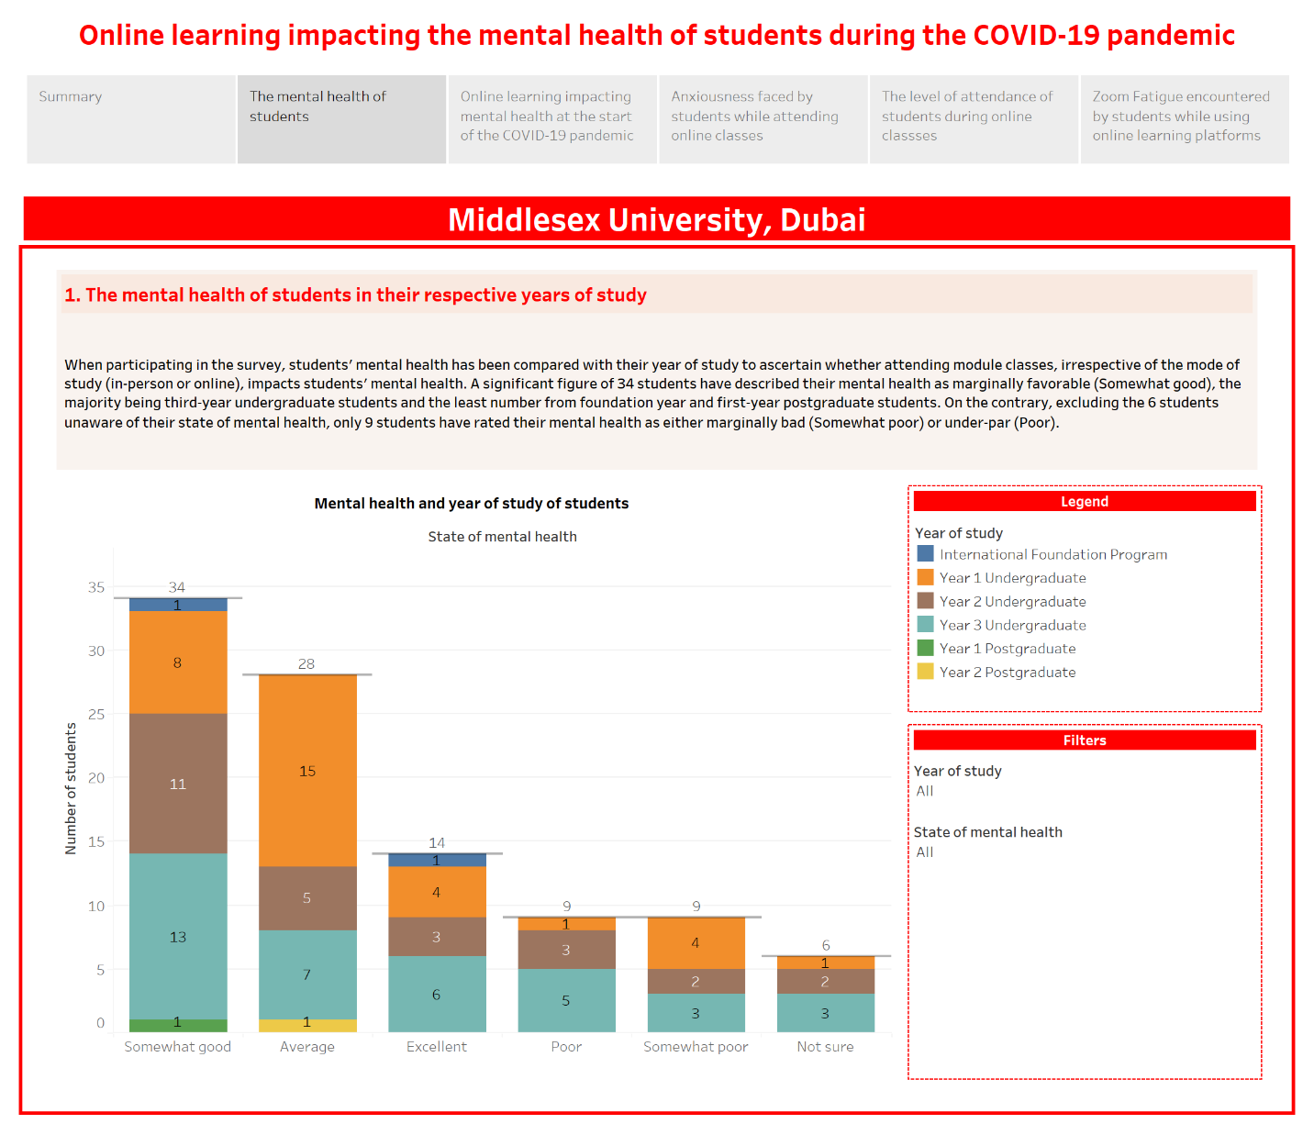**Online learning impacting student's mental health at the start of the COVID-19 pandemic in their respective years of study: -** The third story point of the dashboard story concisely interprets how had online learning affected the student’s mental health at the beginning of the COVID-19 pandemic, when educational institutions, including Middlesex University, Dubai, were, required to shift learning to online platforms. A stacked bar chart has also been implemented, depicting the students' responses concerning online learning impacting mental health.

Figure 43: - Survey Analysis Dashboard Story (Sheet 2)

1. 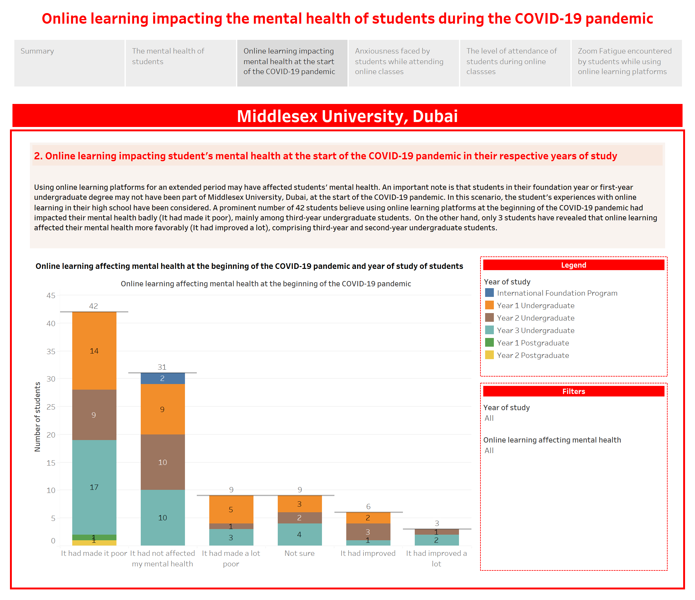**The anxiousness faced by students while attending online classes in their respective years of study: -** The fourth story point of the dashboard story succinctly outlines the rate of anxiousness encountered by students of Middlesex University, Dubai, during online module classes at different years of study. A stacked bar chart also illustrates the varying forms of anxiousness that students deal with.

Figure 44: - Survey Analysis Dashboard Story (Sheet 3)

1. 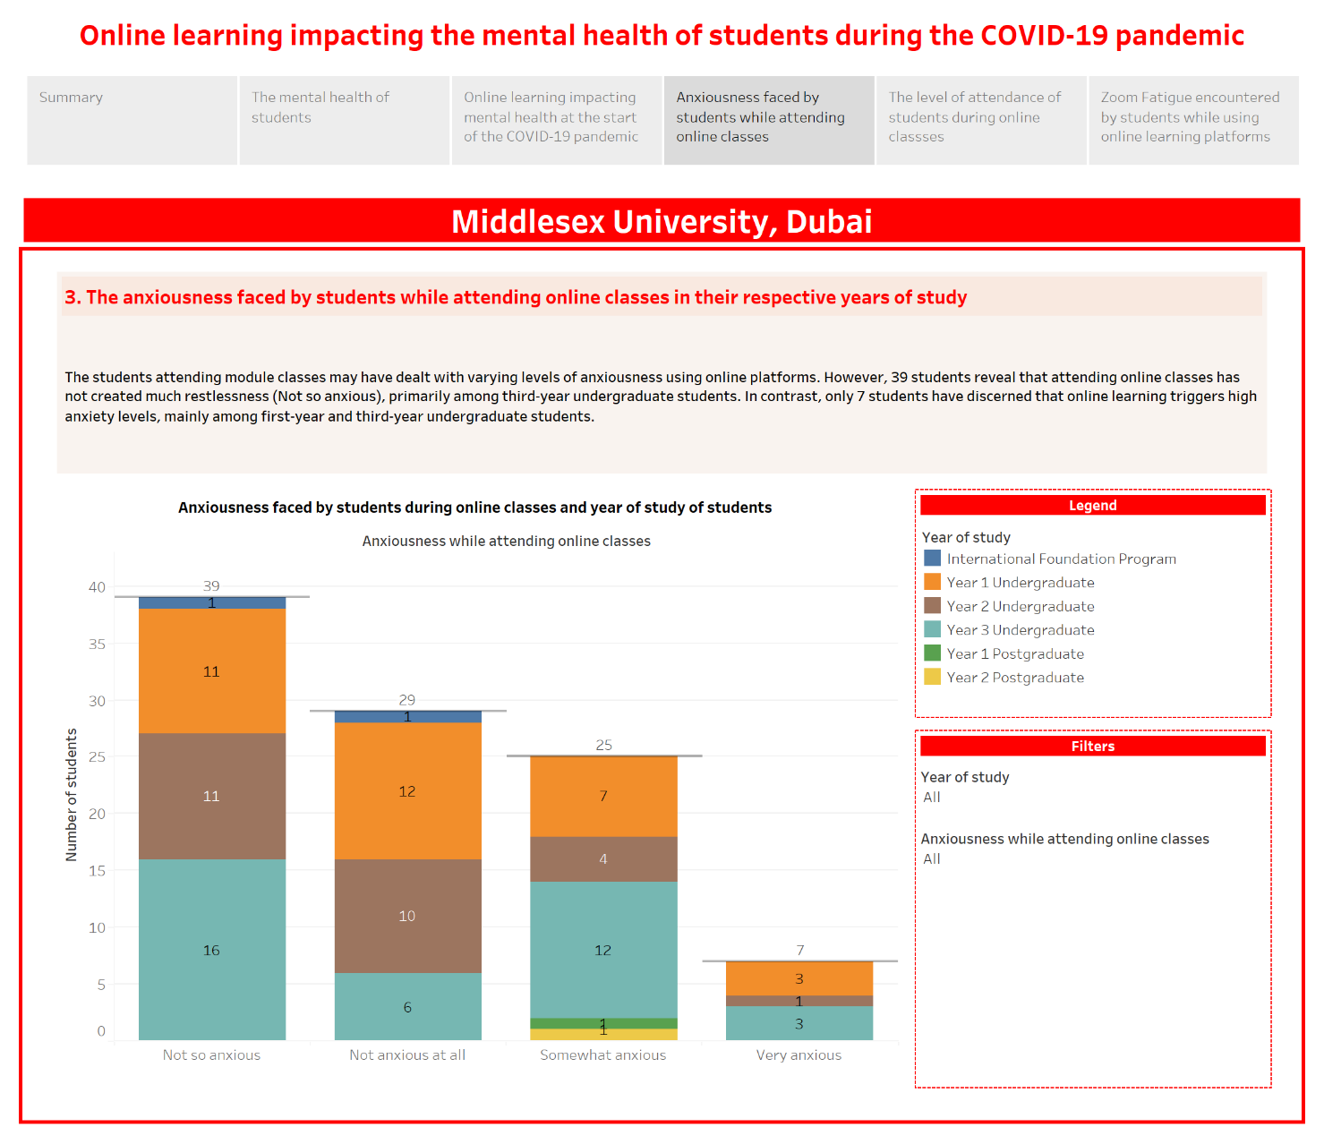**The level of attendance of students during online classes in their respective years of study: -** The fifth story point of the dashboard story compactly elucidates the regularity of attendance by students in module classes conducted in an online format. A stacked bar chart also graphically depicts whether students have attended online classes regularly.

Figure 45: - Survey Analysis Dashboard Story (Sheet 4)

1. 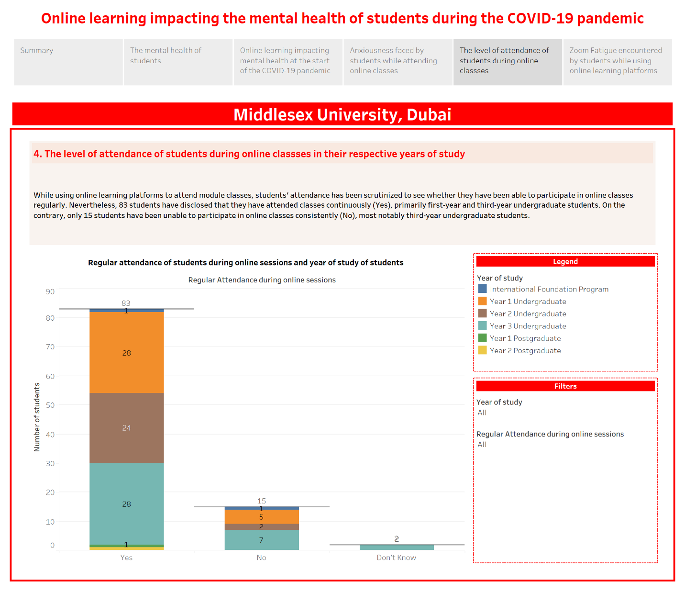**Zoom Fatigue encountered by students while using online learning platforms in their respective years of study: -** The sixth and final story point of the dashboard story concisely describes if students have dealt with Zoom Fatigue while attending online classes at numerous years of study. A stacked bar chart also illustrates whether students have encountered Zoom Fatigue during online classes.

Figure 46: - Survey Analysis Dashboard Story (Sheet 5)

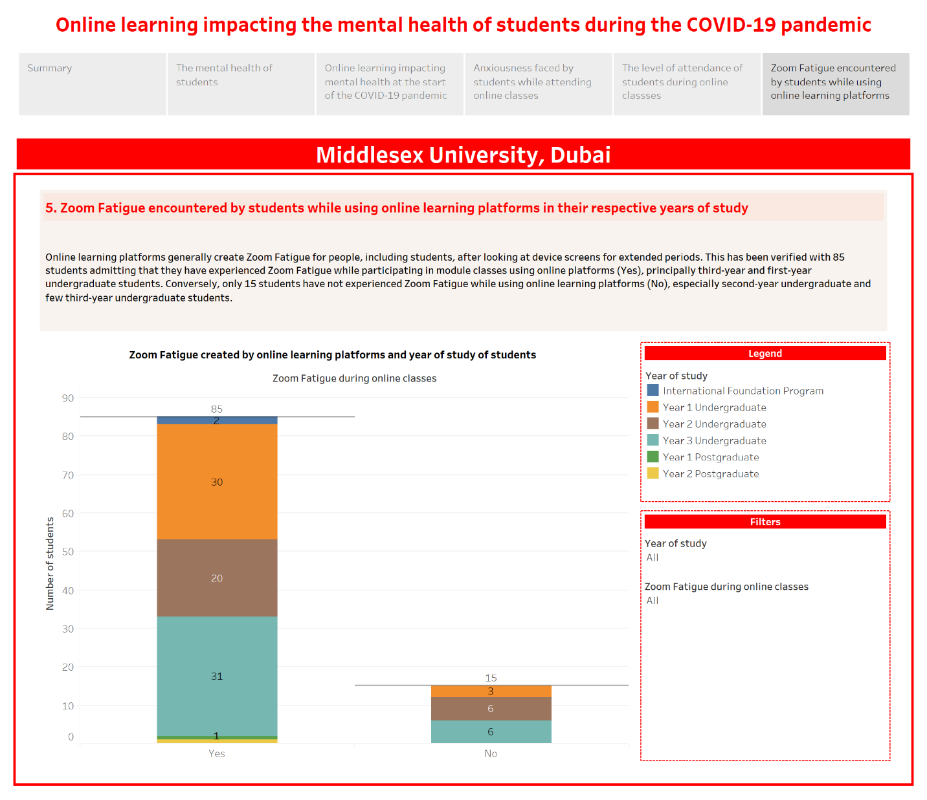

Figure 47: - Survey Analysis Dashboard Story (Sheet 6)

# Discussion and Evaluation

### 5.1. Main findings of the research

As part of the exploratory research on how online learning impacts students' mental health during the COVID-19 pandemic, the literature review enabled to comprehensively finding out the existing publications on how online learning has affected students' mental health during the COVID-19 pandemic. As previously stated in the literature review, the COVID-19 pandemic has raised the levels of fear, worry, and concern within the population on a vast scale (World Health Organization, 2022). However, Lister, Seale and Douce (2021) and Richardson (2015) have noted the limited research concerning online learning or distance learning impacting the mental well-being of students; the majority of the studies on student mental health focus on an environment within the university premises. As a result, the primary data collected from 100 students at Middlesex University, Dubai, enabled to discover comprehensively whether online learning platforms have impacted students’ mental health through the qualitative survey that contains several findings within the data analysis and visualizations. These findings have been compared with a minimal number of other studies that have discovered online learning impacting students' mental health during the COVID-19 pandemic. In the context of this research, the various mental health aspects of online learning that have been compared with the student’s year of study at Middlesex University, Dubai, include students’ mental health affected by online learning at the beginning of the COVID-19 pandemic, the anxiousness encountered by students while using online learning platforms and more.

When participating in the survey, the student's mental health in their respective years of study revealed that most of the students had a relatively positive mental health, i.e., *Somewhat good*, comprising 34 students. Although it was expected that third-year undergraduate students would have ranked their state of mental health as generally lesser positive due to the immense amount of coursework and examinations in their final year of undergraduate studies, 13 third-year undergraduate students have discerned that their mental health is marginally positive. On the other hand, only 8 first-year undergraduate students believe that their mental health is relatively positive, the lowest among undergraduate students who believe that their mental health is fairly positive, i.e., *Somewhat good*.

During the start of the COVID-19 pandemic, due to social distancing measures, students could not use the premises of Middlesex University, Dubai, and attend their module classes in the traditional mode of learning. As a result, students were forced to use online learning platforms to attend module classes, which could negatively impact their mental health due to multiple module classes taking place on the same day through online learning platforms. A prior cross-sectional survey conducted by AlJhani et al. (2021) with medical students in Saudi Arabia in May 2020 at the early stages of the COVID-19 pandemic has noted that approximately 61.8% of students had discerned that the challenges of online learning increased their stress and anxiety. Similarly, another cross-sectional study conducted by Salimi, Gere and Irioogbe (2021) at Midwestern University, United States, has noted that computer anxiety and perceived stress predict the overall mental health of university students because of the pressures from the challenge faced by university students of using technology like online learning for the first time. The impact of online learning on mental health has also proven valid within the survey results that were collected from students at Middlesex University, Dubai; of 100 responses, a substantial number of 42 students disclosed that online learning platforms affected their mental health unfavorably at the beginning of the COVID-19 pandemic by selecting the choice *It had made it poor*.

While using online learning platforms, it has been assumed that students of Middlesex University, Dubai, may face a high level of anxiousness to attend their module classes due to the previous comparison between the sudden switch to online learning impacting mental health at the beginning of the COVID-19 pandemic and year of study showing a negative outcome on students mental health; the numerous reasons for students getting anxious during online classes include quickly getting inattentive, inability to meet their classmates and tutors personally, and increased amount of time sitting in front of devices. Surprisingly, however, the survey reveals that within 100 responses, 39 students believe that attending classes in an online setting does not make them much restless, i.e., *Not so anxious*. Out of this category, 16 students are in the third-year of their undergraduate degree, and 11 students each in their first-year and second-year undergraduate studies have discerned that online learning does not make them feel anxious.

The attendance level of students in class, including online sessions, is essential as students are likelier to flourish in their academic performance when they attend classes consistently. (Ancheta, Daniel and Ahmad, 2021). Students' low level of attendance during classes while utilizing online modes of learning may impact their academic performance, which could further impact students’ mental health. An online survey conducted by Agarwal, S. and Dewan, J. (2020) in the Indian state of Uttar Pradesh during the COVID-19 lockdown has discovered that more than 50% of students had either failed to attend online classes or had a very low attendance in online classes. However, from the perspective of the survey carried out at Middlesex University, Dubai, it was found that out of 100 responses, a considerable number of 83 students have disclosed that they have attended online classes consistently and have selected the option of *Yes*. Of these 83 students, 28 students each in the first-year and third-year of their undergraduate degree have continuously attended online classes. On the contrary, only 15 students have not attended online classes regularly, i.e., they have chosen the response *No*, due to numerous factors such as inability to adjust to online learning platforms, loss of motivation, and procrastination.

During classes that have been conducted in an online setting, students would generally view screens for more extended amounts of time, which would cause mental fatigue, i.e., Zoom Fatigue, especially when they have more than one module session conducted on the same day where the academic difficulty could increase with each passing year. During the COVID-19 pandemic, video conference meetings generated more exhaustion than a typical daily amount of exhaustion (Bennett et al., 2021)**.** According to Peper et al. (2021), a survey carried out with undergraduate students at a metropolitan university attending synchronous online Zoom classes has revealed that only 6% of students had preferred online learning, and the remaining students found online learning ranging from somewhat difficult to extremely difficult.Similarly, the results from the survey conducted with students at Middlesex University, Dubai, have found that 85 students have experienced Zoom Fatigue during online classes of their modules, mainly third-year and first-year undergraduate students, with 31 and 30 students, respectively. These students have dealt with Zoom Fatigue using approaches such as utilizing social media platforms, having some breathing space by talking to another person physically, exercising, and other techniques.

Throughout the research that has been conducted through the literature review and data analysis and visualizations, it can be said that the mental health of students may or may not have been affected by online learning platforms during the COVID-19 pandemic, with mixed results being attained. There are several possible explanations for this result; the data analysis and visualizations, as part of the survey carried out at Middlesex University, Dubai, have revealed contrasting outcomes of whether or not online learning has negatively impacted mental health during the COVID-19 pandemic. The student’s mental health aspects of the sudden switch to online learning at the beginning of the COVID-19 pandemic and Zoom Fatigue encountered by students through online learning platforms have revealed that students’ mental health has been negatively impacted through utilizing online learning platforms during the COVID-19 pandemic. In contrast, the other mental health aspects, containing anxiousness during online classes and regular attendance during online classes, have shown a more favorable impact on students' mental health during the COVID-19 pandemic.

### 5.2. Limitations of the research

While carrying out the research on online learning impacting the mental health of students during the COVID-19 pandemic, numerous limitations have been encountered, as described by the following points: -

* Although a sufficient overall number of 100 student responses were collected from students at Middlesex University, Dubai, who participated in the survey, the likelihood of biases represents a limitation in the research due to the lack of responses from the foundation program and both first-year and second-year postgraduate students.
* The difficulty of comprehending the actual feelings and emotions of students at Middlesex University, Dubai, who have participated in the survey represents another limitation in the research. It could be possible that not all students may have provided reliable responses compared to what they perceived while answering all the questions present in the survey.

# Conclusion

## 6.1. Evaluation of the project

Throughout this project, the aim was to determine how students' mental health is impacted by utilizing online learning platforms to attend their classes during the COVID-19 pandemic. With the research topic being an exploratory research that has not widely been explored primarily due to the unexpected occurrence of the COVID-19 pandemic that forced students to attend classes through online platforms, the literature review substantially critiqued the existing publications on how does online learning impacts students impacts during the COVID-19 pandemic. Moreover, the data collected from the students at Middlesex University, Dubai, through the online survey, further supplemented finding out whether online learning has impacted the student’s mental health positively or negatively during the COVID-19 pandemic.

Based on the literature review and the analysis and visualizations of the survey conducted with the students at Middlesex University, Dubai, it can be concluded that online learning may or may not have impacted the student’s mental health during the COVID-19 pandemic, implying a mixed result. The results have proven that while various aspects of mental health, including the sudden switch to online learning in unforeseen circumstances like the COVID-19 pandemic and students' experiences with Zoom Fatigue, have revealed that online learning negatively impacts mental health, the other elements of mental health including anxiousness encountered while attending online classes and regular attendance during online classes may not have affected students’ mental health during the COVID-19 pandemic.

## 6.2. Limitations of the project

While carrying out this project on how online learning impacts the mental health of students during the COVID-19 pandemic, several limitations have been encountered, as described by the following points: -

* As previously discussed in the literature review chapter, a limitation includes most studies emphasizing the COVID-19 pandemic generally impacting students’ mental health instead of online learning explicitly affecting students’ mental health during the COVID-19 pandemic.
* Within the data analysis and visualizations chapter, despite the adequate number of responses obtained from the students of Middlesex University, Dubai, another limitation is the potential biases because of lesser responses from the foundation program and postgraduate students.
* Another limitation present within the data analysis and visualizations chapter is the challenge of understanding the real feelings and emotions of the students at Middlesex University, Dubai, through the survey. There is a possibility that not all students may have answered reliably compared to what they thought while responding to the survey questions.

## 6.3. Recommendations for future work

Within this project on finding out how online learning impacts students' mental health during the COVID-19 pandemic, a way in which the project could be improved in the future is that the data analysis and visualizations aspects can be extended to collect more data from the foundation program and postgraduate students at Middlesex University, Dubai. Another way the project could be improved is that the data analysis and visualization aspects could also be expanded more comprehensively to compare more mental health aspects of students with the student’s year of study and other student demographics such as the student’s subject area and gender.

# References

Agarwal, S. and Dewan, J. (2020) 'An Analysis of the Effectiveness of Online Learning in Colleges of Uttar Pradesh during the COVID 19 Lockdown', *Journal of Xi'an University of Architecture & Technology*, 12(5), pp. 2957-2963.

Al-Balas, M. et al. (2020) 'Distance learning in clinical medical education amid COVID-19 pandemic in Jordan: current situation, challenges, and perspectives', *BMC Medical Education*, 20(341). Available at: https://doi.org/10.1186/s12909-020-02257-4

AlJhani, S. et al. (2021) 'Mental health and online learning among medical students during the COVID-19 pandemic: a Saudi national study', *The Journal of Mental Health Training, Education and Practice.*Available at: https://doi.org/10.1108/JMHTEP-04-2021-0037

Allen, I.E. and Seaman, J. (2015) *Grade Level: Tracking Online Education in the United States*. Babson Park: Babson Survey Research Group.

Alnusairat, S., Al Maani, D. and Al-Jokhadar, A. (2020) 'Architecture students’ satisfaction with and perceptions of online design studios during COVID-19 lockdown: the case of Jordan universities', *International Journal of Architectural Research*, 15(1), pp. 219-236. Available at: https://doi.org/10.1108/ARCH-09-2020-0195

Amir, L.R. et al. (2020) 'Student perspective of classroom and distance learning during COVID-19 pandemic in the undergraduate dental study program Universitas Indonesia', *BMC Medical Education*, 20(392). Available at: https://doi.org/10.1186/s12909-020-02312-0.

Ancheta, R.F., Daniel, D. and Ahmad, R. (2021) 'Effect of class attendance on academic performance', *European Journal of Educational Studies*, 8(9), pp. 115-131. Available at: http://doi.org/10.46827/ejes.v8i9.3887

Araújo, F.J. et al. (2020) 'Impact Of Sars-Cov-2 And Its Reverberation In Global Higher Education And Mental Health', *Psychiatry Research*, 288. Available at: https://doi.org/10.1016/j.psychres.2020.112977

Arbaugh, J.B. (2000) 'Virtual Classroom Characteristics and Student Satisfaction with Internet-Based MBA Courses', *Journal of Management Education*, 24(1), pp. 32-54. Available at: https://doi.org/10.1177/105256290002400104

Aristovnik, A. et al. (2020) 'Impacts of the COVID-19 Pandemic on Life of Higher Education Students: A Global Perspective', *Sustainability*, 12(20). Available at: https://doi.org/10.3390/su12208438

Astuti, B. Lestari, R. and Bhakti, C.P. (2019) 'Student Decision-Making Ability As A Preparation For Facing The Industrial Revolution 4.0', *International Journal of Scientific & Technology Research*, 8(10), pp. 1200-1204. Available at: http://www.ijstr.org/final-print/oct2019/Student-Decision-making-Ability-As-A-Preparation-For-Facing-The-Industrial-Revolution-40.pdf (Accessed: 30 December 2021).

Bakia, M. et al. (2012) *Understanding the Implications of Online Learning for Educational Productivity*. Washington, D.C: U.S. Department of Education.

Baltà-Salvador, R. et al. (2021) 'Academic and emotional effects of online learning during the COVID-19 pandemic on engineering students', *Education and Information Technologies*. Available at: https://doi.org/10.1007/s10639-021-10593-1

Bartley, S. J. and Golek, J. H. (2004) 'Evaluating the Cost Effectiveness of Online and Face-to-Face Instruction', *Journal of Educational Technology & Society*, 7(4), pp. 167-175. Available at: https://www.jstor.org/stable/jeductechsoci.7.4.167 (Accessed: 14 November 2021)

Basilaia, G. et al. (2020) 'Replacing the Classic Learning Form at Universities as an Immediate Response to the COVID-19 Virus Infection in Georgia', *International Journal for Research in Applied Science & Engineering Technology*, 8(3), pp. 101-108. Available at: https://doi.org/10.22214/ijraset.2020.3021

Bellini, M.I. et al. (2021) 'COVID-19 and education: restructuring after the pandemic', Transplant International, 34(2), pp. 220-223. Available at: https://doi.org/10.1111/tri.13788.

Bennett, A.A. et al. (2021) 'Videoconference Fatigue? Exploring Changes in Fatigue After Videoconference Meetings During COVID-19', *Journal of Applied Psychology*, 106(3), pp. 330-344. Available at: https://doi.org/10.1037/apl0000906

Budhwar, K. (2017) 'The role of technology in education', *International Journal of Engineering Applied Sciences and Technology*, 2(8), pp. 55-57.

Camilleri, M.A. (2021) 'Evaluating service quality and performance of higher education institutions: a systematic review and a post-COVID-19 outlook, *International Journal of Quality and Service Sciences*, 13(2), pp. 268-281.

Chirikov, I. et al. (2020) *Undergraduate and Graduate Students’ Mental Health During the COVID-19 Pandemic*. Berkeley: University of California.

Daniel, S.J. (2020) 'Education and the COVID‑19 pandemic', *Prospects*, 49, pp. 91-96. Available at: https://doi.org/10.1007/s11125-020-09464-3

Davis, C.P. (2021) *Medical Definition of Stress*. Available at: https://www.medicinenet.com/stress/definition.htm (Accessed: 7 January 2022).

Dhawan, S. (2020) 'Online Learning: A Panacea in the Time of COVID-19 Crisis', *Journal of Educational Technology*, 49(1), pp. 5-22. Available at: https://doi.org/10.1177/0047239520934018

Di Pietro, G. (2018) 'The academic impact of natural disasters: evidence from L’Aquila earthquake', *Education Economics*, 26(1), pp: 62-77. Available at: https://doi.org/10.1080/09645292.2017.1394984

Dinh, L.P. and Nguyen, T.T. (2020) 'Pandemic, social distancing, and social work education: students’ satisfaction with online education in Vietnam', *Social Work Education*, 39(8), pp. 1074-1083. Available at: https://doi.org/10.1080/02615479.2020.1823365

Driessen, E. et al. (2020) 'Learning principles of evolution during a crisis: An exploratory analysis of student barriers one week and one month into the COVID-19 pandemic', *Ecology and Evolution*, 10(22), pp. 12431–12436. Available at: https://doi.org/10.1002/ece3.6741

Duraku, Z.H. (2021) *Impact of the COVID-19 Pandemic on Education and Wellbeing: Implications for Practice and Lessons for the Future*. Prishtina: University of Prishtina “Hasan Prishtina”.

Essadek, A. and Rabeyron, T. (2020) 'Mental health of French students during the Covid-19 pandemic', *Journal of Affective Disorders*, 277, pp. 392-393. Available at: https://doi.org/10.1016/j.jad.2020.08.042

Esterwood, E. and Saeed, S.A. (2020) 'Past Epidemics, Natural Disasters, COVID19, and Mental Health: Learning from History as we Deal with the Present and Prepare for the Future', *Psychiatric Quarterly*, 91, 1121-1133. Available at: https://doi.org/10.1007/s11126-020-09808-4

Few, S. (2007) 'Dashboard Confusion Revisited', *Visual Business Intelligence Newsletter*, pp. 1-6.

Freenberg, A. (1993) 'Building a Global Network: The WBSI Experience', in Harasim, L. (ed.) *Global Networks: Computers and International Communication*. Cambridge: MIT Press, pp. 185-197.

Garfin, D.R. (2020) 'Technology as a coping tool during the COVID‐19 pandemic: Implications and recommendations', *Stress and Health: Journal of the International Society for the Investigation of Stress*, 36. Available at: https://doi.org/10.1002/smi.2975

Gelles, L.A. et al. (2020) 'Compassionate Flexibility and Self-Discipline: Student Adaptation to Emergency Remote Teaching in an Integrated Engineering Energy Course during COVID-19', *Education Sciences*, 10(304). Available at: https://doi.org/10.3390/educsci10110304

George, T. (2021) *A guide to exploratory research*. Available at: https://www.scribbr.com/methodology/exploratory-research/ (Accessed: 02 January 2022).

Gonzalez, T. et al. (2020) 'Influence of COVID-19 confinement on students’ performance in higher education', *PLoS ONE*, 15(10). Available at: https://doi.org/10.1371/journal.pone.0239490

Gürel, E. (2017) 'SWOT ANALYSIS: A THEORETICAL REVIEW', *Journal of International Social Research*, 10(51), pp. 994-1006.

Harasim, L. (2000) 'Shift happens: Online education as a new paradigm in learning', *The Internet and Higher Education*, 3(1-2), pp. 41-61. Available at: https://doi.org/10.1016/S1096-7516(00)00032-4

Harasim, L. (2017) Learning Theory and Online Technologies. New York: Routledge.

Hiltz, S.R. and Turoff, M. (2005) 'Education goes digital: The evolution of online learning and the revolution in higher education', *Communications of the ACM*, 48(10), pp. 59-64.

Hines, A. and Sun, P. (2020) *Zoom fatigue: how to make video calls less tiring*. Available at: https://theconversation.com/zoom-fatigue-how-to-make-video-calls-less-tiring-137861 (Accessed: 23 April 2022).

Hiremath, P. et al. (2020) 'COVID 19: Impact of lock-down on mental health and tips to overcome', *Asian Journal of Psychiatry*, 51, pp. 1-2.

Hoelscher, J. and Mortimer, A. (2018) 'Using Tableau to visualize data and drive decision-making', *Journal of Accounting Education*, 44, pp. 49-59. Available at: https://doi.org/10.1016/j.jaccedu.2018.05.002

Hussein, E. et al. (2020) 'Exploring undergraduate students’ attitudes towards emergency online learning during COVID-19: A case from the UAE', *Children and Youth Services Review*, 119, pp. 1-7. Available at: https://doi.org/10.1016/j.childyouth.2020.105699

Hysaj, A. and Hamam, D. (2020) 'Exploring the Affordance of Distance Learning Platform (DLP) in COVID19 Remote Learning Environment', *Cognition, Learning and Games: The 22nd International Conference on Human-Computer Interaction*. Copenhagen, 19-24 July. Cham: Springer Nature, pp. 421-431.

Ibrahim, A.S., Al-Kaabi, A. and El-Zaatari, W. (2013) 'Teacher resistance to educational change in the United Arab Emirates', *International Journal of Research Studies in Education*, 2(3), pp. 25-36. Available at: https://doi.org/10.5861/ijrse.2013.254

Jacques, S., Ouahabi, A. and Lequeu, T. (2020) 'Remote Knowledge Acquisition and Assessment During the COVID-19 Pandemic', *International Journal of Engineering Pedagogy*, 10(6), pp. 120-138. Available at: https://doi.org/10.3991/ijep.v10i6.16205

Kaparounaki, C.K. et al. (2020) 'University students’ mental health amidst the COVID-19 quarantine in Greece', *Psychiatry Research*, 290. Available at: https://doi.org/10.1016/j.psychres.2020.113111

Khalil, R. et al. (2020) 'The sudden transition to synchronized online learning during the COVID-19 pandemic in Saudi Arabia: a qualitative study exploring medical students’ perspectives', *BMC Medical Education*, 20(285). Available at: https://doi.org/10.1186/s12909-020-02208-z

Khan, A.H. et al. (2020) 'The impact of COVID-19 pandemic on mental health & wellbeing among home-quarantined Bangladeshi students: A cross-sectional pilot study', *Journal of Affective Disorders*, 277, pp. 121-128. Available at: https://doi.org/10.1016/j.jad.2020.07.135

Khattar, A., Jain, P.R. and Quadri, S.M.K. (2020) 'Effects of the Disastrous Pandemic COVID 19 on Learning Styles', *Activities and Mental Health of Young Indian Students - A Machine Learning Approach', 4th International Conference on Intelligent Computing and Control Systems*. Madurai, 13-15 May. New Jersey: IEEE, pp. 1190-1195.

Ko, I. and Chang, H. (2017) 'Interactive Visualization of Healthcare Data Using  
Tableau', *Healthcare Informatics Research*, 23(4), pp. 349-354.

Lai, J.W. and Bower, M. (2019) 'How is the use of technology in education evaluated? A systematic review', *Computers and Education*, 133, pp. 27-42. Available at: https://doi.org/10.1016/j.compedu.2019.01.010

Lattie, E.G., Lipson, S.K. and Eisenberg, D. (2019) 'Technology and College Student Mental Health: Challenges and Opportunities', *Psychopathology Among Youth in the 21st Century: Examining Influences from Culture, Society and Technology*, 10(246), pp.53-57. Available at: https://doi.org/10.3389/fpsyt.2019.00246

Lestari, R., Astuti, B. and Bhakti, C.P. (2020) 'A comprehensive teacher strategy for successful online learning process', *International Journal on Education Insight*, 1(1), pp 1-12. Available at: https://doi.org/10.12928/ijei.v1i1.2064

Lischer, S., Safi, N. and Dickson, C. (2021) 'Remote learning and students’ mental health during the Covid‑19 pandemic: A mixed‑method enquiry', *Prospects*, pp 1-11. Available at: https://doi.org/10.1007/s11125-020-09530-w

Lister, K., Seale, J. and Douce, C. (2021) 'Mental health in distance learning: a taxonomy of barriers and enablers to student mental wellbeing', *Open Learning: The Journal of Open, Distance and eLearning*. Available at: https://doi.org/10.1080/02680513.2021.1899907

Luan, L. et al. (2020) 'Exploring the role of online EFL learners’ perceived social support in their learning engagement: a structural equation model', *Interactive Learning Environments*. Available at: https://doi.org/10.1080/10494820.2020.1855211

Lundberg, J., Castillo-Merino, D. and Dahmani, M. (2008) 'Do Online Students Perform Better than Face-to-face Students? Reflections and a Short Review of some Empirical Findings', *RUSC. Universities and Knowledge Society Journal*, 5(1), pp. 35-44. Available at: https://doi.org/10.7238/rusc.v5i1.326

Mahajan, S. (2021) 'The Role of ICT in Education: The Emerging Indian Scenario during Lockdown due to COVID-19', *Contemporary Social Sciences*, 30(2), pp. 54-76.

Maslach, C. and Leiter, M.P. (2017) 'New insights into burnout and health care: Strategies for improving civility and alleviating burnout', *Medical Teacher*, 39(2), pp. 160-163. Available at: https://doi.org/10.1080/0142159X.2016.1248918

McInnerney, J.M. and Roberts, T.S. (2004) 'Online Learning: Social Interaction and the Creation of a Sense of Community', *Educational Technology & Society*, 7(3), pp. 73-81.

Meulenbroeks, R. (2020) 'Suddenly fully online: A case study of a blended university course moving online during the Covid-19 pandemic', *Heliyon*, 6(12), pp. 1-7. Available at: https://doi.org/10.1016/j.heliyon.2020.e05728

Mheidly, N., Fares, M.Y. and Fares, J. (2020) 'Coping With Stress and Burnout Associated With Telecommunication and Online Learning', *Frontiers in Public Health*, 8, pp. 1-7. Available at: https://doi.org/10.3389/fpubh.2020.574969

Milligan, J.N. (2015) *Learning Tableau*. Birmingham: Packt.

Moore, J.L., Dickson-Deane, C. and Galyen, K. (2011) 'e-Learning, online learning, and distance learning environments: Are they the same?', *Internet and Higher Education*, 14(2), pp. 129-135. Available at: https://doi.org/10.1016/j.iheduc.2010.10.001

Muthuprasad, T. et al. (2021) 'Students’ perception and preference for online education in India during COVID -19 pandemic, Social Sciences & Humanities Open, 3(1), pp. 1-11.

Palvia, S. et al. (2018) 'Online Education: Worldwide Status, Challenges, Trends, and Implications', *Journal of Global Information Technology Management*, 21(4), pp. 233-241. Available at: https://doi.org/10.1080/1097198X.2018.1542262

Parvez, M.S., Rahman, A. and Tasnim, N. (2019) 'Ergonomic mismatch between students anthropometry and university classroom furniture', *Theoretical Issues in Ergonomics Science*, 20(5), pp. 603-631. Available at: https://doi.org/10.1080/1463922X.2019.1617909

Paul, J. and Jefferson, F. (2019) 'A Comparative Analysis of Student Performance in an Online vs. Face-to-Face Environmental Science Course From 2009 to 2016', *Frontiers of Computer Science*, 1(7), pp. 1-9. Available at: https://doi.org/10.3389/fcomp.2019.00007

Peper, E. et al. (2021) 'Avoid Zoom Fatigue, Be Present and Learn', *NeuroRegulation*, 8(1), pp. 47-56. Available at: https://doi.org/10.15540/nr.8.1.478.1.47

Piccoli, G., Ahmad, R. and Ives, B. (2001) 'Web-Based Virtual Learning Environments: A Research Framework and a Preliminary Assessment of Effectiveness in Basic IT Skills Training', *MIS Quarterly*, 25(4), pp. 401-426. Available at: https://doi.org/10.2307/3250989

Puljak, L. et al. (2020) 'Attitudes and concerns of undergraduate university health sciences students in Croatia regarding complete switch to e-learning during COVID-19 pandemic: a survey', *BMC Medical Education*, 20(416). Available at: https://doi.org/10.1186/s12909-020-02343-7

Rahman, A.A., Adamu, Y.B. and Harun, P. (2017) 'Review on Dashboard Application from Managerial Perspective', *Proceedings of the 5th International Conference on Research and Innovation: Social Transformation through Data Science*, Langkawi, 16-17 July. pp. 1-6. Available at: https://doi.org/10.1109/ICRIIS.2017.8002461

Raja, R. and Nagasubramani, P.C. (2018) 'Impact of modern technology in education', *Proceedings of the conference on recent trend of teaching methods in education*, Dindigul. S33-S35. Available at: https://doi.org/10.21839/jaar.2018.v3iS1.165

Realyvásquez-Vargas, A. et al. (2020) 'The Impact of Environmental Factors on Academic Performance of University Students Taking Online Classes during the COVID-19 Pandemic in Mexico', *Sustainability*, 12(21). Available at: https://doi.org/10.3390/su12219194

Richardson, J.T.E. (2015) 'Academic Attainment in Students with Mental Health Difficulties in Distance Education', *International Journal of Mental Health*, 44(3), pp. 231-240. Available at: https://doi.org/10.1080/00207411.2015.1035084

Salimi, N., Gere, B. and Irioogbe, B. (2021) 'Online Learning in the Era of COVID-19: Computer Anxiety and Mental Health Among College Students', *IAFOR Journal of Psychology & the Behavioral Sciences*, 7(1), pp. 35-50. Available at: https://doi.org/10.22492/ijpbs.7.1.03

Savage, M.J. et al. (2020) 'Mental health and movement behaviour during the COVID-19 pandemic in UK university students: Prospective cohort study', *Mental Health and Physical Activity*, 19. Available at: https://doi.org/10.1016/j.mhpa.2020.100357

Simamora, R.M. (2020) 'The Challenges of Online Learning during the COVID-19 Pandemic: An Essay Analysis of Performing Arts Education Students', Studies in Learning and Teaching, 1(2), pp. 86-103. Available at: https://doi.org/10.46627/silet.v1i2.38

Singh, V. and Thurman, A. (2019) 'How Many Ways Can We Define Online Learning? A Systematic Literature Review of Definitions of Online Learning (1988-2018)', *American Journal of Distance Education*, 33(4), pp. 289-306. Available at: https://doi.org/10.1080/08923647.2019.1663082

Siranjeevi, M.S. and Pattanwala, H. (2021) 'Embracing the Change: SWOT Analysis of the Education Technology in Online Learning', *International Journal of Innovative Research in Technology*, 6(12), pp. 776-779.

Smith, P.J. (2005) 'Learning Preferences and Readiness for Online Learning', *Educational Psychology*, 25(1), pp. 3-12. Available at: https://doi.org/10.1080/0144341042000294868

Son, C. et al. (2020) 'Effects of COVID-19 on College Students’ Mental Health in the United States: Interview Survey Study', *Journal of Medical Internet Research*, 22(9). Available at: https://doi.org/10.2196/21279

Sun, A.Q. and Chen, X. (2016) 'Online Education and Its Effective Practice: A Research Review', *Journal of Information Technology Education: Research*, 15, pp. 157-190. Available at: https://doi.org/10.28945/3502

Sun, P.C. et al. (2008) 'What drives a successful e-Learning? An empirical investigation of the critical factors influencing learner satisfaction', *Computers & Education*, 50(4), pp. 1183-1202. Available at: https://doi.org/10.1016/j.compedu.2006.11.007

Tableau (2022) *What Is Data Visualization? Definition, Examples, And Learning Resources*. Available at: https://www.tableau.com/learn/articles/data-visualization (Accessed: 24 April 2022).

Taylor-Beswick, A. (2021) 'Social Work, technologies and Covid-19', in Turner, D. (ed.) *Social Work and Covid-19: Lessons for Education and Practice*. St Albans: Critical Publishing, pp. 7-13.

Todorova, N. and Bjorn-Andersen, N. (2011) 'University Learning in Times of Crisis: The Role of IT', *Accounting Education*, 20(6), 597-599. Available at: https://doi.org/10.1080/09639284.2011.632913

United Nations Sustainable Development Group (2020) *Policy Brief: Education during COVID-19 and beyond*. Available at: https://unsdg.un.org/sites/default/files/2020-08/sg\_policy\_brief\_covid-19\_and\_education\_august\_2020.pdf (Accessed: 30 December 2021).

Vargo, D. et al. (2020) 'Digital technology use during COVID-19 pandemic: A rapid review', *Human Behavior and Emerging Technologies*, 3(1), pp. 13-24. Available at: https://doi.org/10.1002/hbe2.242

Wallace, R.M. (2003) 'Online Learning in Higher Education: a review of research on interactions among teachers and students', *Education, Communication & Information*, 3(2), pp. 241-280. Available at: https://doi.org/10.1080/14636310303143

Williams, C.A. and James, D.V.B. (2001) *Science for Exercise and Sport*. Abingdon: Routledge.

World Health Organization (2003) *Investing in Mental Health*. Geneva: Department of Mental Health and Substance Dependence. Available at: https://www.who.int/mental\_health/media/investing\_mnh.pdf (Accessed: 1 January 2022).

World Health Organization (2020) *WHO Director-General's opening remarks at the media briefing on COVID-19 - 11 March 2020.* Available at: https://www.who.int/director-general/speeches/detail/who-director-general-s-opening-remarks-at-the-media-briefing-on-covid-19---11-march-2020 (Accessed: 23 April 2022).

World Health Organization (2022) *Mental health and COVID-19*. Available at: https://www.euro.who.int/en/health-topics/health-emergencies/coronavirus-covid-19/publications-and-technical-guidance/noncommunicable-diseases/mental-health-and-covid-19 (Accessed: 02 January 2022).

Zhai, Y. and Du, X. (2020) 'Addressing collegiate mental health amid COVID-19 pandemic', *Psychiatry Research*, 288, pp. 1-2. Available at: https://doi.org/10.1016/j.psychres.2020.113003

# Appendices

## 8.1. Ethics Approval Form

**Application for Ethical Approval for Research Projects**

This is an application form for ethical approval for research undertaken by any Middlesex University Dubai staff and students. The person who completes this form should be the principal (or sole) Middlesex University Dubai researcher on the proposed study. After completion, this form (along with accompanying documents) should be submitted to the Research Ethics Committee (REC) for review. Student Researchers should submit to their Supervisor.

**Section 1 – Applicant details**

|  |  |  |
| --- | --- | --- |
| **1.1 Details of Applicant (Principal Investigator or Student Researcher)** | | |
| Name: Alester D’Costa | Department/Position: Student | |
| Qualifications: Student | Email: AD1531@live.mdx.ac.uk | Tel: +971503204467 |
| **1.2 Details of Supervisor for student applicants (if applicable)** | | |
| Name: Geethu Joy | Programme of study/module: Undergraduate Individual Project | |
| Supervisor Qualifications: | Email: g.joy@mdx.ac.ae | Tel: |
| **1.3 Details of any co-investigators** (if applicable) | | |
| Name: | Organisation: | Email: |
| Name: | Organisation: | Email: |
| Name: | Organisation: | Email: |
| **1.4 Details of External Funding (if applicable)** | | |

**Section 2 – Details of the proposed study**

|  |  |  |  |
| --- | --- | --- | --- |
| **2.1 Research project title** | An investigation of online learning affecting the mental health of students during the COVID-19 pandemic. | | |
| **2.2 Proposed start date** | 11th November 2021 | **2.3 Proposed end date** | 15th April 2022 |
| **2.4 Describe the aim and rationale of this study?** | | | |
| This project aims to find out how online learning affects students' mental health during the COVID-19 pandemic. Even though mental health has gained wider attention during the COVID-19 pandemic within the academic field, research has focused on examining unfavorable mental health states, including depression, stress, and anxiety. However, a broader viewpoint has been placed on the state of students emotionally, with positive states of emotions including calm or trust been found to be missing. | | | |
| **2.5. Discuss the research questions and/or hypotheses of this study?** | | | |
| This project focuses on the research topic of how online learning affects the mental health of students during the COVID-19 pandemic. The research methodology that would be used for the project is the exploratory research methodology as the research topic has not been investigated in-depth. It would enable to understand students’ perceptions towards online learning and the benefits and limitations of online learning. | | | |
| **2.6 Details of study design, data collection methods to achieve the research aims** (e.g., interviews, questionnaire, observation etc.) and/or secondary data sources (e.g., National Statistics) to be used in the research, proposed hypotheses, data analysis, with references and citations (where applicable). Include details of any online data collection (ie online survey, via social media). | | | |
| In the context of this project, primary data would be collected using a survey that would focus on how students find pursuing their relevant courses using online learning platforms and whether it has impacted their mental health. This survey would be created online using Qualtrics. | | | |

**Section 3 – Initial Checklist to be completed by the applicant**

|  |  |  |
| --- | --- | --- |
| **3.1 Does this research involve human participants** | Yes | No |
| **If yes, please provide the following details:** | | |
| Who are your participants? Please specify any specific groups of human participants: (e.g., students, general public, specific groups etc.)  Students from Middlesex University Dubai | | |
| How many participants will you have? (Under each category)  60-100 students | | |
| How will participants be recruited and approached?  Sample size of 150-200 students | | |
| **Do you need access to groups of participants** (e.g., through gatekeepers, e.g., organisations, managers, parents, schools etc.) | Yes | No |
| If yes, please provide details including no objection certificate(s): | | |
| **3.2 Does this research involve secondary data collection?** | Yes | No |
| **If yes, please Indicate your response below:** |  |  |
| 3.2.1 Do you have the necessary approval to access the data\*?  (\*If yes, please provide evidence of approval)  (If no, please provide details and plan of action) | Yes | No |
| **3.3 The outputs from research** (e.g., products, reports, publications, etc.) are not likely to cause harm to others and are in-line with the local legislation | Yes | No |
| If no, please explain how this can be avoided or managed: | | |
| **3.4 Will the study require data collection by proxy** (someone else doing part of or all of your data collection) | Yes | No |
| If yes, please provide details including its rationale:  *Note: When collecting data by proxy, you need to ensure that the highest ethical standards and procedures are adopted by all research partners/fieldworkers* | | |

**Section 4 – Anonymity, confidentiality, and consent for primary and secondary research**

|  |  |  |  |
| --- | --- | --- | --- |
| **4.1 Will the research involve collecting or analysing personal data or sensitive personal data? or involve sharing of confidential information beyond the initial consent given** (i.e., personal data refers to information that may identify individuals e.g., name, address, date of birth, opinion, specific event, set of characteristics that would clearly identify individuals or very small groups. Sensitive personal data refers to racial or ethnic origin, political opinion, religious beliefs, trade union membership, sexual life, physical or mental health, criminal matters.) | Yes | No | NA |
| If yes, please provide details: (e.g., Justification for use personal data or sensitive personal data? How you plan to anonymise the data? Where the data will be kept and care/storage facilities etc.)  *Alternatively, if personal or sensitive personal data is required for the research, you must comply with the GDPR act and understand your responsibilities under the GDPR and have received data protection training. Please complete the Data Protection Checklist for Researchers* | | | |
| **4.2 Will lists of identity numbers/codes or pseudonyms for individuals and/or organisations (i.e., linking keys to personal identifiers) be stored securely and separately from the research data and destroyed after the study to avoid any risk of confidentiality being compromised?** | Yes | No | NA |
| If no, please provide details on how this can be avoided or managed: | | | |
| **4.3 Will you tell participants that their data will be treated confidentially and the limits of anonymity will be made clear in your Participant Information Sheet?** (e.g., their identities as participants will be concealed unless prior consent is given to include the name of the participant in any documents resulting from the research. Consider how participants’ narratives, quotes or involvement in specific events may make anonymity difficult to maintain.) Attach: Participant information sheet | Yes | No | NA |
| If yes, provide details on how you will ensure this:  The participant information sheet would be attached within the online survey stating that no personally identifiable data would be collected due to the research being a minimal risk study. | | | |
| **4.4 Will you obtain Written Informed Consent directly from research participants (if applicable)?** Attach: Informed Consent sheet | Yes | No | NA |
| If no, please explain why?  Due to the high number of participants needed for the survey to be conducted, the written informed consent sheet may not be needed. Additionally, the information participant sheet would be attached within the survey t confirm participants' consent.  If yes, please specify how and when this will be achieved? |  |  |  |
| **4.5 Will you obtain Written Informed Consent directly from gatekeepers (if applicable)?** Attach: Informed Consent sheet | Yes | No | NA |
| If no, please explain why?  If yes, please specify how and when this will be achieved? |  |  |  |
| **4.6 Will you inform participants that their participation is voluntary and that they have a right to withdraw from the research at any time?** | Yes | No | NA |
| If no, please explain why? | | | |
| **4.7 Will you have a process for managing withdrawal of consent? Please provide details:** | Yes | No | NA |
| If no, please explain why?  If yes, please provide details on how this will be managed?  The responses of participants who wish to withdraw their responses would be deleted from the collected responses. These participants may contact directly with the emails being attached below. | | | |
| **4.8 Will it be necessary for participants to take part in the study without their knowledge and consent at the time, or by deception e.g., covert observation?** | Yes | No | NA |
| If yes, please provide justification and details of how this will be managed to respect the participants/third parties involved to respect their privacy, values, and to minimise any risk of harmful consequences: | | | |
| **4.9 Will you provide a Written Debriefing Sheet? (if applicable, also attach)** | Yes | No | NA |
| If no, please explain why? | | | |
| **4.10 Will you need consent from people who appear in visual data (e.g., photos or films or social media)?** | Yes | No | NA |
| If yes, please provide details on how this will be managed:  If no, please explain why? | | | |
| **4.11 Will you audio or video record interviews and/or observations?** | Yes | No | NA |
| If yes, please provide details on how participants’ anonymity will be maintained: |  |  |  |
| **4.12** Will your research involve **participants responding to internet** **surveys, emails, chatroom discussions, blogs, interactive games, social media and networking sites etc,** | Yes | No | NA |
| If ‘yes’, please explain how will you obtain permission from the website authors, or informed consent from participants, and ensure anonymity and protect confidentiality in an environment that generates significant amounts of background information e.g., data logs, IP addresses, cookies and caches and/or with low levels of system security?  The surveys would be conducted using Qualtrics. The needed permission has been obtained to utilize the software in creating the surveys for the research study. | | | |
| **4.13 Do you have a Data Management Plan?**  *(E.g.: Where the data will be stored, who will have access to data, how will the data be shared, how long the data will be stored, how it will be deleted/destroyed after your research completion etc.)* | Yes | No | NA |
| If no, please explain why? | | | |

**Section 5 –** **Avoiding harm: risk assessment and management, safety and legal issues**

|  |  |  |  |
| --- | --- | --- | --- |
| **5.1** Will you use an **experimental research design** (ie.,implement a specific plan for assigning participants to conditions and noting consequent changes?) | Yes | No | NA |
| If yes, please provide details of treatment/intervention (and specify is these are intrusive interventions e.g., hypnosis or physical exercise, or include the use of drugs, placebos or other substances e.g., vitamins, food substances etc.) and provide details of required resources for this study: | | | |
| **5.2** Will the research involve **discussion of sensitive topics**? (e.g., sexual activity, drug use, national security etc.) | Yes | No | NA |
| If yes, please provide details of how possible adverse reactions will be avoided and what support will be in place to manage any adverse consequences: | | | |
| **5.3** **Is** **pain or more than mild discomfort** likely to result from the study? | Yes | No | NA |
| If yes, please provide details on how this can be avoided or managed: | | | |
| **5.4** Could the study induce **psychological stress or anxiety** or **cause harm or negative consequences** beyond the risks encountered in normal life? | Yes | No | NA |
| If yes, please provide details and state how participants will be supported: | | | |
| **5.5 Will the study involve prolonged and repetitive testing?** | Yes | No | NA |
| If yes, please provide details, justification and state how participants will be supported and length of each data collection session, number of sessions and location of data collection: | | | |
| **5.6** Will this research be conducted **off-site** (i.e., not on Middlesex University Dubai premises)? | Yes | No | NA |
| If yes, please provide details of other locations and explain how you will minimise any risks to your own health while off-site. | | | |
| **5.7** Will you **being alone** with individual participants or group of participants place you at risk? | Yes | No | NA |
| If yes, please state how this can be avoided or managed? | | | |
| **5.8** Are there any **adverse risks** or **safety issues** (e.g., from **potential hazards)** that your methodology raises for you and/or for your participants or others? | Yes | No | NA |
| If yes, please specify and provide details of mitigating actions that will be taken (e.g., travelling alone, working in hazardous conditions, discussing illegal activities on-line etc.) and how you, and your participants/third parties will be supported? | | | |
| **5.9** Is the research or outputs from the research **likely to cause harm** to others (e.g., to their physical well-being, mental health, dignity or personal values) to an extent greater than that encountered in ordinary life? | Yes | No | NA |
| If yes, please state how this can be avoided or managed? | | | |

**Section 6 – Research Sponsorship and/or Collaboration (if applicable)**

|  |  |  |  |
| --- | --- | --- | --- |
| **6.1 Does the research have a sponsor**  *(i.e., any person or organisation who provides support for the research in the form of income, use of data, facilities, materials, assistance with data collection etc.) that may have ethical implications for the research?* | Yes | No | NA |
| If ‘yes’ please provide details of the role of the funder and issues: | | | |
| **6.2 Does the research involve an international collaborator or research conducted overseas?** | Yes | No | NA |
| If ‘yes’, what ethical review procedures must this research comply with for that country, and what steps have been taken to comply with these: (e.g., Do you need local permission/approval? Are there any country specific cultural social or legal considerations that need to be taken into account? Who will be collecting the data overseas? Have you considered intellectual property issues?) | | | |
| **6.3 Does this research already have or require Approval from an External Research Ethics Committee?** | **Yes** | **No** | **NA** |
| If ‘yes’ please provide details: | | | |
| **6.4 Will this research or part of it be conducted in a language other than English?** | Yes | No | NA |
| If ‘yes’, full translations of all non-English materials will need to be submitted. | | | |

**Section 7 –** **Other Issues**

|  |  |  |  |
| --- | --- | --- | --- |
| **7.1 Does the research involve any ethical and/or legal issues not already covered that should be taken into consideration?** | Yes | No | NA |
| If yes, please give details: | | | |
| **7.2 Do you require training on the requirements of GDPR for researchers?** | Yes | No | NA |
| If yes, please give details: | | | |
| **7.3 Does the research raise any other risks to safety for you or others that would be greater than in normal life?** | Yes | No | NA |
| If yes, please provide details and state how this can be avoided or managed? If appropriate, complete a separate state **Risk Assessment Form** along with this application | | | |
| **7.4 Will participants receive any reimbursements or payments for participating?** | Yes | No | NA |
| If yes, please provide details and justification: | | | |
| **7.5 Are there any conflict of interests to be declared in relation to this research?** | Yes | No | NA |
| If yes, please complete and attach the “Disclosure of Potential Conflict of Interest Form” along with this application | | | |

**Section 8 –** **Pre-Submission Checklist**

Please mention the documents (where applicable) you will be attaching with this application:

|  |  |  |  |
| --- | --- | --- | --- |
| **Please check and attach the following documents where applicable**: |  |  |  |
| 1. Participant Information Sheet *(in Appendix)* | Yes | No | NA |
| 1. Informed Consent Sheet | Yes | No | NA |
| 1. Debriefing Sheet *(in Appendix)* | Yes | No | NA |
| 1. Copy of questionnaire/interview guide/details of materials for data collection (including translations, visual images etc.) *(in Appendix)* | Yes | No | NA |
| 1. Letter of permission (if required from organisation where research is to be conducted) | Yes | No | NA |
| 1. Evidence of external approval – for access to secondary data | Yes | No | NA |
| 1. Completed Risk Assessment Form | Yes | No | NA |
| 1. Data Protection Checklist for Researchers | Yes | No | NA |
| 1. Disclosure of Conflict of Interests | Yes | No | NA |
| 1. Evidence of external approval – from external ethics body | Yes | No | NA |
| 1. Evidence of relevant licence for research with animals/animal by-products | Yes | No | NA |
| 1. If you are attaching any other documents, please provide details below: | NA | | |

**Section 9: Declaration – to be completed by student, supervisor and reviewers**

**As principal investigator or student researcher I confirm that:**

1. I have read and agree to abide by the relevant Code(s) of Ethics appropriate to my research field and topic.
2. I have reviewed the information provided in this form and believe it accurately represents the proposed research.
3. I have read and agree to abide by the University’s Code of Practice for Research: Principles and Procedures.
4. I agree to inform my Supervisor of any adverse effects or changes to the research procedures.
5. I understand that research/data may be subject to inspection for audit purposes and I agree to participate in any audit procedures required by the Research Ethics Committee (REC) if requested.
6. I have completed and signed a risk assessment for this research study (if applicable).
7. I understand that it is my own responsibility and not that of Middlesex University Dubai to assess the personal risks involved with undertaking this research and to do my best to limit them.
8. I understand that Middlesex University Dubai is not accountable or liable for any adverse personal circumstances I may encounter as a result of the risk factors involved with undertaking this research.
9. No data collection will be undertaken before receiving approval for this application. If there is any alteration in the research methodology after approval, then submission of a Change in Ethics Approval form is required.
10. I understand that the owner of the data from this research will be the supervisor for undergraduate and master's level students' projects.

Principal Investigator or Student Researcher

Name: Alester D’Costa Signature: Date: 02/01/2022

**As Supervisor, I confirm that (Student Applicant only):**

1. I have reviewed all the information submitted with this research ethics application and believe it accurately represents the proposed research.
2. I accept responsibility for guiding the applicant so as to ensure compliance with the terms of the protocol and with any applicable Code(s) of Ethics.
3. I understand that research/data may be subject to inspection for audit purposes and I agree to participate in any audit procedures required by the Research Ethics Committee (REC) if requested.
4. I confirm that it is my responsibility to ensure that students under my supervision undertake a risk assessment to ensure that health and safety of themselves, participants and others is not jeopardised during the course of this study.
5. I understand that personal data about me contained in this form will be managed in accordance with the GDPR Act.
6. I have seen and signed a risk assessment for this research study (if applicable).

|  |  |  |
| --- | --- | --- |
| **Supervisor’s recommendation to the REC** |  |  |
| This is a low risk project and all ethical, legal and safety issues have been sufficiently addressed | Yes | No |

Supervisor Name: Geethu Joy……………………..…….. Signature:GJ……….……… Date:10/1/2022……………

**As peer-reviewer I confirm that (Student Research Applications only):**

1. I have carefully reviewed the ethics application
2. I have relevant knowledge of the research topic
3. I have no involvement in the study
4. Declare any conflicts of interest which may influence the peer review process
5. Act in confidence and not disclose the content or outcome of the process to anyone other than to REC and those responsible in research supervision)

|  |  |
| --- | --- |
| **Peer Reviewer Assessment** |  |
| This is a low risk project |  |
| This is a high risk project and therefore recommends full review by the University REC |  |

|  |  |
| --- | --- |
| **Peer Reviewer Decision (For Low Risk Projects)**  **(Please select one)** | |
| 1. Approved |  |
| 1. Approved with minor amendments (Please provide details): |  |
| 1. Revisions and further information required (Please provide details): |  |
| 1. Not Approved for the following reasons: |  |

Peer Reviewer Name:…Chinnu George………………..Signature:…C.G……….……… Date:…10/1/22…………

**FOR RESEARCH ETHICS COMMITTEE (REC) USE ONLY**

|  |  |
| --- | --- |
| **Research Committee Decision (For Staff Application or High Risk Student Projects)**  **(Please select one)** | |
| 1. Approved |  |
| 1. Approved with minor amendments (Please provide details): |  |
| 1. Revisions and further information required (Please provide details): |  |
| 1. Not Approved for the following reasons: |  |

Name of the Chair of the Research Ethics Committee or nominee (If applicable):……………………..……..

Signature:………….……… Date:………………

**ADDITIONAL NOTES FOR COMPLETING THIS FORM**

1. Refer to Middlesex University Research Ethics section on the University intranet
2. Please read Middlesex University’s Code of Practice for Research: Principles and Procedures available on the University intranet
3. Please read and ensure compliance with Data Protection under the General Data Protection Regulation (GDPR)
4. Please note that a student (UG, PG taught or research) cannot be the Principal Investigator for ethics purposes
5. External ethics approval is required from some organisations, agencies and local authorities that have their own ethics processes and require completion of additional ethical approval forms and processing in addition to the MU process. It is your responsibility to check whether additional permissions apply to you.
6. Accompanying forms and checklists are available on the University Intranet. This include but not limited to:

* The Middlesex University Risk Assessment Form is available on the University intranet
* Disclosure of Potential Conflict of Interest form is available on the University intranet
* Data Protection Act Checklist for Researchers is available on the University intranet
* Child Parent Consent Form
* Gate Keeper Letter

1. Templates for Participant information sheet, Informed consent sheet, Debriefing guide and other related materials are available on the University intranet.

**Appendix: Data protection**

As stated in the privacy policy, Middlesex University is required by law to comply with the Data Protection Act, 1998 (the 1998 Act). To comply with the law, information is collected and used fairly, stored safely and not disclosed to any other person unlawfully. To do this Middlesex University complies with the Data Protection Principles which are set out in the 1998 Act. In summary these state that personal data shall be:

* Processed fairly and lawfully and shall not be processed unless certain conditions are met.
* Obtained for specified and lawful purposes and not further processed in a manner incompatible with that purpose.
* Adequate, relevant and not excessive.
* Accurate and where necessary up to date.
* Kept for no longer than necessary.
* Processed in accordance with data subjects' rights.
* Protected by appropriate security.
* Not transferred without adequate protection. The university is committed to ensuring that current employees comply with this act regarding the confidentiality of any personal data held by the university, in whatever medium.

In addition, people whose data is recorded have the right to view that data (‘right of subject access’), make corrections or have it deleted.

**Appendix: Participant Information Sheet**

1. **Project/Study title**

An investigation of online learning affecting the mental health of students during the COVID-19 pandemic.

1. **Invitation paragraph**

You are being invited to take part in a research study. Before you decide, it is essential for you to understand why the research is being done and what it will involve. Please take time to read the following information carefully and discuss it with others if you wish. Ask us if there is anything that is not clear or if you would like more information. Take time to decide whether or not you wish to take part.

1. **What is the purpose of the project/study?**

This project aims to find out how online learning affects students' mental health during the COVID-19 pandemic and understand students' perceptions while utilizing online learning platforms.

1. **Why have I been chosen?**

It is important that we assess as many participants as possible, and you have indicated that you are interested in taking part in this study. This research is intended for any student studying at Middlesex University, Dubai, with a sample size of 200 participants.

1. **Do I have to take part?**

It is up to you to decide whether or not to take part. You can withdraw from the study at any time. It may not be possible to withdraw any answers (to questions) that you give since no personal data will be collected to identify you and your answers.

1. **What will I have to do?**

You would be asked to answer questions for a survey that would take approximately 10-15 minutes of your time.

1. **What are the possible risks or benefits of taking part?**

There are no known risks in participating in this project. We hope that participating in the study will help you. However, this cannot be guaranteed. The information we get from this study may help us analyze how students perceive online learning using visualization tools.

1. **Data Protection and Confidentiality**

Personal data (e.g., your name, email address, voice or any data that can identify you) will NOT be collected by this study and your confidentiality will be protected.

1. **What will happen to the results of the research study?**

The results of the research study will be used as part of an Undergraduate/Postgraduate dissertation. The results may also be presented at conferences or in journal articles.

1. **Who has reviewed the study?**

The study has received full ethical clearance from the Research Ethics committee/Supervisory team who reviewed the study. The Committee/Supervisory team is the Middlesex University Dubai Research Committee.

1. **Contact for further information**

If you require further information, have any questions, or would like to withdraw your data, then please contact: -

Student: - Alester D’Costa

AD1531@live.mdx.ac.uk

Supervisor: - Geethu Joy

g.joy@mdx.ac.ae

**Appendix: Debriefing Sheet**

Study title: - An investigation of online learning affecting the mental health of students during the COVID-19 pandemic.

The study aims to find out how online learning affects students' mental health during the COVID-19 pandemic. During the COVID-19 pandemic, the utilization of online learning platforms has increased due to the inability of conducting face-to-face classes. As a result, students may face challenges of stress, anxiety and isolation while utilizing online learning platforms. An online survey has been designed to understand the perceptions of students while utilizing online learning platforms.

The students' responses would be analyzed and visualized using Tableau that explains the trends of students while utilizing online learning platforms. This is to assure that you, as a participant, that data will be collected only for this study, and personally identifiable data will not be collected.

If you wish to withdraw your consent from participating in the study, you may please do so. As mentioned above, no personally identifiable data will be collected. Should you wish to withdraw your data, you may contact me through the details mentioned below in this debriefing sheet.

Thank you for your considerate time and efforts to participate in this study. If there are further queries related to the study, you may choose to contact me through the details provided below.

**Contact:** Alester D’Costa (AD1531@live.mdx.ac.uk)

**Appendix: Copy of Survey**

***Demographics questions***

1. What is your gender?
   * Male
   * Female
   * Prefer not to say
2. What age group do you belong to?
   * 16 to 18 years
   * 19 to 21 years
   * 22 years and above
3. Which subject area does your course fall under?
   * Business
   * Information Technology
   * Psychology
   * Engineering
   * Other (please specify)
4. What is your current year of study?
   * International Foundation Program
   * Year 1 Undergraduate
   * Year 2 Undergraduate
   * Year 3 Undergraduate
   * Year 1 Postgraduate
   * Year 2 Postgraduate

***Technical aspects of online learning***

1. Which of the following platforms have you accessed while attending online classes? (Please select multiple options, if applicable)
   * Microsoft Teams
   * Zoom
   * WebEx
   * Other (please specify)
2. Which of the following devices have you utilized while attending online classes? (Please select multiple options, if applicable)
   * Laptop
   * Desktop
   * Smartphone
   * Tablet
3. How easy or difficult did you find using online platforms when the subsequent lockdown of the COVID-19 pandemic had been imposed in 2020?
   * Extremely difficult
   * Somewhat difficult
   * Neither easy nor difficult
   * Somewhat easy
   * Extremely easy

***Student Experiences with online learning***

1. Based on your previous or current experience, how do you describe the quality of education delivered through online learning?
   * Extremely bad
   * Somewhat bad
   * Neither good nor bad
   * Somewhat good
   * Extremely good
2. How do you perceive studying through online learning platforms instead of traditional face-to-face classes?
   * Not effective at all
   * Slightly effective
   * Moderately effective
   * Very effective
   * Extremely effective
3. What are the significant challenges you have faced while attending online classes? (Please select multiple options, if applicable)
   * Technical issues (such as internet connectivity or system crash)
   * Ease of getting distracted
   * Lack of physical interaction with classmates and teachers
   * Rise in screen time
   * Other (please specify)
4. What do you believe are the advantages of online learning as compared to a traditional class? (Please select multiple options, if applicable)

* Avoidance of traveling to campus
* Ease of attending classes from any location
* Ease of managing time in terms of schedule
* Gaining more technical skills
* Other (please specify)

1. While attending online classes currently or previously, how well have you been to maintain your time concerning the following activities?

|  |  |  |  |  |  |
| --- | --- | --- | --- | --- | --- |
|  | Not well at all | Slightly well | Moderately well | Very well | Extremely well |
| Academic Work |  |  |  |  |  |
| Social Life |  |  |  |  |  |
| Extracurricular activities |  |  |  |  |  |

***Students’ mental health***

1. Please rate your current state of mental health
   * Poor
   * Somewhat poor
   * Average
   * Somewhat good
   * Excellent
   * Not sure
2. How has the outbreak of the COVID-19 pandemic disturbed your normal university experience?

* Very disturbed
* Somewhat disturbed
* Not so disturbed
* Not disturbed at all
* Not applicable

1. How do you believe that online learning had affected your mental health after the sudden switch from traditional learning to online learning at the beginning of the COVID-19 pandemic?
   * It had made a lot poor
   * It had made it poor
   * It had not affected my mental health
   * It had improved
   * It had improved a lot
   * Not sure
2. How anxious or nervous do you feel while attending online classes?
   * Very anxious
   * Somewhat anxious
   * Not so anxious
   * Not anxious at all
3. During the sudden switch from traditional classes to online learning after the shutdown of educational institutes due to the COVID-19 pandemic or in the present circumstances, have you been able to attend online sessions regularly?
   * Yes (Skip to 19)
   * No (Skip to 18)
   * Don’t know (Skip to 19)
4. What are the potential reasons behind your decision not to attend online classes? (Please select multiple options, if applicable)
   * Difficulty to adapt to online platforms for long intervals
   * Lack of interest in a particular module
   * Lack of motivation (social isolation, lack of control)
   * Procrastination (being slow or late)
   * Other (please specify)
5. While using online learning platforms, do you get “Zoom Fatigue”? (The sense of getting tired while using virtual communication platforms)
   * Yes (Skip to 20)
   * No (Skip to 21)
6. What approaches do you use to deal with “Zoom Fatigue” (The sense of getting tired while using virtual communication platforms) while using online platforms? (Please select multiple options, if applicable)
   * Using social media platforms (Instagram, WhatsApp, and more)
   * Taking a break and speaking to someone in person
   * Taking a break and exercising
   * Preventing multitasking
   * Other (please specify)
7. Do you believe that your course performance, whether good or bad grades, affects your mental health?
   * Yes
   * No
8. Do you believe it becomes difficult to attain a good grade through online learning platforms instead of traditional classes?
   * Yes
   * No

***Experiences with University and Tutors***

1. While attending online classes, have the relevant learning resources been provided to you?
   * Yes
   * No
2. How helpful have your tutors been to you while attending online classes?
   * Not at all helpful
   * Slightly helpful
   * Moderately helpful
   * Very helpful
   * Extremely helpful
3. How frequently have you been able to hold one-to-one discussions with your tutors with respect to your assignment feedback while attending online classes?
   * Never
   * Rarely
   * Sometimes
   * Often
   * Always
4. Did you have any online examinations held while utilizing online modes of education?
   * Yes
   * No
   * Don’t know
5. Do you believe that the marking scale for students attending online classes should be more lenient?
   * Yes
   * No
6. Do you believe that online learning can completely replace the traditional mode of classes?
   * Yes
   * No
   * Maybe

## 8.2 Survey Questions and Qualtrics Screenshots

### 8.2.1. Survey Questions

**a. Demographics of students**

1. What is your gender?







1. What age group do you belong to?







1. Which subject area does your course fall under?











1. What is your current year of study?













**b. Technical aspects of online learning**

1. Which of the following platforms have you accessed while attending online classes? (Please select multiple options, if applicable)

Microsoft Teams

Zoom

WebEx

Other (please specify) \_\_\_\_\_\_\_\_\_\_\_\_\_\_\_\_\_\_\_\_\_\_\_\_\_\_\_\_\_

1. Which of the following devices have you utilized while attending online classes? (Please select multiple options, if applicable)

Laptop

Desktop

Smartphone

Tablet

1. How easy or difficult did you find using online platforms when the subsequent lockdown of the COVID-19 pandemic had been imposed in 2020?











**c. Student experiences with online learning**

1. Based on your previous or current experience, how do you describe the quality of education delivered through online learning?











1. How do you perceive studying through online learning platforms instead of traditional face-to-face classes?











1. What are the significant challenges you have faced while attending online classes? (Please select multiple options, if applicable)

Technical issues (such as internet connectivity or system crash)

Ease of getting distracted

Lack of physical interaction with classmates and teachers

Rise in screen time

Other (please specify) \_\_\_\_\_\_\_\_\_\_\_\_\_\_\_\_\_\_\_\_\_\_\_\_\_\_\_\_\_

1. What do you believe are the advantages of online learning as compared to a traditional class? (Please select multiple options, if applicable)

Avoidance of traveling to campus

Ease of attending classes from any location

Ease of managing time in terms of schedule

Gaining more technical skills

Other (please specify) \_\_\_\_\_\_\_\_\_\_\_\_\_\_\_\_\_\_\_\_\_\_\_\_\_\_\_\_\_

1. While attending online classes currently or previously, how well have you been to maintain your time concerning the following activities?

|  |  |  |  |  |  |
| --- | --- | --- | --- | --- | --- |
|  | Not well at all | Slightly well | Moderately well | Very well | Extremely well |
| Academic Work |  |  |  |  |  |
| Social Life |  |  |  |  |  |
| Extracurricular Activities |  |  |  |  |  |

**d. Students' mental health**

1. Please rate your current state of mental health













1. How has the outbreak of the COVID-19 pandemic disturbed your normal university experience?











1. How do you believe that online learning had affected your mental health after the sudden switch from traditional learning to online learning at the beginning of the COVID-19 pandemic?













1. How anxious or nervous do you feel while attending online classes?









1. During the sudden switch from traditional classes to online learning after the shutdown of educational institutes due to the COVID-19 pandemic or in the present circumstances, have you been able to attend online sessions regularly?







1. What are the potential reasons behind your decision not to attend online classes? (Please select multiple options, if applicable)

Difficulty to adapt to online platforms for long intervals

Lack of interest in a particular module

Lack of motivation (social isolation, lack of control)

Procrastination (being slow or late)

Other (please specify) \_\_\_\_\_\_\_\_\_\_\_\_\_\_\_\_\_\_\_\_\_\_\_\_\_\_\_\_\_

1. While using online learning platforms, do you get “Zoom Fatigue”? (The sense of getting tired while using virtual communication platforms)





1. What approaches do you use to deal with “Zoom Fatigue” (The sense of getting tired while using virtual communication platforms) while using online platforms? (Please select multiple options, if applicable)

Using social media platforms, such as Instagram, WhatsApp, and more

Taking a break and speaking to someone in person

Taking a break and exercising

Preventing multitasking

Other (please specify) \_\_\_\_\_\_\_\_\_\_\_\_\_\_\_\_\_\_\_\_\_\_\_\_\_\_\_\_\_

1. Do you believe that your course performance, whether good or bad grades, affects your mental health?





1. Do you believe it becomes difficult to attain a good grade through online learning platforms instead of traditional classes?





**e. Student experiences with university and tutors**

1. While attending online classes, have the relevant learning resources been provided to you?





1. How helpful have your tutors been to you while attending online classes?











1. How frequently have you been able to hold one-to-one discussions with your tutors with respect to your assignment feedback while attending online classes?











1. Did you have any online examinations held while utilizing online modes of education?







1. Do you believe that the marking scale for students attending online classes should be more lenient?





1. Do you believe that online learning can completely replace the traditional mode of classes?







### 8.2.2. Screenshots of survey questions on Qualtrics

**a. Demographics of students**

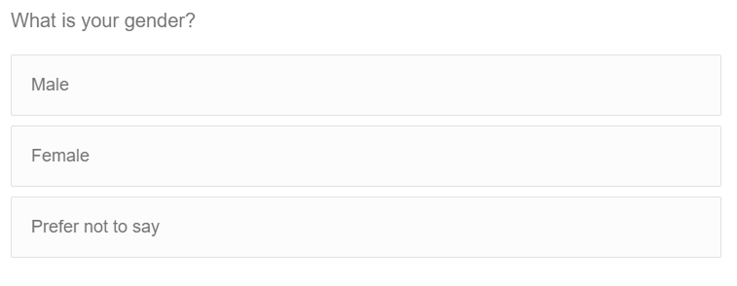

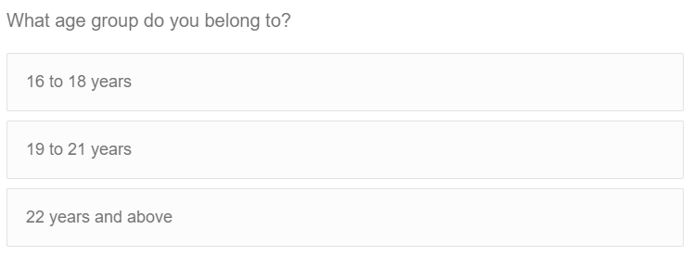

Figure 48: - Survey questions on demographics of students implemented in Qualtrics (Page 1)

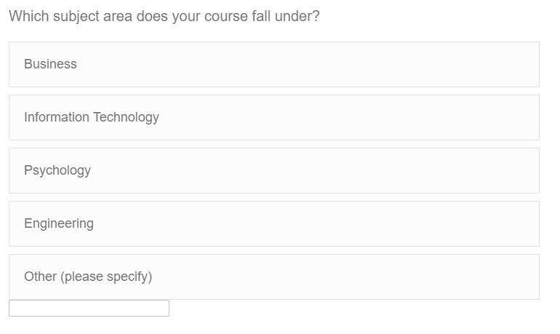

Figure 49: - Survey questions on demographics of students implemented in Qualtrics (Page 2)

**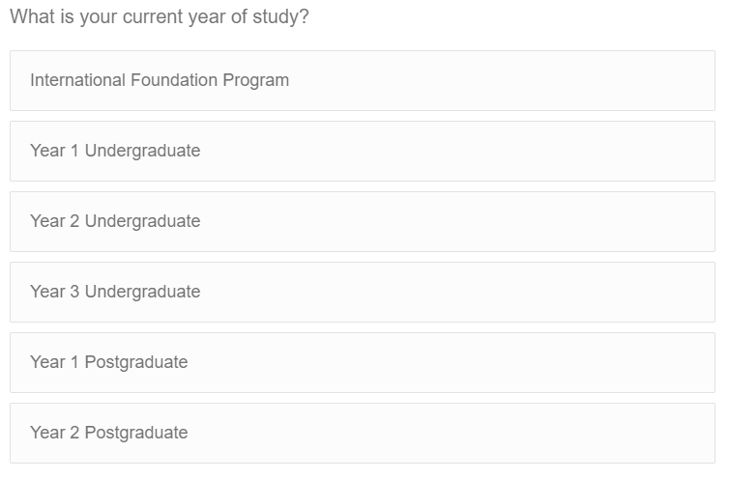b. Technical aspects of online learning**

Figure 50: - Survey questions on demographics of students implemented in Qualtrics (Page 3)

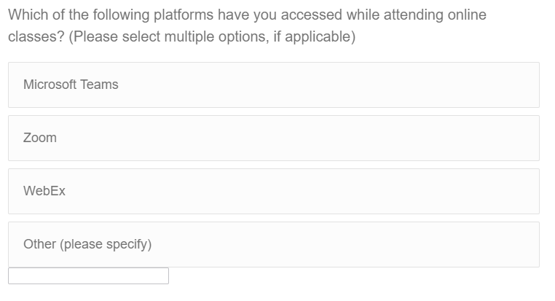

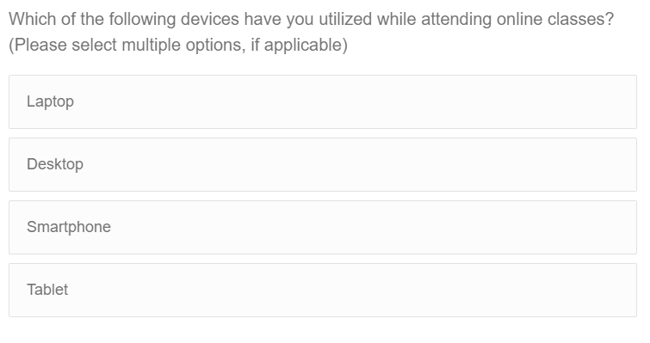

Figure 51: - Survey questions on technical aspects of online learning implemented in Qualtrics (Page 3)

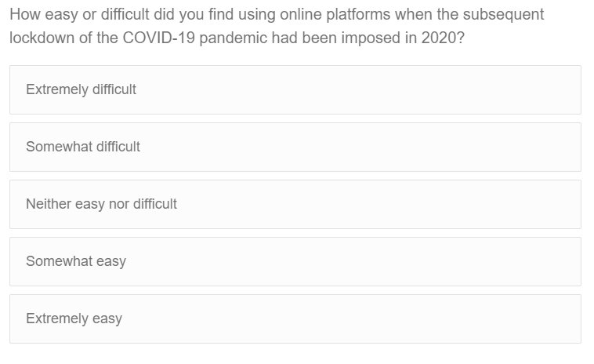

Figure 52: - Survey questions on technical aspects of online learning implemented in Qualtrics (Page 5)

**c. Student experiences with online learning**

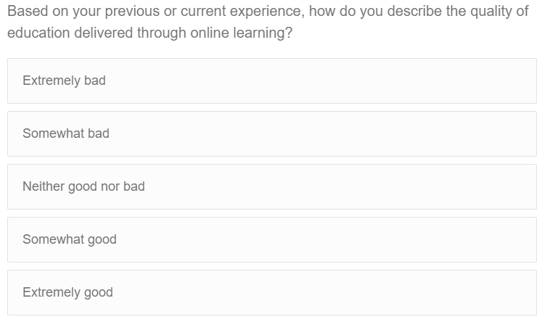

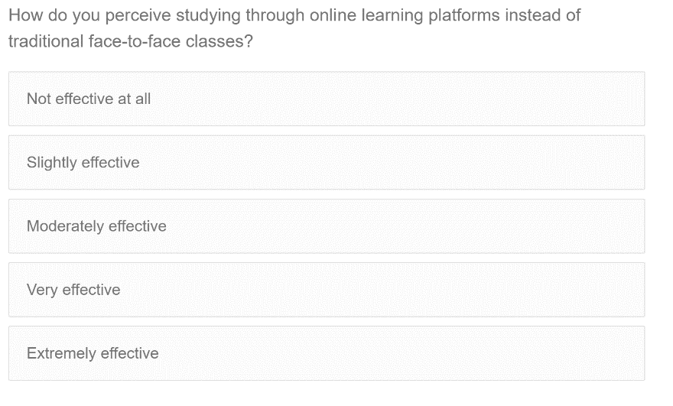

Figure 53: - Survey questions on technical aspects of online learning implemented in Qualtrics (Page 6)

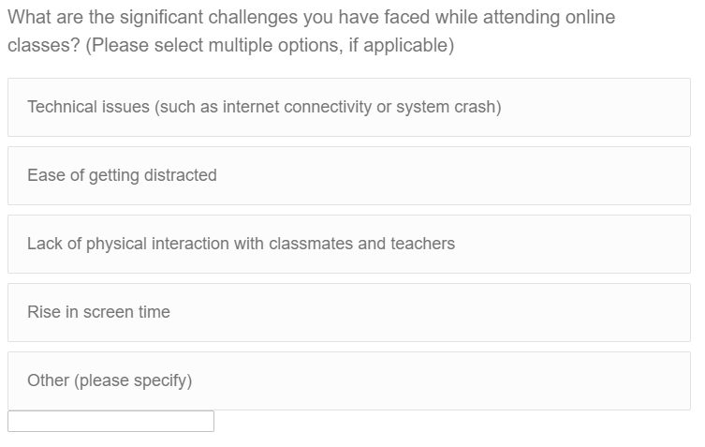

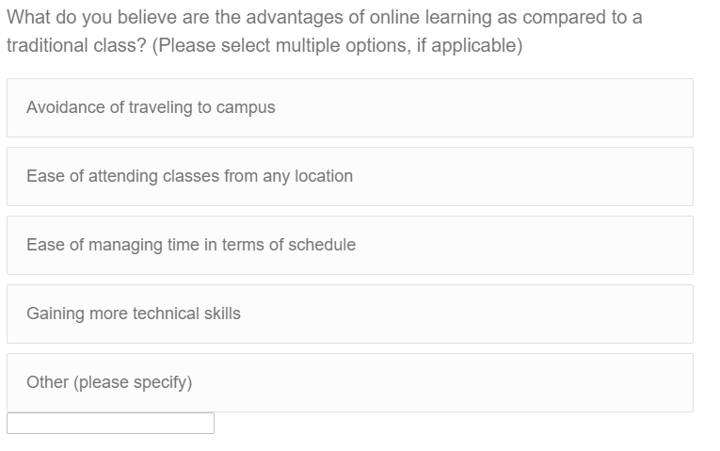

Figure 54: - Survey questions on technical aspects of online learning implemented in Qualtrics (Page 7)

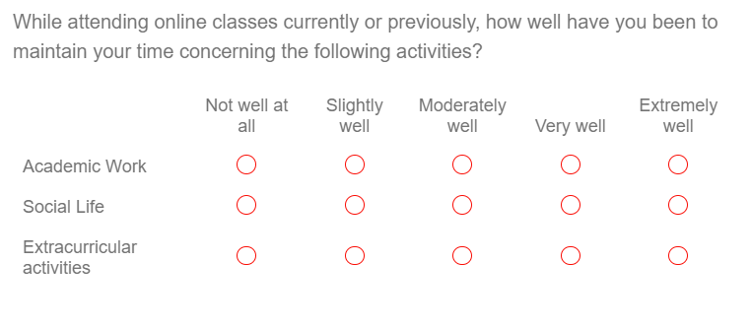

Figure 55: - Survey questions on technical aspects of online learning implemented in Qualtrics (Page 8)

**d. Students' mental health**

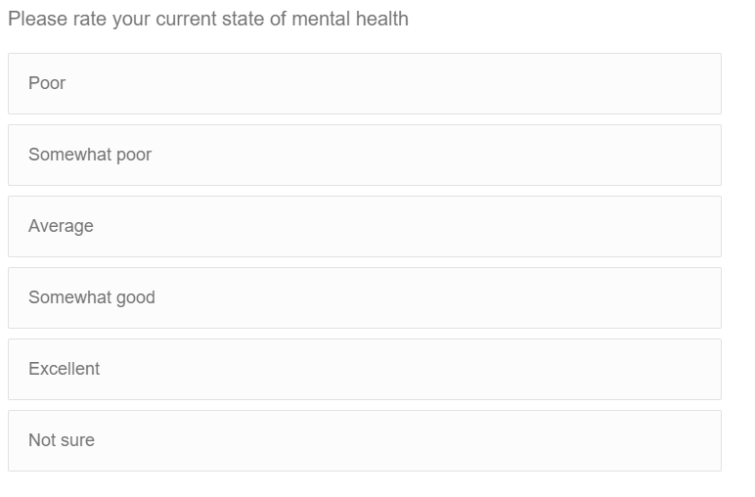

Figure 56: - Survey questions on students' mental health implemented in Qualtrics (Page 9)

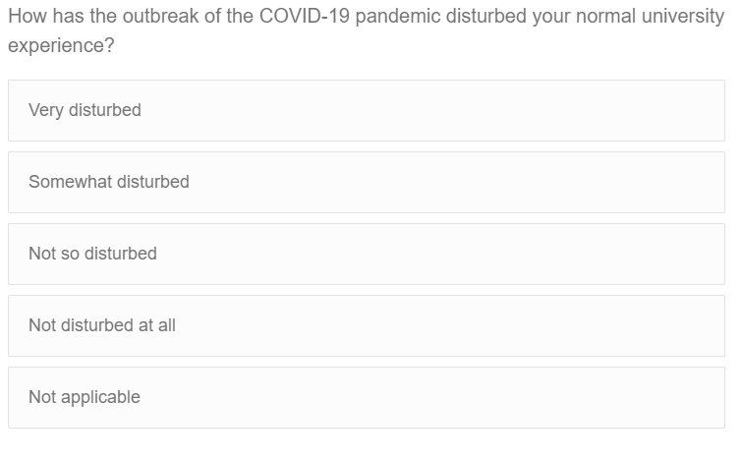

Figure 57: - Survey questions on students' mental health implemented in Qualtrics (Page 10)

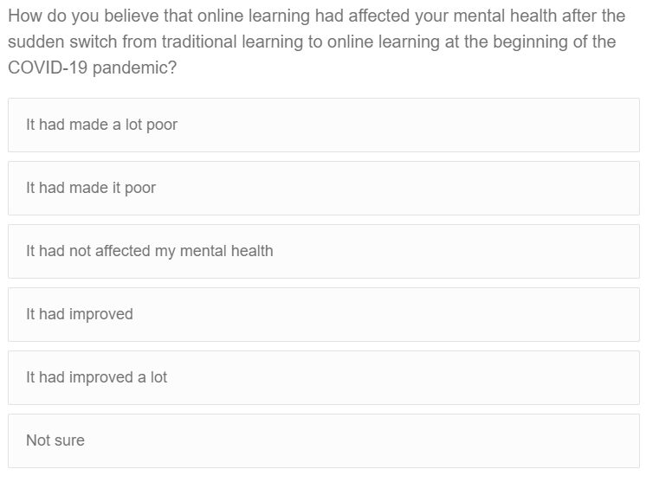

Figure 58: - Survey questions on students' mental health implemented in Qualtrics (Page 11)

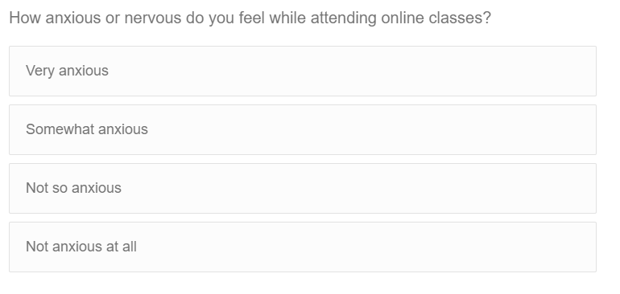

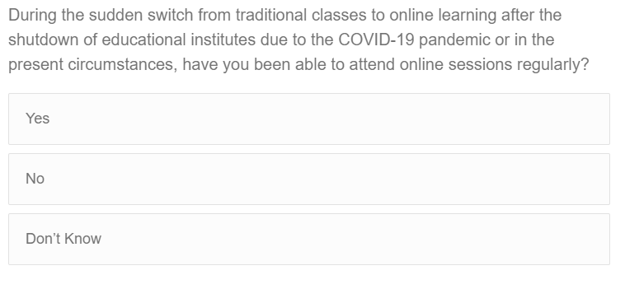

Figure 59: - Survey questions on students' mental health implemented in Qualtrics (Page 12)

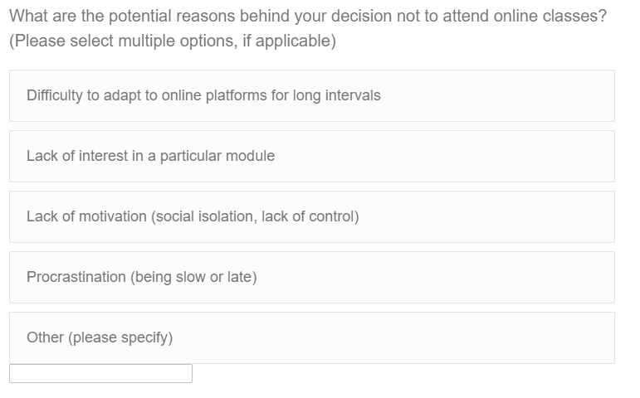

Figure 60: - Survey questions on students' mental health implemented in Qualtrics (Page 13)

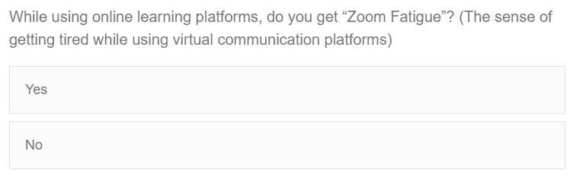

Figure 61: - Survey questions on students' mental health implemented in Qualtrics (Page 14)

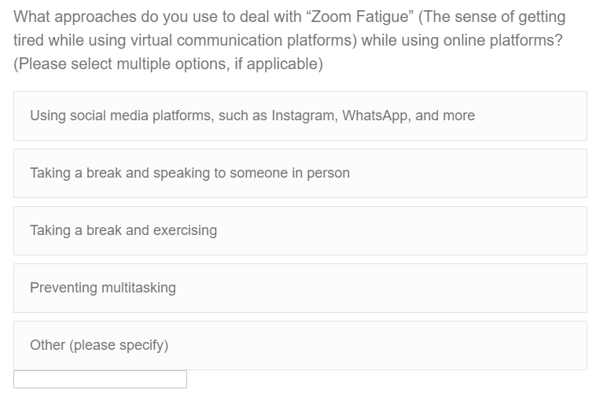

Figure 62: - Survey questions on students' mental health implemented in Qualtrics (Page 15)

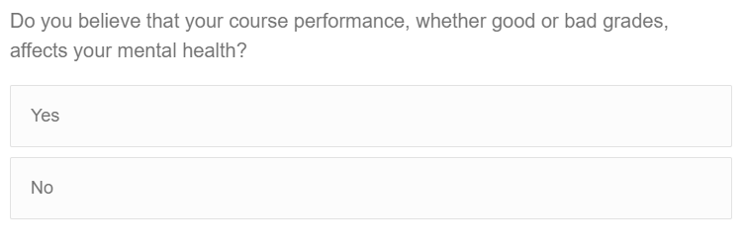

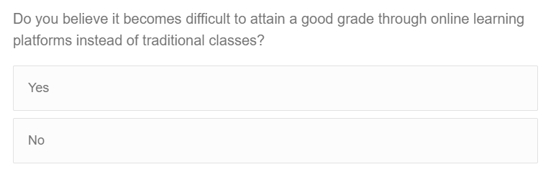

Figure 63: - Survey questions on students' mental health implemented in Qualtrics (Page 16)

**e. Student experiences with university and tutors**

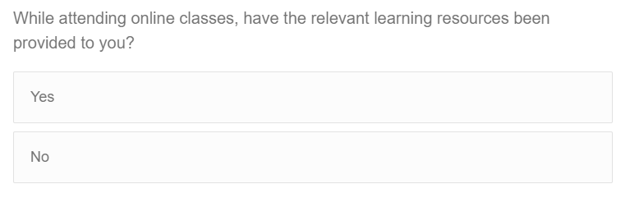

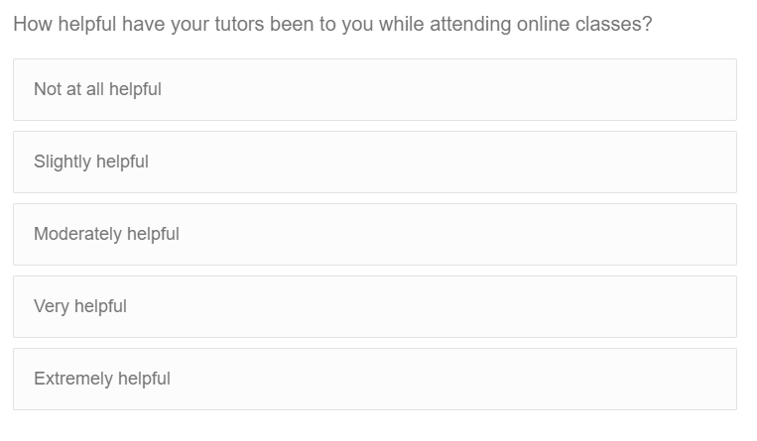

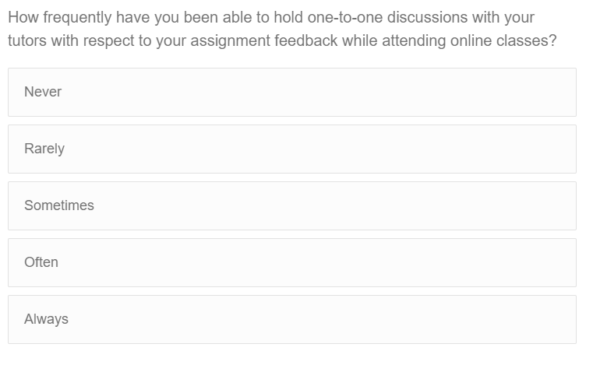

Figure 64: - Survey questions on student experiences with university and tutors implemented in Qualtrics (Page 17)

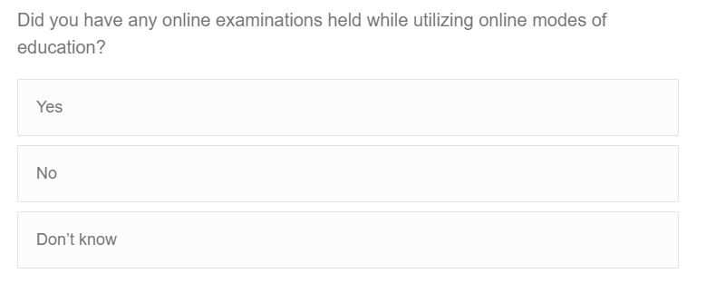

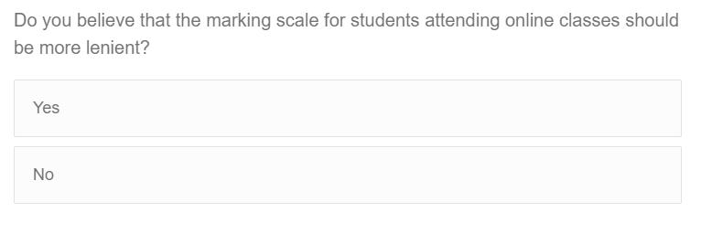

Figure 65: - Survey questions on student experiences with university and tutors implemented in Qualtrics (Page 18)

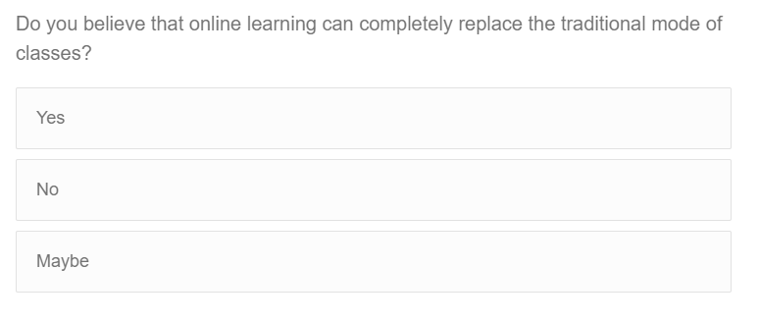

Figure 66: - Survey questions on student experiences with university and tutors implemented in Qualtrics (Page 19)

## 8.3. Meeting Logs

|  |  |  |  |  |
| --- | --- | --- | --- | --- |
| **Meeting No** | **Meeting Date** | **Topic** | **Comments** | **Supervisor Signature** |
| 1 | 28 October 2021 | Discussion of project topic and guidelines for project proposal | * Finalized the topic for the project. * Discussed the required outcome of the project, i.e., visualization through dashboards and dashboard story. * Comprehended the structure and content of the project proposal. | GJ |
| 2 | 11 November 2021 | Guidelines for intermediate deliverable | * Discussed the required structure of the intermediate deliverable. * Brief apprehension on the needed content for the next project stage, i.e., data collection and visualizations. | GJ |
| 3 | 28 January 2022 | Briefing on ideas for visualization using Tableau | * Examples provided on dashboard and dashboard story to be implemented on Tableau. | GJ |
| 4 | 11 March 2022 | Guidelines for data collection and visualizations and structure of the overall project | * Discussed the needed content for the sections of data collection and visualizations. * Apprehended the overall structure of the project comprehensively. | GJ |
| 5 | 1 April 2022 | Doubts with multiple choice questions on Tableau | * Solved various doubts on Tableau concerning multiple choice questions and filtering. | GJ |

|  |  |  |  |  |
| --- | --- | --- | --- | --- |
| **Meeting No** | **Meeting Date** | **Topic** | **Comments** | **Supervisor Signature** |
| 6 | 20 April 2022 | Doubts with sharing file on Tableau | * Clarified various doubts about Tableau on whether the file had to be shared on Tableau Public | GJ |
| 7 | 25 April 2022 | Review of final report and rehearsal demo of visualizations on Tableau | * Feedback provided on the final report * Performed a practice try-out with dashboards and story on Tableau | GJ |